SNOWFLAKE ARCHITECTURE:

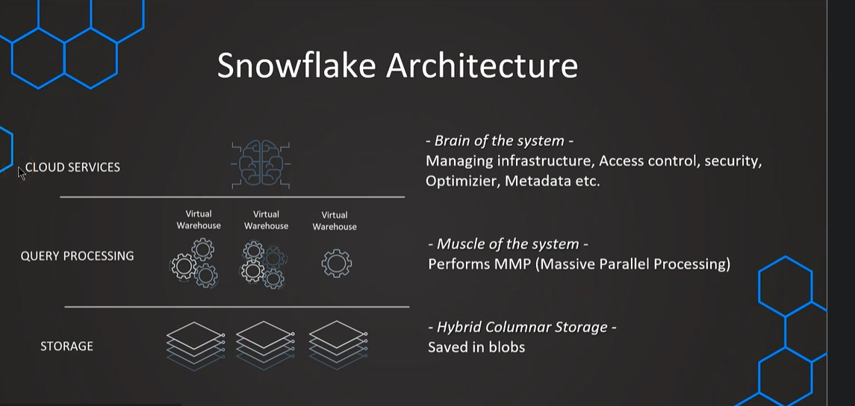

VIRTUAL WAREHOUSE SIZES:
XS – 1 Servers
S – 2 Servers
M – 4 Servers
L - 8 Servers
XL – 16 Servers
4XL – 128 Servers
And also it is important to note that larger is our warehouse is more expensive.
1 server means 1 credit is consumed per hour when we activate the warehouse
Billed by second – with 1 minute as minimum
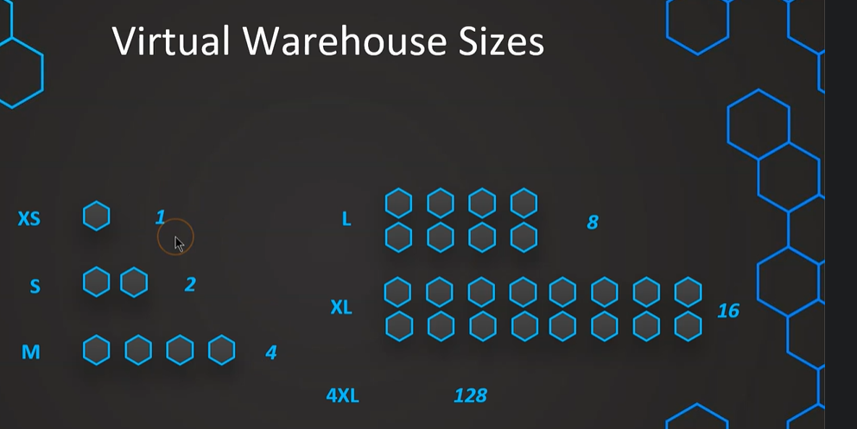

Suppose we have virtual warehouse of size S and we are able to query and all good then What if we have too many queries to process and they are waiting in Queue as there is no enough processing capability we go for Multi-Clustering
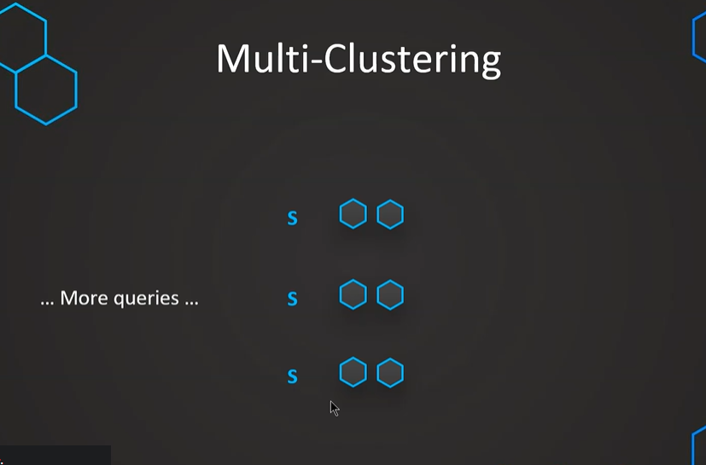
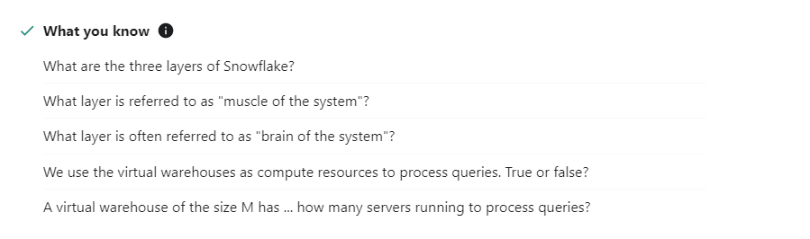
- Storage, Virtual Warehouses, cloud services
- Virtual Warehouses
- Cloud Services
- True
- 4

CREATE WAREHOUSE:
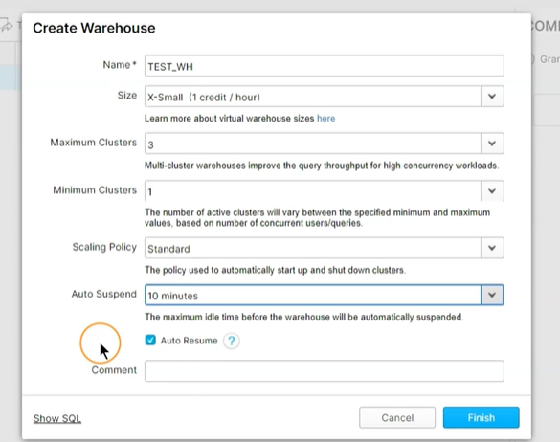

CREATE WAREHOUSE TEST_WH WITH WAREHOUSE_SIZE = 'XSMALL'
WAREHOUSE_TYPE = 'STANDARD'
AUTO_SUSPEND = 600
MAX_CLUSTER_COUNT=3
MIN_CLUSTER_COUNT=1
AUTO_RESUME = TRUE;

DROP WAREHOUSE TEST_WH;

AUTO SCALING:
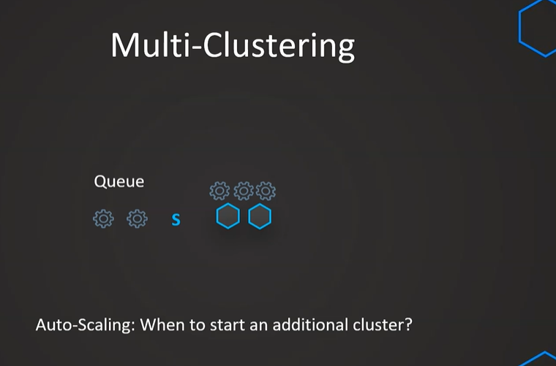

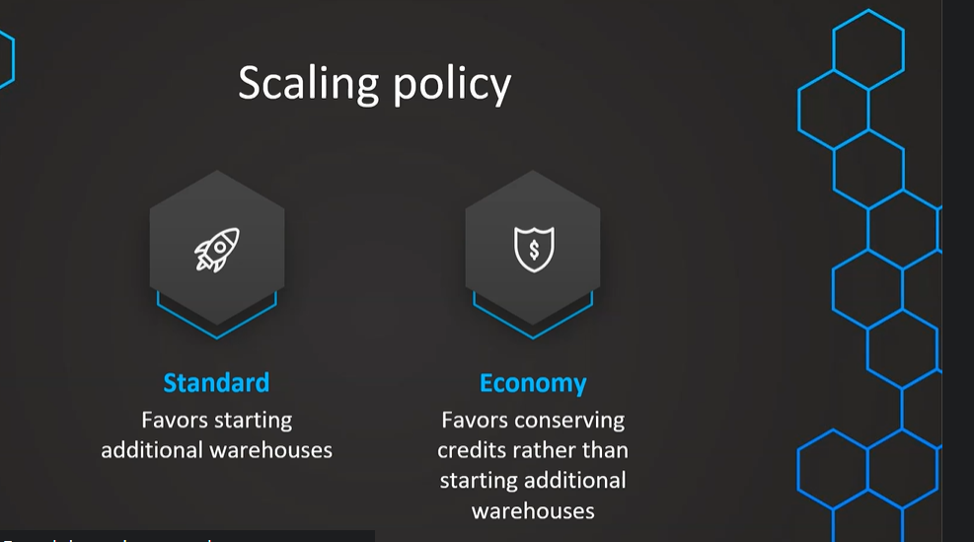

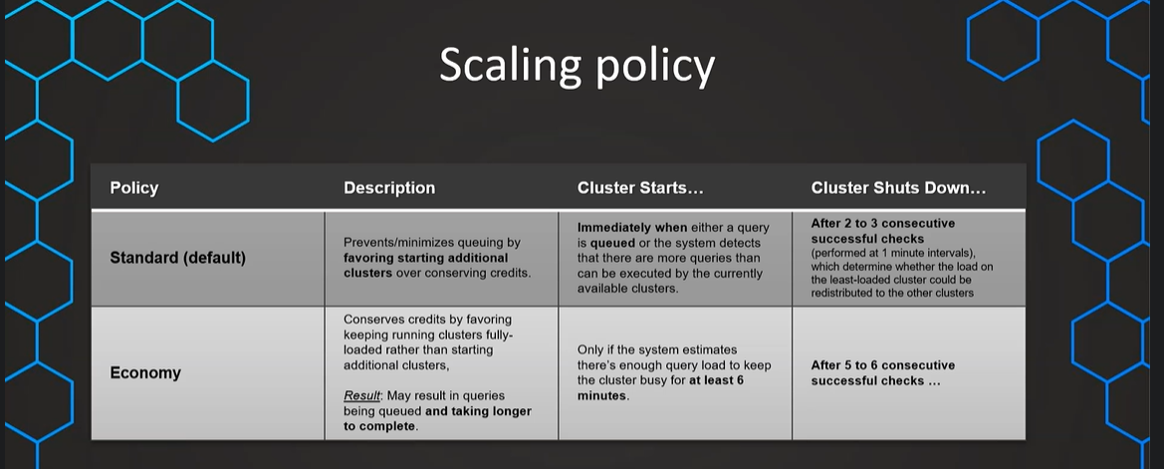

CREATE DATABASE OUR_FIRST_DB COMMENT = 'This is our first db';

CREATE TABLE "OUR_FIRST_DB"."PUBLIC"."SECOND_TABLE" ("ID" INTEGER NOT NULL, "NAME" STRING NOT NULL);

LOAD DATA INTO SNOWFLAKE FROM S3:
//Creating the table / Meta data
CREATE TABLE "OUR_FIRST_DB"."PUBLIC"."LOAN_PAYMENT" (
"Loan_ID" STRING,
"loan_status" STRING,
"Principal" STRING,
"terms" STRING,
"effective_date" STRING,
"due_date" STRING,
"paid_off_time" STRING,
"past_due_days" STRING,
"age" STRING,
"education" STRING,
"Gender" STRING);

//Check that table is empy
USE DATABASE OUR_FIRST_DB;

SELECT * FROM LOAN_PAYMENT;

//Loading the data from S3 bucket

COPY INTO LOAN_PAYMENT
FROM s3://bucketsnowflakes3/Loan_payments_data.csv
file_format = (type = csv
field_delimiter = ','
skip_header=1);

//Validate
SELECT * FROM LOAN_PAYMENT;

CREATE DATABASE EXERCISE_DB COMMENT = 'This is our second db';

CREATE TABLE "EXERCISE_DB"."PUBLIC"."CUSTOMERS" (
"ID" INTEGER,
"FIRST_NAME" STRING,
"LAST_NAME" STRING,
"EMAIL" STRING,
"AGE" INTEGER,
"CITY" STRING
);

USE DATABASE EXERCISE_DB;

s3://snowflake-assignments-mc/gettingstarted/customers.csv

COPY INTO CUSTOMERS
FROM s3://snowflake-assignments-mc/gettingstarted/customers.csv
file_format = (type = csv
field_delimiter = ','
skip_header=1);

SELECT COUNT(*) FROM CUSTOMERS

DATA WAREHOUSE:
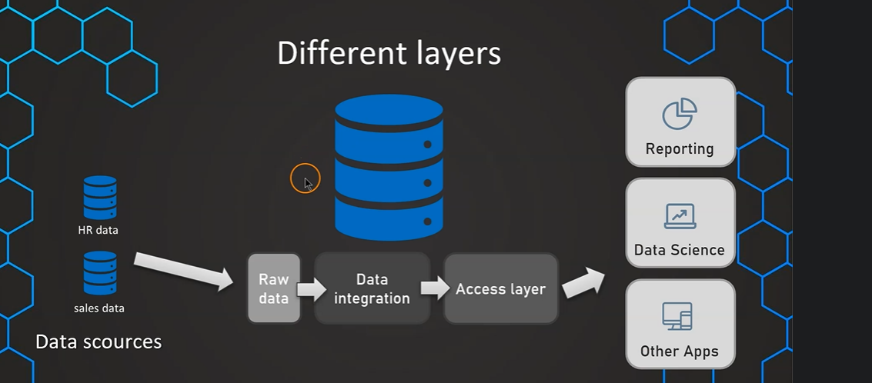
Relating to snowflake:
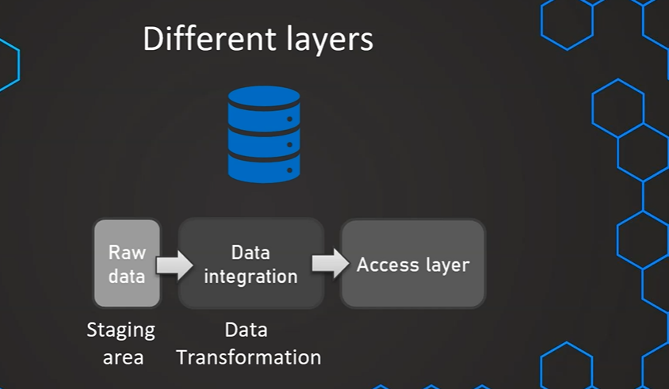

WHY CLOUD COMPUTING:
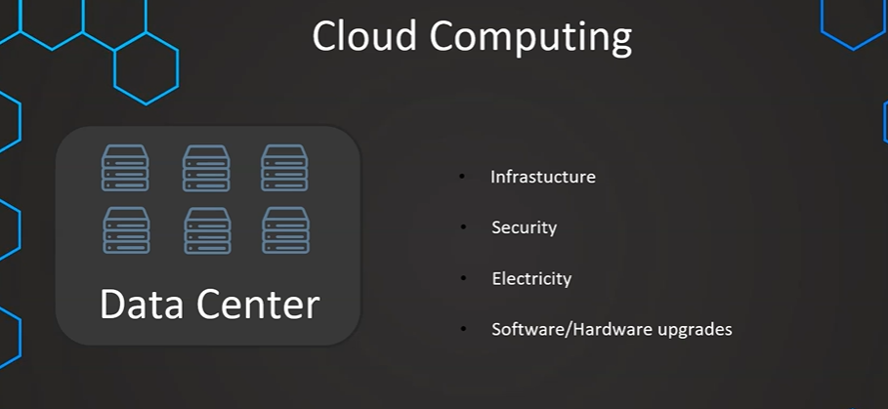
Above are all the issues having physical data centers so how snowflake manages those for us shows below as software-as-a-service
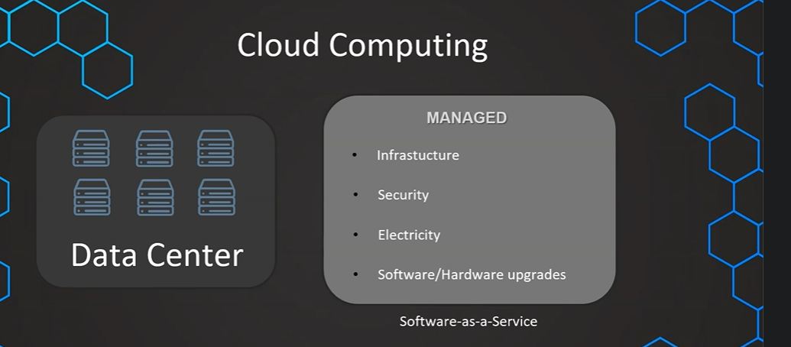

Snowflake SAAS: We as a client only manages the application and rest all taken care by snowflake and cloud provider.
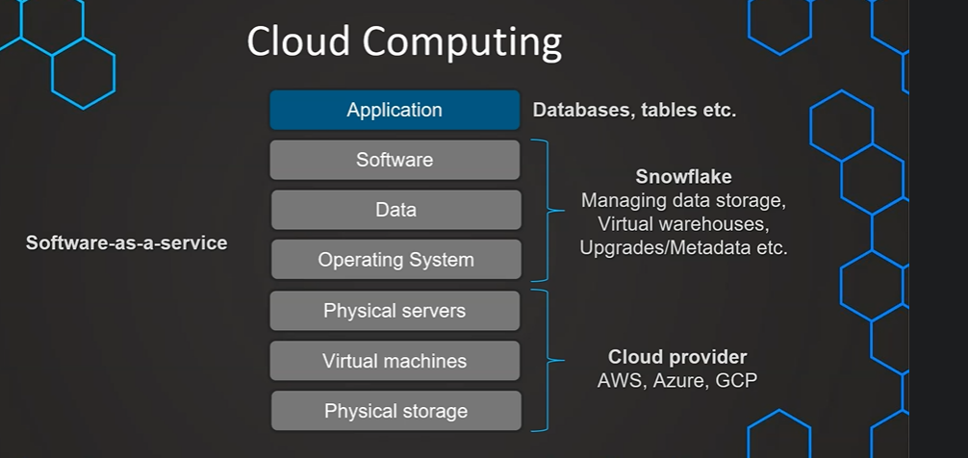
SNOWFLAKE EDITIONS:
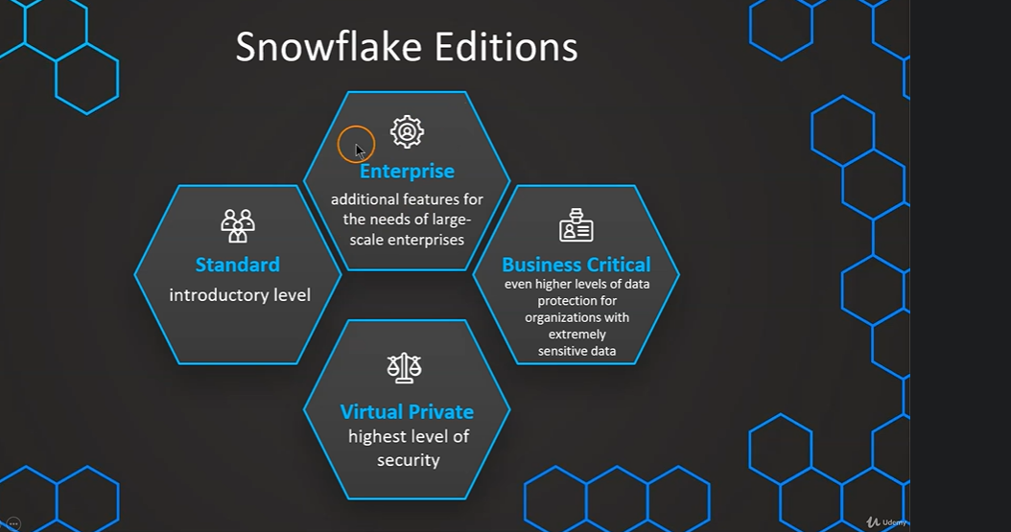
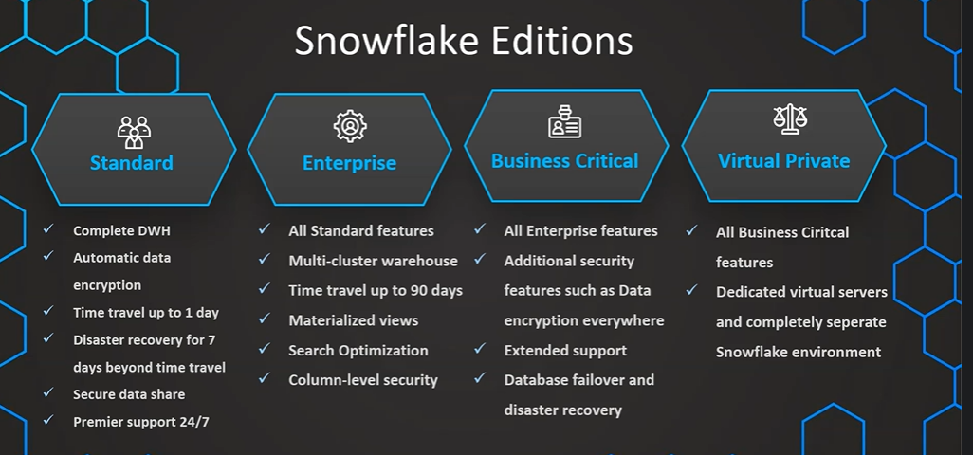
SNOWFLAKE PRICING:
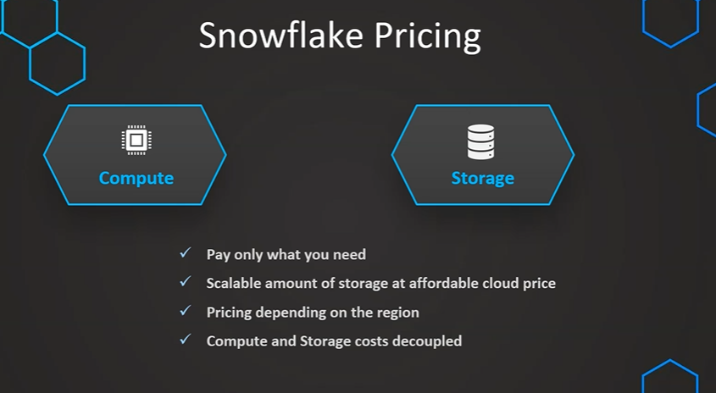
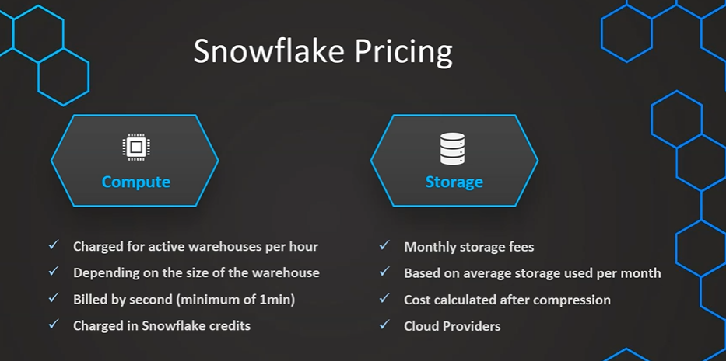
Compute Cost :
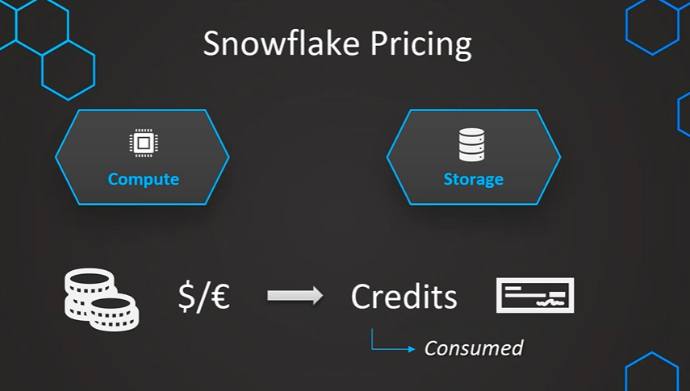

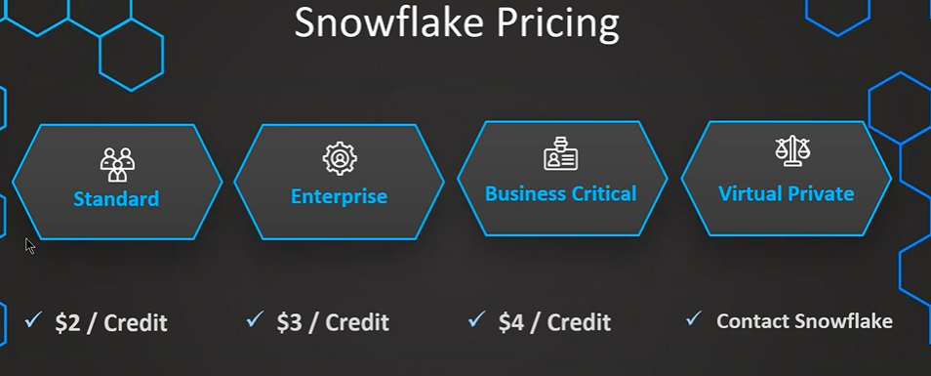

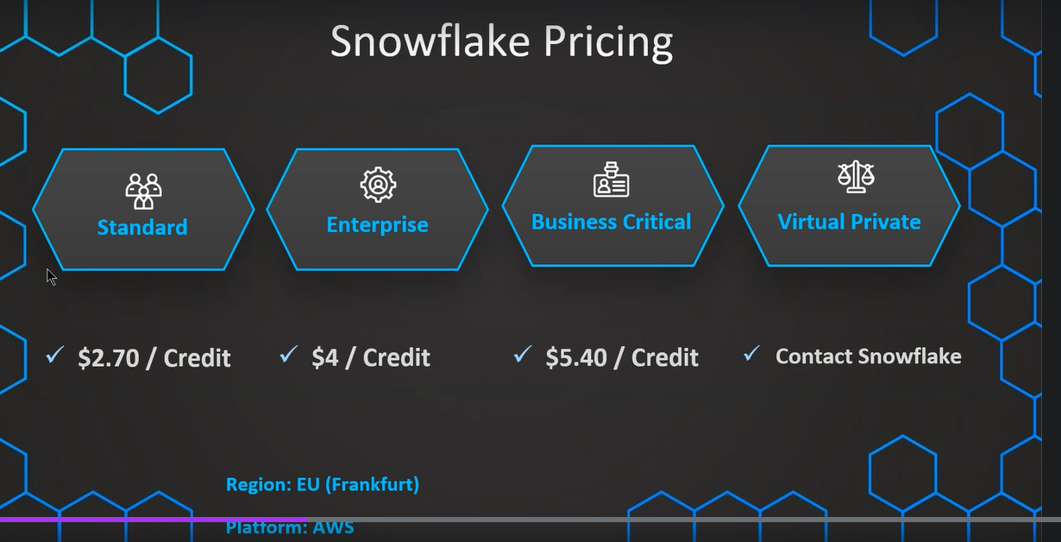

Storage Cost:
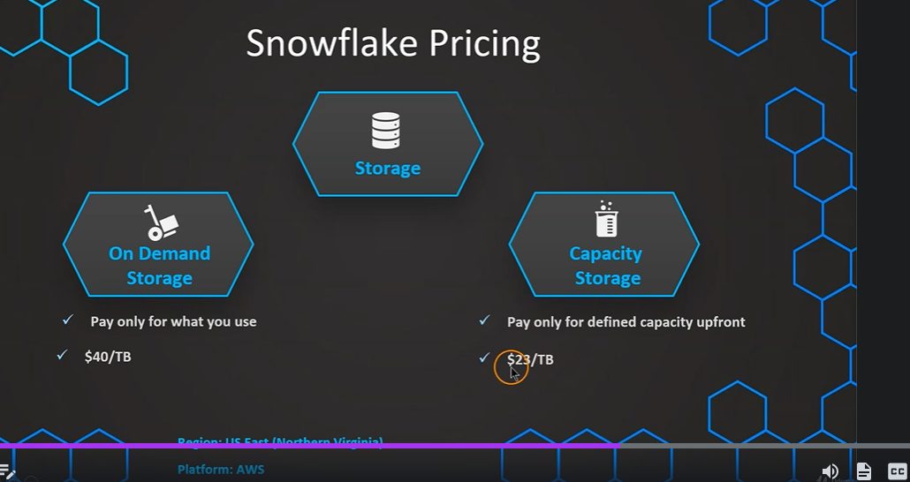
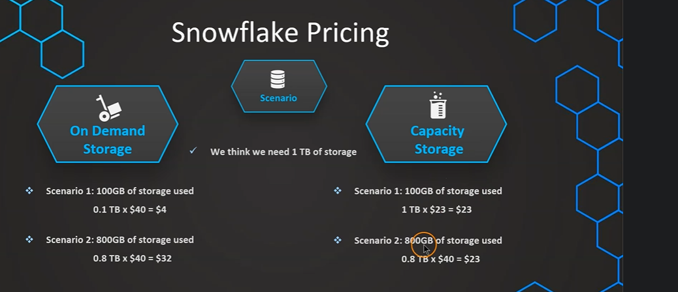

Which one to choose:
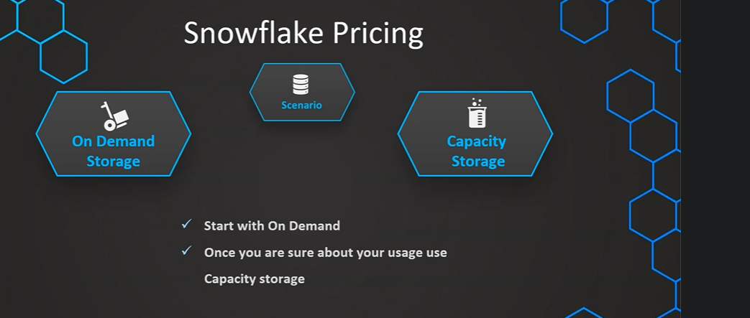
Consumption:
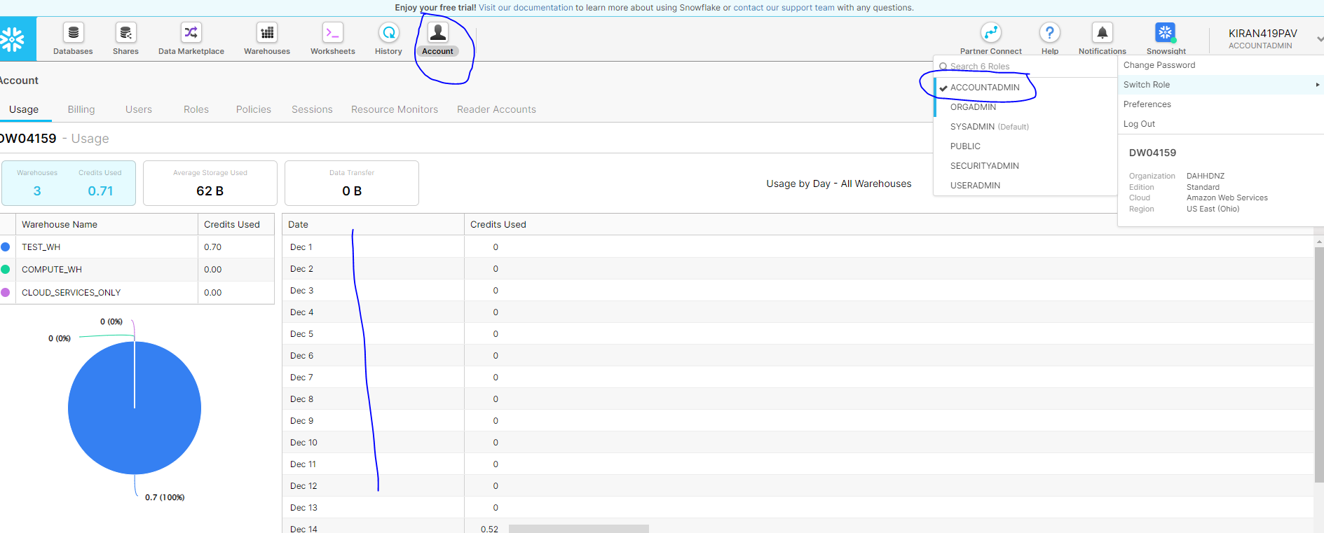

No Database is selected below, but we can click on any date and see the consumption related to all the available databases on selected day.
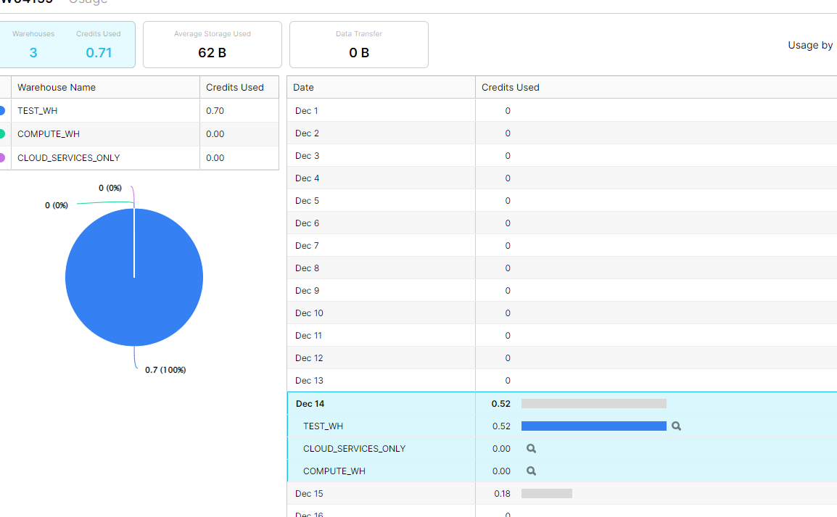
ROLES IN SNOWFLAKE:
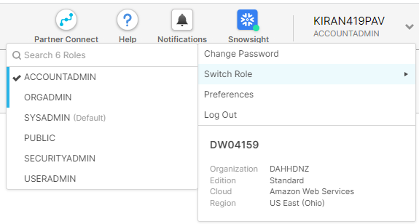
By default, will have sysadmin role

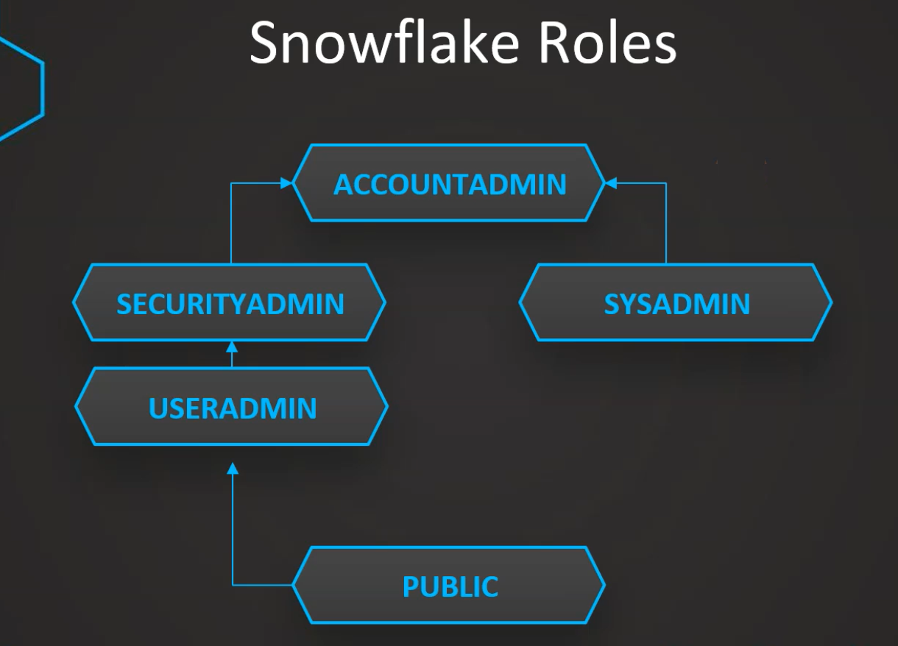
Accountadmin role is a combination of security and sysadmin and the securityadmin can do anything that useradmin can do and additional ones.
Public is lowest level role.
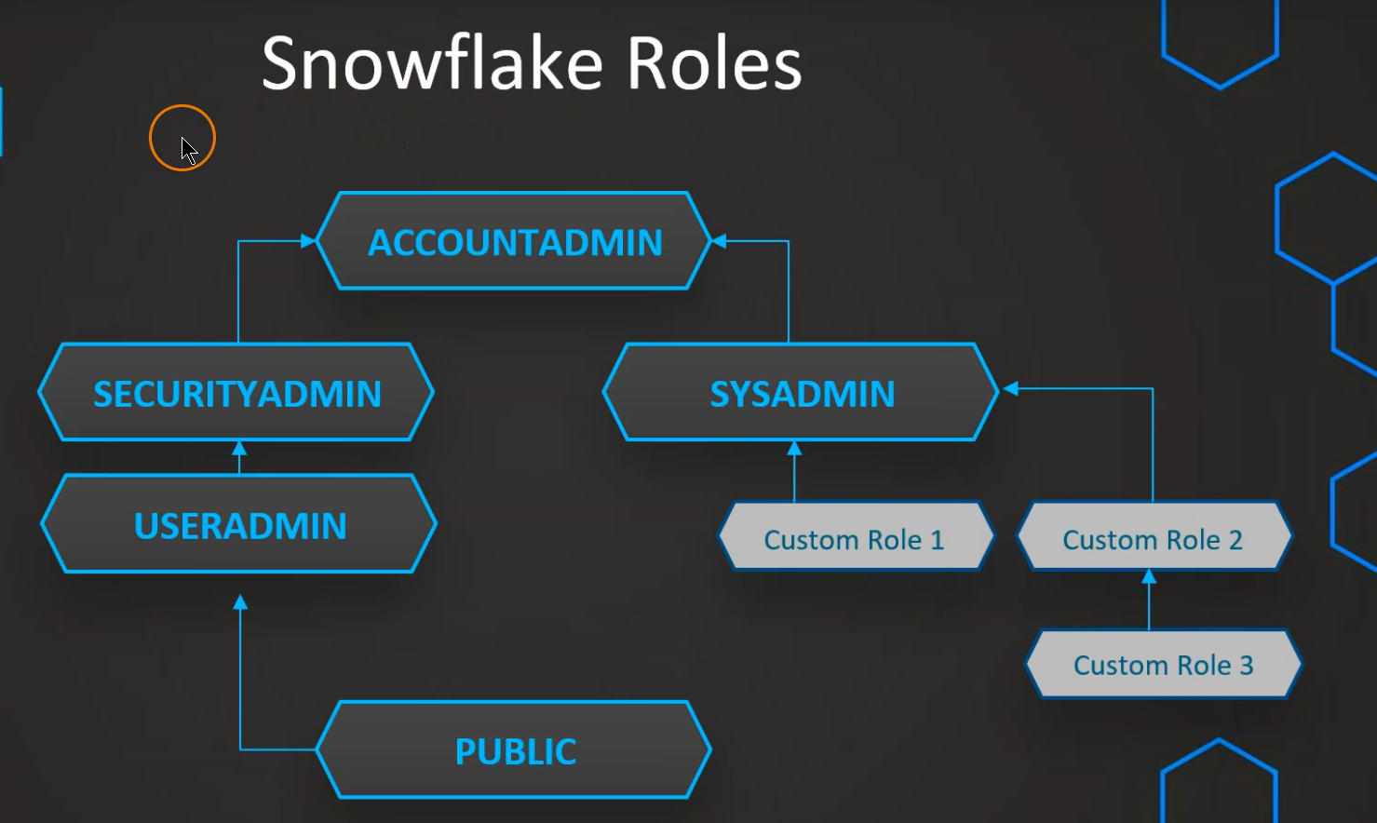
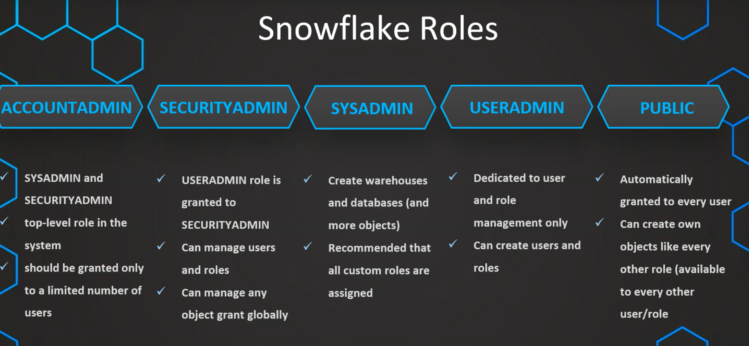

Loading Data:
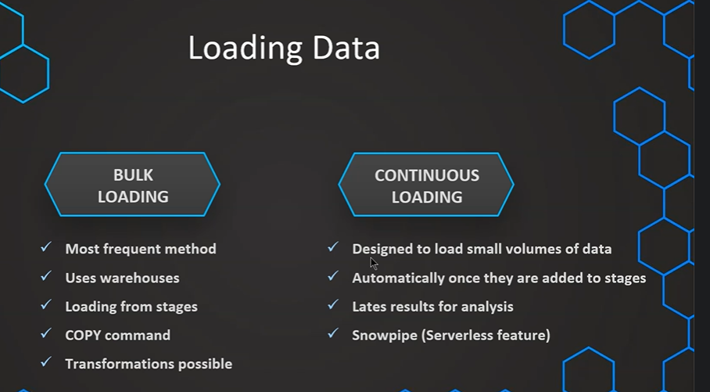
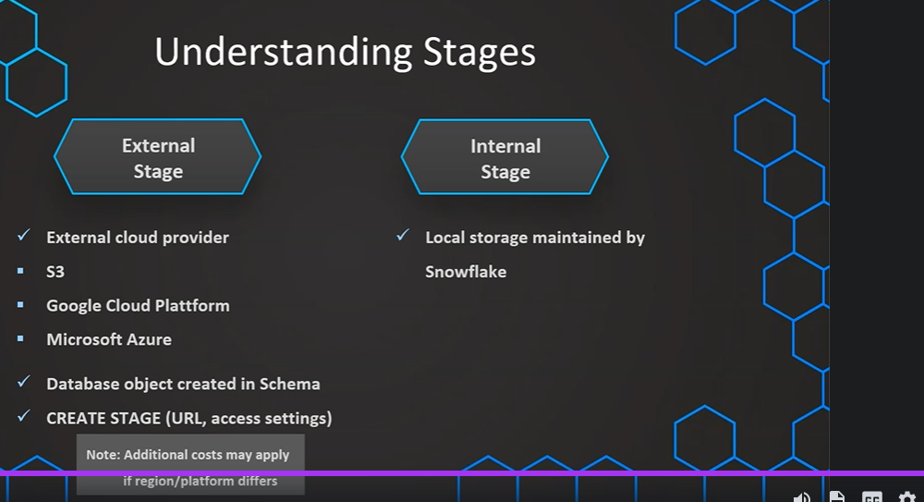

// Database to manage stage objects, fileformats etc.

CREATE OR REPLACE DATABASE MANAGE_DB;

CREATE OR REPLACE SCHEMA external_stages;

// Creating external stage

CREATE OR REPLACE STAGE MANAGE_DB.external_stages.aws_stage
url='s3://bucketsnowflakes3'
credentials=(aws_key_id='ABCD_DUMMY_ID' aws_secret_key='1234abcd_key');

// Description of external stage

DESC STAGE MANAGE_DB.external_stages.aws_stage;

// Alter external stage

ALTER STAGE aws_stage
SET credentials=(aws_key_id='XYZ_DUMMY_ID' aws_secret_key='987xyz');

// Publicly accessible staging area

CREATE OR REPLACE STAGE MANAGE_DB.external_stages.aws_stage
url='s3://bucketsnowflakes3';

// List files in stage

LIST @aws_stage;

//Load data using copy command

COPY INTO OUR_FIRST_DB.PUBLIC.ORDERS
FROM @aws_stage
file_format= (type = csv field_delimiter=',' skip_header=1)
pattern='.*Order.*';
COPY COMMAND:

// Creating ORDERS table

CREATE OR REPLACE TABLE OUR_FIRST_DB.PUBLIC.ORDERS (
ORDER_ID VARCHAR(30),
AMOUNT INT,
PROFIT INT,
QUANTITY INT,
CATEGORY VARCHAR(30),
SUBCATEGORY VARCHAR(30));

SELECT * FROM OUR_FIRST_DB.PUBLIC.ORDERS;

// First copy command

COPY INTO OUR_FIRST_DB.PUBLIC.ORDERS
FROM @aws_stage
file_format = (type = csv field_delimiter=',' skip_header=1);

// Copy command with fully qualified stage object

COPY INTO OUR_FIRST_DB.PUBLIC.ORDERS
FROM @MANAGE_DB.external_stages.aws_stage
file_format= (type = csv field_delimiter=',' skip_header=1);

// List files contained in stage

LIST @MANAGE_DB.external_stages.aws_stage;

// Copy command with specified file(s)

COPY INTO OUR_FIRST_DB.PUBLIC.ORDERS
FROM @MANAGE_DB.external_stages.aws_stage
file_format= (type = csv field_delimiter=',' skip_header=1)
files = ('OrderDetails.csv');

// Copy command with pattern for file names

COPY INTO OUR_FIRST_DB.PUBLIC.ORDERS
FROM @MANAGE_DB.external_stages.aws_stage
file_format= (type = csv field_delimiter=',' skip_header=1)
pattern='.*Order.*';

Transformations:

// Transforming using the SELECT statement

COPY INTO OUR_FIRST_DB.PUBLIC.ORDERS_EX
FROM (select s.$1, s.$2 from @MANAGE_DB.external_stages.aws_stage s)
file_format= (type = csv field_delimiter=',' skip_header=1)
files=('OrderDetails.csv');

// Example 1 - Table

CREATE OR REPLACE TABLE OUR_FIRST_DB.PUBLIC.ORDERS_EX (
ORDER_ID VARCHAR(30),
AMOUNT INT
)

SELECT * FROM OUR_FIRST_DB.PUBLIC.ORDERS_EX;

// Example 2 - Table

CREATE OR REPLACE TABLE OUR_FIRST_DB.PUBLIC.ORDERS_EX (
ORDER_ID VARCHAR(30),
AMOUNT INT,
PROFIT INT,
PROFITABLE_FLAG VARCHAR(30)

)

// Example 2 - Copy Command using a SQL function (subset of functions available)

COPY INTO OUR_FIRST_DB.PUBLIC.ORDERS_EX
FROM (select
s.$1,
s.$2,
s.$3,
CASE WHEN CAST(s.$3 as int) < 0 THEN 'not profitable' ELSE 'profitable' END
from @MANAGE_DB.external_stages.aws_stage s)
file_format= (type = csv field_delimiter=',' skip_header=1)
files=('OrderDetails.csv');

SELECT * FROM OUR_FIRST_DB.PUBLIC.ORDERS_EX
------------------------------------------

// Example 3 - Table

CREATE OR REPLACE TABLE OUR_FIRST_DB.PUBLIC.ORDERS_EX (
ORDER_ID VARCHAR(30),
AMOUNT INT,
PROFIT INT,
CATEGORY_SUBSTRING VARCHAR(5)

)

// Example 3 - Copy Command using a SQL function (subset of functions available)

COPY INTO OUR_FIRST_DB.PUBLIC.ORDERS_EX
FROM (select
s.$1,
s.$2,
s.$3,
substring(s.$5,1,5)
from @MANAGE_DB.external_stages.aws_stage s)
file_format= (type = csv field_delimiter=',' skip_header=1)
files=('OrderDetails.csv');

SELECT * FROM OUR_FIRST_DB.PUBLIC.ORDERS_EX

//Example 3 - Table

CREATE OR REPLACE TABLE OUR_FIRST_DB.PUBLIC.ORDERS_EX (
ORDER_ID VARCHAR(30),
AMOUNT INT,
PROFIT INT,
PROFITABLE_FLAG VARCHAR(30)

)

//Example 4 - Using subset of columns

COPY INTO OUR_FIRST_DB.PUBLIC.ORDERS_EX (ORDER_ID,PROFIT)
FROM (select
s.$1,
s.$3
from @MANAGE_DB.external_stages.aws_stage s)
file_format= (type = csv field_delimiter=',' skip_header=1)
files=('OrderDetails.csv');

SELECT * FROM OUR_FIRST_DB.PUBLIC.ORDERS_EX;

//Example 5 - Table Auto increment

CREATE OR REPLACE TABLE OUR_FIRST_DB.PUBLIC.ORDERS_EX (
ORDER_ID number autoincrement start 1 increment 1,
AMOUNT INT,
PROFIT INT,
PROFITABLE_FLAG VARCHAR(30)

)

//Example 5 - Auto increment ID

COPY INTO OUR_FIRST_DB.PUBLIC.ORDERS_EX (PROFIT,AMOUNT)
FROM (select
s.$2,
s.$3
from @MANAGE_DB.external_stages.aws_stage s)
file_format= (type = csv field_delimiter=',' skip_header=1)
files=('OrderDetails.csv');

SELECT * FROM OUR_FIRST_DB.PUBLIC.ORDERS_EX WHERE ORDER_ID > 15;

DROP TABLE OUR_FIRST_DB.PUBLIC.ORDERS_EX

----------------------------------------

// Create new stage
CREATE OR REPLACE STAGE MANAGE_DB.external_stages.aws_stage_errorex
url='s3://bucketsnowflakes4'

// List files in stage
LIST @MANAGE_DB.external_stages.aws_stage_errorex;

// Create example table
CREATE OR REPLACE TABLE OUR_FIRST_DB.PUBLIC.ORDERS_EX (
ORDER_ID VARCHAR(30),
AMOUNT INT,
PROFIT INT,
QUANTITY INT,
CATEGORY VARCHAR(30),
SUBCATEGORY VARCHAR(30));

// Demonstrating error message
COPY INTO OUR_FIRST_DB.PUBLIC.ORDERS_EX
FROM @MANAGE_DB.external_stages.aws_stage_errorex
file_format= (type = csv field_delimiter=',' skip_header=1)
files = ('OrderDetails_error.csv');

// Validating table is empty
SELECT * FROM OUR_FIRST_DB.PUBLIC.ORDERS_EX

// Error handling using the ON_ERROR option
COPY INTO OUR_FIRST_DB.PUBLIC.ORDERS_EX
FROM @MANAGE_DB.external_stages.aws_stage_errorex
file_format= (type = csv field_delimiter=',' skip_header=1)
files = ('OrderDetails_error.csv')
ON_ERROR = 'CONTINUE';

// Validating results and truncating table
SELECT * FROM OUR_FIRST_DB.PUBLIC.ORDERS_EX
SELECT COUNT(*) FROM OUR_FIRST_DB.PUBLIC.ORDERS_EX

TRUNCATE TABLE OUR_FIRST_DB.PUBLIC.ORDERS_EX;

// Error handling using the ON_ERROR option = ABORT_STATEMENT (default)
COPY INTO OUR_FIRST_DB.PUBLIC.ORDERS_EX
FROM @MANAGE_DB.external_stages.aws_stage_errorex
file_format= (type = csv field_delimiter=',' skip_header=1)
files = ('OrderDetails_error.csv','OrderDetails_error2.csv')
ON_ERROR = 'ABORT_STATEMENT';

// Validating results and truncating table
SELECT * FROM OUR_FIRST_DB.PUBLIC.ORDERS_EX
SELECT COUNT(*) FROM OUR_FIRST_DB.PUBLIC.ORDERS_EX

TRUNCATE TABLE OUR_FIRST_DB.PUBLIC.ORDERS_EX;

// Error handling using the ON_ERROR option = SKIP_FILE
COPY INTO OUR_FIRST_DB.PUBLIC.ORDERS_EX
FROM @MANAGE_DB.external_stages.aws_stage_errorex
file_format= (type = csv field_delimiter=',' skip_header=1)
files = ('OrderDetails_error.csv','OrderDetails_error2.csv')
ON_ERROR = 'SKIP_FILE';

// Validating results and truncating table
SELECT * FROM OUR_FIRST_DB.PUBLIC.ORDERS_EX
SELECT COUNT(*) FROM OUR_FIRST_DB.PUBLIC.ORDERS_EX

TRUNCATE TABLE OUR_FIRST_DB.PUBLIC.ORDERS_EX;

// Error handling using the ON_ERROR option = SKIP_FILE_<number>
COPY INTO OUR_FIRST_DB.PUBLIC.ORDERS_EX
FROM @MANAGE_DB.external_stages.aws_stage_errorex
file_format= (type = csv field_delimiter=',' skip_header=1)
files = ('OrderDetails_error.csv','OrderDetails_error2.csv')
ON_ERROR = 'SKIP_FILE_2';

// Validating results and truncating table
SELECT * FROM OUR_FIRST_DB.PUBLIC.ORDERS_EX
SELECT COUNT(*) FROM OUR_FIRST_DB.PUBLIC.ORDERS_EX

TRUNCATE TABLE OUR_FIRST_DB.PUBLIC.ORDERS_EX;

// Error handling using the ON_ERROR option = SKIP_FILE_<number>
COPY INTO OUR_FIRST_DB.PUBLIC.ORDERS_EX
FROM @MANAGE_DB.external_stages.aws_stage_errorex
file_format= (type = csv field_delimiter=',' skip_header=1)
files = ('OrderDetails_error.csv','OrderDetails_error2.csv')
ON_ERROR = 'SKIP_FILE_0.5%';

SELECT * FROM OUR_FIRST_DB.PUBLIC.ORDERS_EX

CREATE OR REPLACE TABLE OUR_FIRST_DB.PUBLIC.ORDERS_EX (
ORDER_ID VARCHAR(30),
AMOUNT INT,
PROFIT INT,
QUANTITY INT,
CATEGORY VARCHAR(30),
SUBCATEGORY VARCHAR(30));

COPY INTO OUR_FIRST_DB.PUBLIC.ORDERS_EX
FROM @MANAGE_DB.external_stages.aws_stage_errorex
file_format= (type = csv field_delimiter=',' skip_header=1)
files = ('OrderDetails_error.csv','OrderDetails_error2.csv')
ON_ERROR = SKIP_FILE_3
SIZE_LIMIT = 30;

File format type of file format object cannot be altered

// Specifying file_format in Copy command
COPY INTO OUR_FIRST_DB.PUBLIC.ORDERS_EX
FROM @MANAGE_DB.external_stages.aws_stage_errorex
file_format = (type = csv field_delimiter=',' skip_header=1)
files = ('OrderDetails_error.csv')
ON_ERROR = 'SKIP_FILE_3';

// Creating table
CREATE OR REPLACE TABLE OUR_FIRST_DB.PUBLIC.ORDERS_EX (
ORDER_ID VARCHAR(30),
AMOUNT INT,
PROFIT INT,
QUANTITY INT,
CATEGORY VARCHAR(30),
SUBCATEGORY VARCHAR(30));

// Creating schema to keep things organized
CREATE OR REPLACE SCHEMA MANAGE_DB.file_formats;

// Creating file format object
CREATE OR REPLACE file format MANAGE_DB.file_formats.my_file_format;

// See properties of file format object
DESC file format MANAGE_DB.file_formats.my_file_format;

// Using file format object in Copy command
COPY INTO OUR_FIRST_DB.PUBLIC.ORDERS_EX
FROM @MANAGE_DB.external_stages.aws_stage_errorex
file_format= (FORMAT_NAME=MANAGE_DB.file_formats.my_file_format)
files = ('OrderDetails_error.csv')
ON_ERROR = 'SKIP_FILE_3';

// Altering file format object
ALTER file format MANAGE_DB.file_formats.my_file_format
SET SKIP_HEADER = 1;

// Defining properties on creation of file format object
CREATE OR REPLACE file format MANAGE_DB.file_formats.my_file_format
TYPE=JSON,
TIME_FORMAT=AUTO;

// See properties of file format object
DESC file format MANAGE_DB.file_formats.my_file_format;

// Using file format object in Copy command
COPY INTO OUR_FIRST_DB.PUBLIC.ORDERS_EX
FROM @MANAGE_DB.external_stages.aws_stage_errorex
file_format= (FORMAT_NAME=MANAGE_DB.file_formats.my_file_format)
files = ('OrderDetails_error.csv')
ON_ERROR = 'SKIP_FILE_3';

// Altering the type of a file format is not possible
ALTER file format MANAGE_DB.file_formats.my_file_format
SET TYPE = CSV;

// Recreate file format (default = CSV)
CREATE OR REPLACE file format MANAGE_DB.file_formats.my_file_format

// See properties of file format object
DESC file format MANAGE_DB.file_formats.my_file_format;

// Truncate table
TRUNCATE table OUR_FIRST_DB.PUBLIC.ORDERS_EX;

// overwriting properties of file format object
COPY INTO OUR_FIRST_DB.PUBLIC.ORDERS_EX
FROM @MANAGE_DB.external_stages.aws_stage_errorex
file_format = (FORMAT_NAME= MANAGE_DB.file_formats.my_file_format field_delimiter = ',' skip_header=1 )
files = ('OrderDetails_error.csv')
ON_ERROR = 'SKIP_FILE_3';

DESC STAGE MANAGE_DB.external_stages.aws_stage_errorex;

COPY OPTIONS:
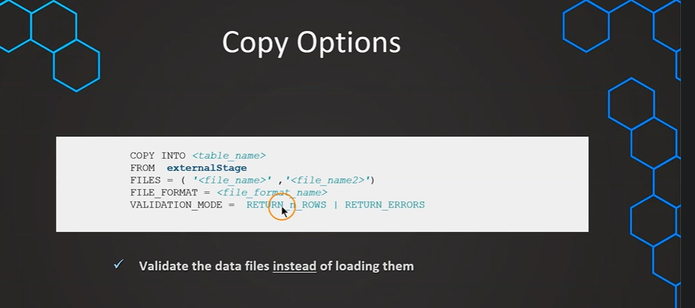
VALIDATIO MODE:
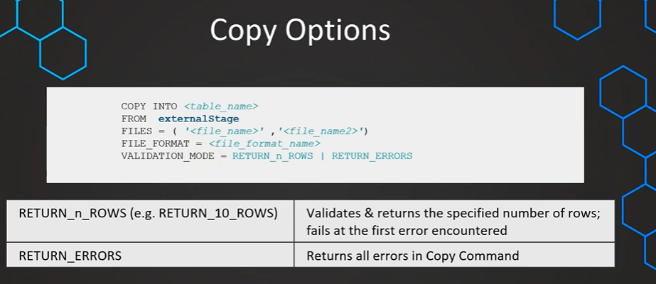
---- VALIDATION_MODE WHEN THERE ARE NO ERRORS----
// Prepare database & table
CREATE OR REPLACE DATABASE COPY_DB;

CREATE OR REPLACE TABLE COPY_DB.PUBLIC.ORDERS (
ORDER_ID VARCHAR(30),
AMOUNT VARCHAR(30),
PROFIT INT,
QUANTITY INT,
CATEGORY VARCHAR(30),
SUBCATEGORY VARCHAR(30));

// Prepare stage object
CREATE OR REPLACE STAGE COPY_DB.PUBLIC.aws_stage_copy
url='s3://snowflakebucket-copyoption/size/';

LIST @COPY_DB.PUBLIC.aws_stage_copy;

//Load data using copy command
COPY INTO COPY_DB.PUBLIC.ORDERS
FROM @aws_stage_copy
file_format= (type = csv field_delimiter=',' skip_header=1)
pattern='.*Order.*'
VALIDATION_MODE = RETURN_ERRORS

COPY INTO COPY_DB.PUBLIC.ORDERS
FROM @aws_stage_copy
file_format= (type = csv field_delimiter=',' skip_header=1)
pattern='.*Order.*'
VALIDATION_MODE = RETURN_5_ROWS --RETURNS FIRST 5 ROWS IF THEY ARE NO ERRORS BUT COPY COMMAND WILL NOT LOAD ANYTHING AS WE ARE JUST VALIDATING. IF THEY ARE ANY ERRORS THEN ERROR MESSAGE WILL BE RETURNED
-----------------------------------
---- VALIDATION_MODE WHEN THERE ARE ERRORS----

---- Use files with errors ----
CREATE OR REPLACE STAGE COPY_DB.PUBLIC.aws_stage_copy
url='s3://snowflakebucket-copyoption/returnfailed/';

LIST @COPY_DB.PUBLIC.aws_stage_copy;

COPY INTO COPY_DB.PUBLIC.ORDERS
FROM @aws_stage_copy
file_format= (type = csv field_delimiter=',' skip_header=1)
pattern='.*Order.*'
VALIDATION_MODE = RETURN_ERRORS

COPY INTO COPY_DB.PUBLIC.ORDERS
FROM @aws_stage_copy
file_format= (type = csv field_delimiter=',' skip_header=1)
pattern='.*Order.*'
VALIDATION_MODE = RETURN_5_rows

-------------WORK WITH ERROR RESULTS ------------------

-------------- Working with error results -----------

---- 1) Saving rejected files after VALIDATION_MODE ----

CREATE OR REPLACE TABLE COPY_DB.PUBLIC.ORDERS (
ORDER_ID VARCHAR(30),
AMOUNT VARCHAR(30),
PROFIT INT,
QUANTITY INT,
CATEGORY VARCHAR(30),
SUBCATEGORY VARCHAR(30));

COPY INTO COPY_DB.PUBLIC.ORDERS
FROM @aws_stage_copy
file_format= (type = csv field_delimiter=',' skip_header=1)
pattern='.*Order.*'
VALIDATION_MODE = RETURN_ERRORS;

// Storing rejected /failed results in a table
CREATE OR REPLACE TABLE rejected AS
select rejected_record from table(result_scan(last_query_id()));

INSERT INTO rejected
select rejected_record from table(result_scan(last_query_id()));

SELECT * FROM rejected;

---- 2) Saving rejected files without VALIDATION_MODE ----

COPY INTO COPY_DB.PUBLIC.ORDERS
FROM @aws_stage_copy
file_format= (type = csv field_delimiter=',' skip_header=1)
pattern='.*Order.*'
ON_ERROR=CONTINUE

select * from table(validate(orders, job_id => '_last'));

---- 3) Working with rejected records ----

SELECT REJECTED_RECORD FROM rejected;

CREATE OR REPLACE TABLE rejected_values as
SELECT
SPLIT_PART(rejected_record,',',1) as ORDER_ID,
SPLIT_PART(rejected_record,',',2) as AMOUNT,
SPLIT_PART(rejected_record,',',3) as PROFIT,
SPLIT_PART(rejected_record,',',4) as QUATNTITY,
SPLIT_PART(rejected_record,',',5) as CATEGORY,
SPLIT_PART(rejected_record,',',6) as SUBCATEGORY
FROM rejected;

SELECT * FROM rejected_values;

SIZE LIMIT:
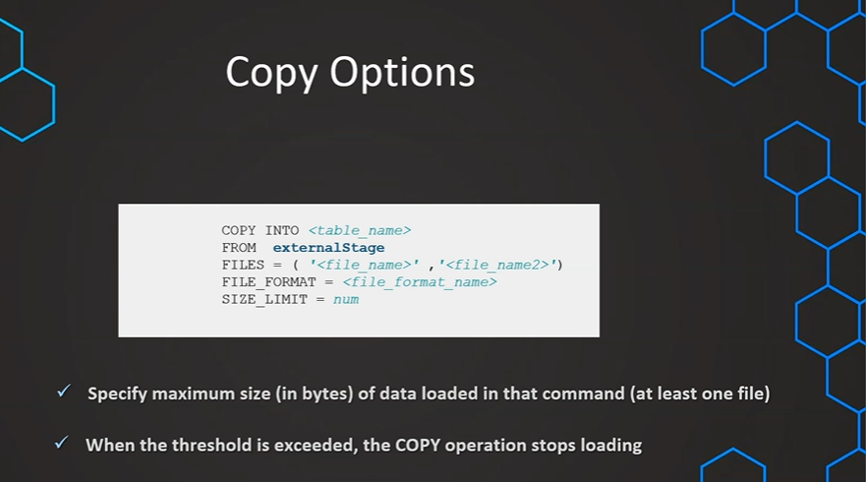

---- SIZE_LIMIT ----

// Prepare database & table
CREATE OR REPLACE DATABASE COPY_DB;

CREATE OR REPLACE TABLE COPY_DB.PUBLIC.ORDERS (
ORDER_ID VARCHAR(30),
AMOUNT VARCHAR(30),
PROFIT INT,
QUANTITY INT,
CATEGORY VARCHAR(30),
SUBCATEGORY VARCHAR(30));

// Prepare stage object
CREATE OR REPLACE STAGE COPY_DB.PUBLIC.aws_stage_copy
url='s3://snowflakebucket-copyoption/size/';

// List files in stage
LIST @aws_stage_copy;

//Load data using copy command
COPY INTO COPY_DB.PUBLIC.ORDERS
FROM @aws_stage_copy
file_format= (type = csv field_delimiter=',' skip_header=1)
pattern='.*Order.*'
SIZE_LIMIT=20000; - IF THERE ARE MULTIPLE FILES, FIRST FILE WILL ALWAYS BE LOADED REGARDLESS OF THE SIZE_LIMIT MENTIONED

RETURN FAILED ONLY :

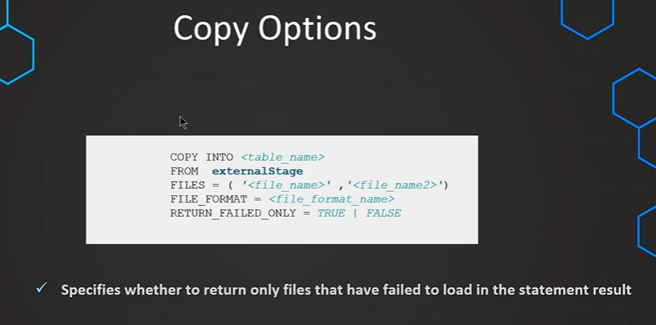

---- RETURN_FAILED_ONLY ----

CREATE OR REPLACE TABLE COPY_DB.PUBLIC.ORDERS (
ORDER_ID VARCHAR(30),
AMOUNT VARCHAR(30),
PROFIT INT,
QUANTITY INT,
CATEGORY VARCHAR(30),
SUBCATEGORY VARCHAR(30));

// Prepare stage object
CREATE OR REPLACE STAGE COPY_DB.PUBLIC.aws_stage_copy
url='s3://snowflakebucket-copyoption/returnfailed/';

LIST @COPY_DB.PUBLIC.aws_stage_copy

//Load data using copy command
COPY INTO COPY_DB.PUBLIC.ORDERS
FROM @aws_stage_copy
file_format= (type = csv field_delimiter=',' skip_header=1)
pattern='.*Order.*'
RETURN_FAILED_ONLY = TRUE -- THIS IS NOY MAKING ANY SENSE SO WE USE CONTINUE

COPY INTO COPY_DB.PUBLIC.ORDERS
FROM @aws_stage_copy
file_format= (type = csv field_delimiter=',' skip_header=1)
pattern='.*Order.*'
ON_ERROR =CONTINUE
RETURN_FAILED_ONLY = TRUE

// Default = FALSE

CREATE OR REPLACE TABLE COPY_DB.PUBLIC.ORDERS (
ORDER_ID VARCHAR(30),
AMOUNT VARCHAR(30),
PROFIT INT,
QUANTITY INT,
CATEGORY VARCHAR(30),
SUBCATEGORY VARCHAR(30));

COPY INTO COPY_DB.PUBLIC.ORDERS
FROM @aws_stage_copy
file_format= (type = csv field_delimiter=',' skip_header=1)
pattern='.*Order.*'
ON_ERROR =CONTINUE

TRUNCATECOLUMNS:
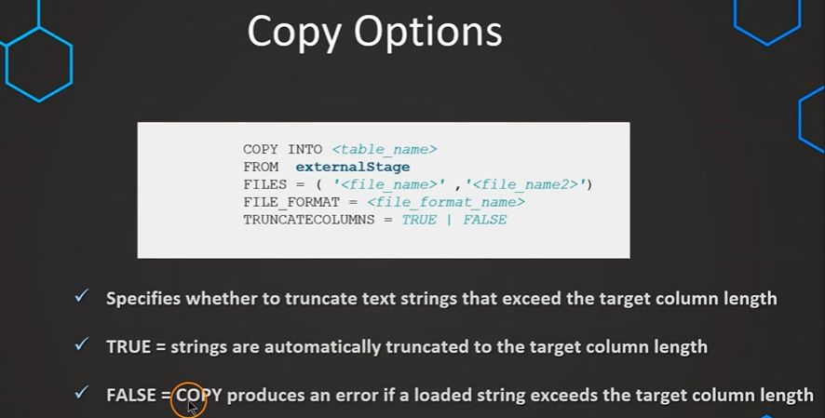
---- TRUNCATECOLUMNS ----

CREATE OR REPLACE TABLE COPY_DB.PUBLIC.ORDERS (
ORDER_ID VARCHAR(30),
AMOUNT VARCHAR(30),
PROFIT INT,
QUANTITY INT,
CATEGORY VARCHAR(10),
SUBCATEGORY VARCHAR(30));

// Prepare stage object
CREATE OR REPLACE STAGE COPY_DB.PUBLIC.aws_stage_copy
url='s3://snowflakebucket-copyoption/size/';

LIST @COPY_DB.PUBLIC.aws_stage_copy

//Load data using copy command
COPY INTO COPY_DB.PUBLIC.ORDERS
FROM @aws_stage_copy
file_format= (type = csv field_delimiter=',' skip_header=1)
pattern='.*Order.*'

COPY INTO COPY_DB.PUBLIC.ORDERS
FROM @aws_stage_copy
file_format= (type = csv field_delimiter=',' skip_header=1)
pattern='.*Order.*'
TRUNCATECOLUMNS = true;

SELECT * FROM ORDERS;

FORCE:
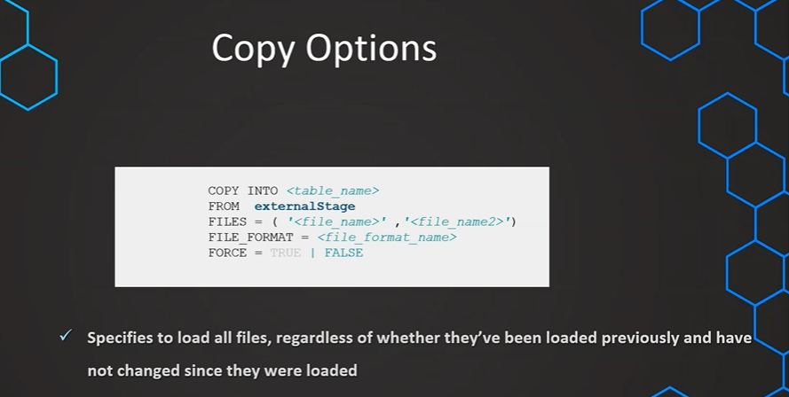

---- FORCE ----

CREATE OR REPLACE TABLE COPY_DB.PUBLIC.ORDERS (
ORDER_ID VARCHAR(30),
AMOUNT VARCHAR(30),
PROFIT INT,
QUANTITY INT,
CATEGORY VARCHAR(30),
SUBCATEGORY VARCHAR(30));

// Prepare stage object
CREATE OR REPLACE STAGE COPY_DB.PUBLIC.aws_stage_copy
url='s3://snowflakebucket-copyoption/size/';

LIST @COPY_DB.PUBLIC.aws_stage_copy

//Load data using copy command
COPY INTO COPY_DB.PUBLIC.ORDERS
FROM @aws_stage_copy
file_format= (type = csv field_delimiter=',' skip_header=1)
pattern='.*Order.*'

// Not possible to load file that have been loaded and data has not been modified
COPY INTO COPY_DB.PUBLIC.ORDERS
FROM @aws_stage_copy
file_format= (type = csv field_delimiter=',' skip_header=1)
pattern='.*Order.*'

SELECT * FROM ORDERS; -- 3000 ROWS

// Using the FORCE option

COPY INTO COPY_DB.PUBLIC.ORDERS
FROM @aws_stage_copy
file_format= (type = csv field_delimiter=',' skip_header=1)
pattern='.*Order.*'
FORCE = TRUE;

SELECT * FROM ORDERS; -- 6000 ROWS
-------------- LOAD HISTORY ----------------
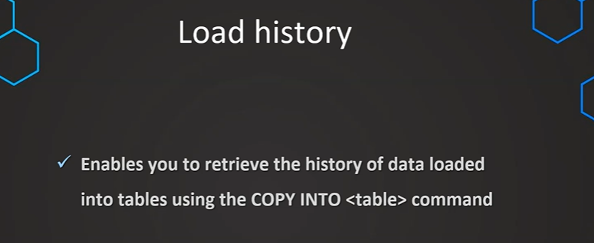

-- Query load history within a database --

USE COPY_DB;

SELECT * FROM information_schema.load_history

-- Query load history gloabally from SNOWFLAKE database --

SELECT * FROM snowflake.account_usage.load_history

// Filter on specific table & schema
SELECT * FROM snowflake.account_usage.load_history
where schema_name='PUBLIC' and
table_name='ORDERS'

// Filter on specific table & schema
SELECT * FROM snowflake.account_usage.load_history
where schema_name='PUBLIC' and
table_name='ORDERS' and
error_count > 0

// Filter on specific table & schema
SELECT * FROM snowflake.account_usage.load_history
WHERE DATE(LAST_LOAD_TIME) <= DATEADD(days,-1,CURRENT_DATE)

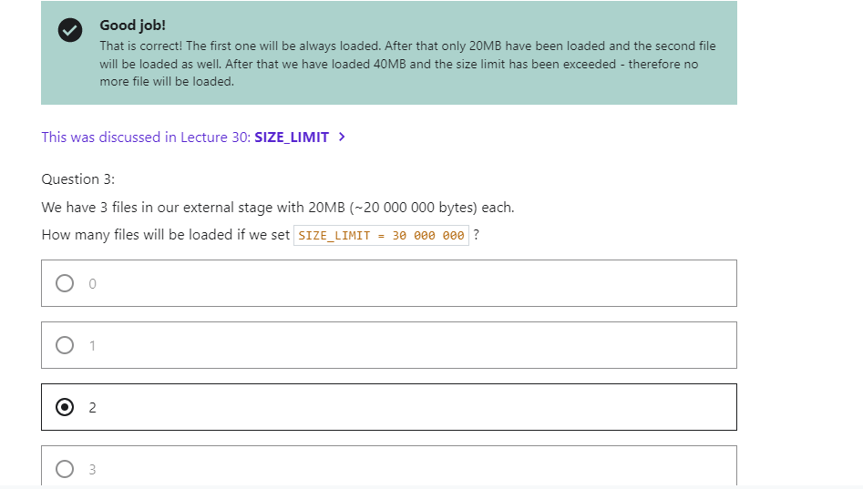

LOADING UNSTRACTURED DATA:
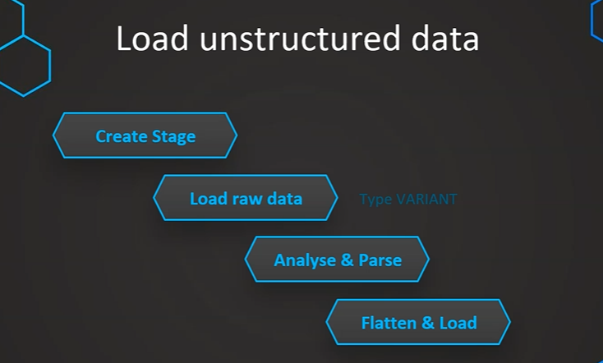
Loading raw JSON to one column
// First step: Load Raw JSON

CREATE OR REPLACE stage MANAGE_DB.EXTERNAL_STAGES.JSONSTAGE
url='s3://bucketsnowflake-jsondemo';

CREATE OR REPLACE file format MANAGE_DB.FILE_FORMATS.JSONFORMAT
TYPE = JSON;

CREATE OR REPLACE table OUR_FIRST_DB.PUBLIC.JSON_RAW (
raw_file variant);

COPY INTO OUR_FIRST_DB.PUBLIC.JSON_RAW
FROM @MANAGE_DB.EXTERNAL_STAGES.JSONSTAGE
file_format= MANAGE_DB.FILE_FORMATS.JSONFORMAT
files = ('HR_data.json');

SELECT * FROM OUR_FIRST_DB.PUBLIC.JSON_RAW;

// Second step: Parse & Analyse Raw JSON

// Selecting attribute/column

SELECT RAW_FILE:city FROM OUR_FIRST_DB.PUBLIC.JSON_RAW

SELECT $1:first_name FROM OUR_FIRST_DB.PUBLIC.JSON_RAW

// Selecting attribute/column - formattted

SELECT RAW_FILE:first_name::string as first_name FROM OUR_FIRST_DB.PUBLIC.JSON_RAW;

SELECT RAW_FILE:id::int as id FROM OUR_FIRST_DB.PUBLIC.JSON_RAW;

SELECT
RAW_FILE:id::int as id,
RAW_FILE:first_name::STRING as first_name,
RAW_FILE:last_name::STRING as last_name,
RAW_FILE:gender::STRING as gender

FROM OUR_FIRST_DB.PUBLIC.JSON_RAW;

// Handling nested data

SELECT RAW_FILE:job as job FROM OUR_FIRST_DB.PUBLIC.JSON_RAW;

SELECT
RAW_FILE:job.salary::INT as salary
FROM OUR_FIRST_DB.PUBLIC.JSON_RAW;

SELECT
RAW_FILE:first_name::STRING as first_name,
RAW_FILE:job.salary::INT as salary,
RAW_FILE:job.title::STRING as title
FROM OUR_FIRST_DB.PUBLIC.JSON_RAW;

// Handling arreys

SELECT
RAW_FILE:prev_company as prev_company
FROM OUR_FIRST_DB.PUBLIC.JSON_RAW;

SELECT
RAW_FILE:prev_company[1]::STRING as prev_company
FROM OUR_FIRST_DB.PUBLIC.JSON_RAW;

SELECT
ARRAY_SIZE(RAW_FILE:prev_company) as prev_company
FROM OUR_FIRST_DB.PUBLIC.JSON_RAW;

SELECT
RAW_FILE:id::int as id,
RAW_FILE:first_name::STRING as first_name,
RAW_FILE:prev_company[0]::STRING as prev_company
FROM OUR_FIRST_DB.PUBLIC.JSON_RAW
UNION ALL
SELECT
RAW_FILE:id::int as id,
RAW_FILE:first_name::STRING as first_name,
RAW_FILE:prev_company[1]::STRING as prev_company
FROM OUR_FIRST_DB.PUBLIC.JSON_RAW
ORDER BY id

SELECT
RAW_FILE:spoken_languages as spoken_languages
FROM OUR_FIRST_DB.PUBLIC.JSON_RAW;

SELECT * FROM OUR_FIRST_DB.PUBLIC.JSON_RAW;

SELECT
array_size(RAW_FILE:spoken_languages) as spoken_languages
FROM OUR_FIRST_DB.PUBLIC.JSON_RAW

SELECT
RAW_FILE:first_name::STRING as first_name,
array_size(RAW_FILE:spoken_languages) as spoken_languages
FROM OUR_FIRST_DB.PUBLIC.JSON_RAW

SELECT
RAW_FILE:spoken_languages[0] as First_language
FROM OUR_FIRST_DB.PUBLIC.JSON_RAW;

SELECT
RAW_FILE:first_name::STRING as first_name,
RAW_FILE:spoken_languages[0] as First_language
FROM OUR_FIRST_DB.PUBLIC.JSON_RAW;

SELECT
RAW_FILE:first_name::STRING as First_name,
RAW_FILE:spoken_languages[0].language::STRING as First_language,
RAW_FILE:spoken_languages[0].level::STRING as Level_spoken
FROM OUR_FIRST_DB.PUBLIC.JSON_RAW

SELECT
RAW_FILE:id::int as id,
RAW_FILE:first_name::STRING as First_name,
RAW_FILE:spoken_languages[0].language::STRING as First_language,
RAW_FILE:spoken_languages[0].level::STRING as Level_spoken
FROM OUR_FIRST_DB.PUBLIC.JSON_RAW
UNION ALL
SELECT
RAW_FILE:id::int as id,
RAW_FILE:first_name::STRING as First_name,
RAW_FILE:spoken_languages[1].language::STRING as First_language,
RAW_FILE:spoken_languages[1].level::STRING as Level_spoken
FROM OUR_FIRST_DB.PUBLIC.JSON_RAW
UNION ALL
SELECT
RAW_FILE:id::int as id,
RAW_FILE:first_name::STRING as First_name,
RAW_FILE:spoken_languages[2].language::STRING as First_language,
RAW_FILE:spoken_languages[2].level::STRING as Level_spoken
FROM OUR_FIRST_DB.PUBLIC.JSON_RAW
ORDER BY ID

select
RAW_FILE:first_name::STRING as First_name,
f.value:language::STRING as First_language,
f.value:level::STRING as Level_spoken
from OUR_FIRST_DB.PUBLIC.JSON_RAW, table(flatten(RAW_FILE:spoken_languages)) f;

// Option 1: CREATE TABLE AS

CREATE OR REPLACE TABLE Languages AS
select
RAW_FILE:first_name::STRING as First_name,
f.value:language::STRING as First_language,
f.value:level::STRING as Level_spoken
from OUR_FIRST_DB.PUBLIC.JSON_RAW, table(flatten(RAW_FILE:spoken_languages)) f;

SELECT * FROM Languages;

truncate table languages;

// Option 2: INSERT INTO

INSERT INTO Languages
select
RAW_FILE:first_name::STRING as First_name,
f.value:language::STRING as First_language,
f.value:level::STRING as Level_spoken
from OUR_FIRST_DB.PUBLIC.JSON_RAW, table(flatten(RAW_FILE:spoken_languages)) f;

SELECT * FROM Languages;

// Create file format and stage object

CREATE OR REPLACE FILE FORMAT MANAGE_DB.FILE_FORMATS.PARQUET_FORMAT
TYPE = 'parquet';

CREATE OR REPLACE STAGE MANAGE_DB.EXTERNAL_STAGES.PARQUETSTAGE
url = 's3://snowflakeparquetdemo'
FILE_FORMAT = MANAGE_DB.FILE_FORMATS.PARQUET_FORMAT;

// Preview the data

LIST @MANAGE_DB.EXTERNAL_STAGES.PARQUETSTAGE;

SELECT * FROM @MANAGE_DB.EXTERNAL_STAGES.PARQUETSTAGE;

// File format in Queries

CREATE OR REPLACE STAGE MANAGE_DB.EXTERNAL_STAGES.PARQUETSTAGE
url = 's3://snowflakeparquetdemo'

SELECT *
FROM @MANAGE_DB.EXTERNAL_STAGES.PARQUETSTAGE
(file_format => 'MANAGE_DB.FILE_FORMATS.PARQUET_FORMAT')

// Quotes can be omitted in case of the current namespace
USE MANAGE_DB.FILE_FORMATS;

SELECT *
FROM @MANAGE_DB.EXTERNAL_STAGES.PARQUETSTAGE
(file_format => MANAGE_DB.FILE_FORMATS.PARQUET_FORMAT)

CREATE OR REPLACE STAGE MANAGE_DB.EXTERNAL_STAGES.PARQUETSTAGE
url = 's3://snowflakeparquetdemo'
FILE_FORMAT = MANAGE_DB.FILE_FORMATS.PARQUET_FORMAT;

// Syntax for Querying unstructured data

SELECT
$1:__index_level_0__,
$1:cat_id,
$1:date,
$1:"__index_level_0__",
$1:"cat_id",
$1:"d",
$1:"date",
$1:"dept_id",
$1:"id",
$1:"item_id",
$1:"state_id",
$1:"store_id",
$1:"value"
FROM @MANAGE_DB.EXTERNAL_STAGES.PARQUETSTAGE;

// Date conversion

SELECT 1;

SELECT DATE(365*60*60*24);

// Querying with conversions and aliases

SELECT
$1:__index_level_0__::int as index_level,
$1:cat_id::VARCHAR(50) as category,
DATE($1:date::int ) as Date,
$1:"dept_id"::VARCHAR(50) as Dept_ID,
$1:"id"::VARCHAR(50) as ID,
$1:"item_id"::VARCHAR(50) as Item_ID,
$1:"state_id"::VARCHAR(50) as State_ID,
$1:"store_id"::VARCHAR(50) as Store_ID,
$1:"value"::int as value
FROM @MANAGE_DB.EXTERNAL_STAGES.PARQUETSTAGE;

PERFORMANCE OPTIMIZATION:
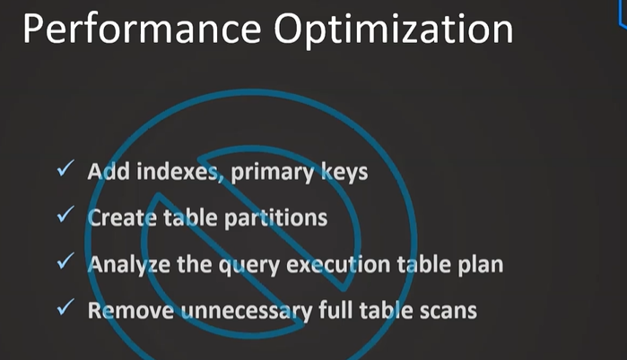
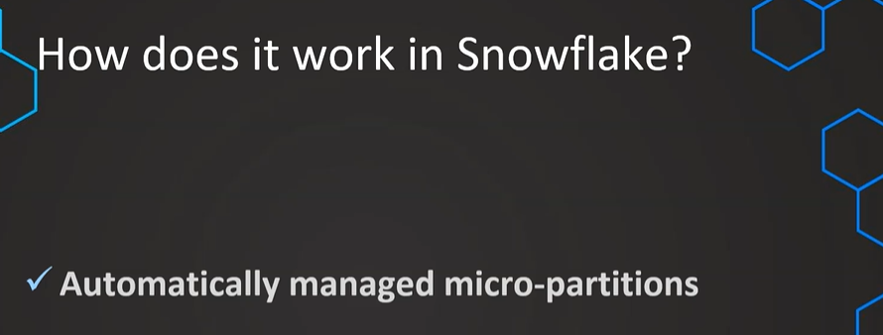
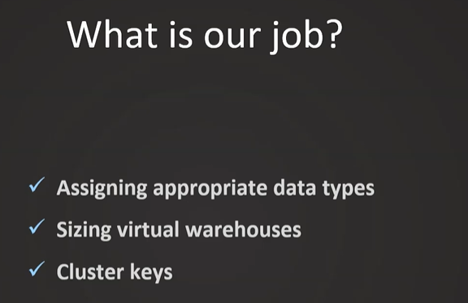
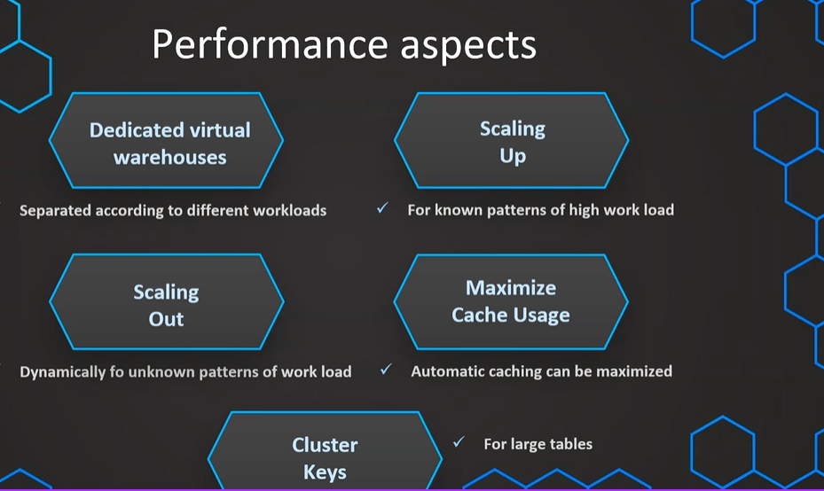

Dedicated Virtual Warehouse:
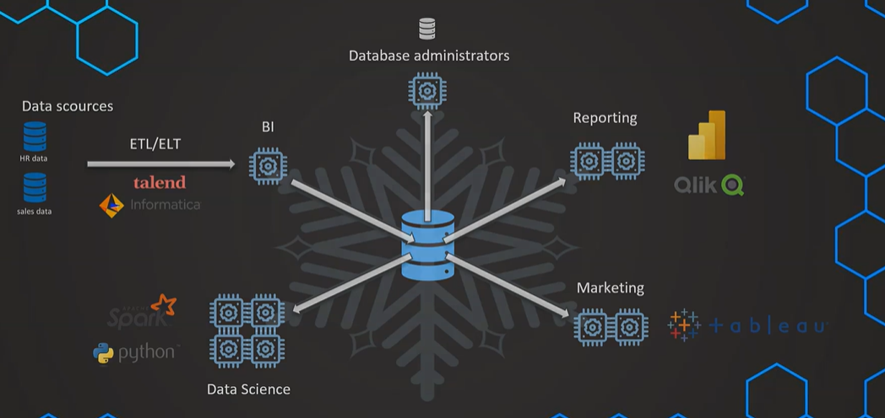
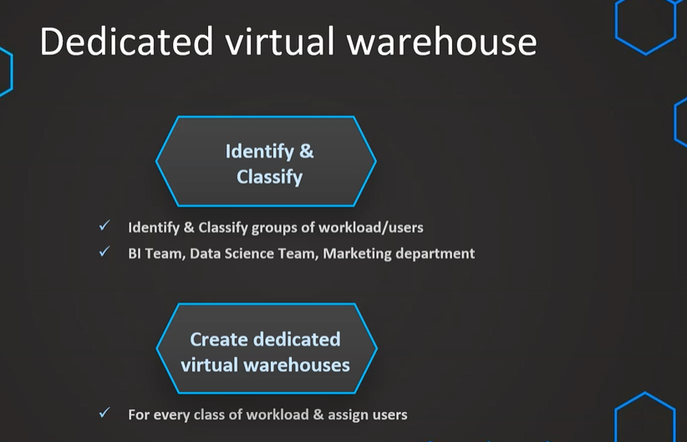
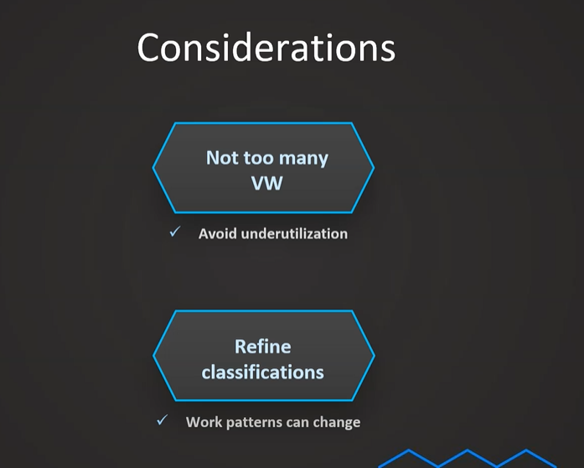

// Create virtual warehouse for data scientist & DBA

// Data Scientists
CREATE WAREHOUSE DS_WH
WITH WAREHOUSE_SIZE = 'SMALL'
WAREHOUSE_TYPE = 'STANDARD'
AUTO_SUSPEND = 300
AUTO_RESUME = TRUE
MIN_CLUSTER_COUNT = 1
MAX_CLUSTER_COUNT = 1
SCALING_POLICY = 'STANDARD';

// DBA
CREATE WAREHOUSE DBA_WH
WITH WAREHOUSE_SIZE = 'XSMALL'
WAREHOUSE_TYPE = 'STANDARD'
AUTO_SUSPEND = 300
AUTO_RESUME = TRUE
MIN_CLUSTER_COUNT = 1
MAX_CLUSTER_COUNT = 1
SCALING_POLICY = 'STANDARD';

// Create role for Data Scientists & DBAs

CREATE ROLE DATA_SCIENTIST;
GRANT USAGE ON WAREHOUSE DS_WH TO ROLE DATA_SCIENTIST;

CREATE ROLE DBA;
GRANT USAGE ON WAREHOUSE DBA_WH TO ROLE DBA;

// Setting up users with roles

// Data Scientists
CREATE USER DS1 PASSWORD = 'DS1' LOGIN_NAME = 'DS1' DEFAULT_ROLE='DATA_SCIENTIST' DEFAULT_WAREHOUSE = 'DS_WH' MUST_CHANGE_PASSWORD = FALSE;
CREATE USER DS2 PASSWORD = 'DS2' LOGIN_NAME = 'DS2' DEFAULT_ROLE='DATA_SCIENTIST' DEFAULT_WAREHOUSE = 'DS_WH' MUST_CHANGE_PASSWORD = FALSE;
CREATE USER DS3 PASSWORD = 'DS3' LOGIN_NAME = 'DS3' DEFAULT_ROLE='DATA_SCIENTIST' DEFAULT_WAREHOUSE = 'DS_WH' MUST_CHANGE_PASSWORD = FALSE;

GRANT ROLE DATA_SCIENTIST TO USER DS1;
GRANT ROLE DATA_SCIENTIST TO USER DS2;
GRANT ROLE DATA_SCIENTIST TO USER DS3;

// DBAs
CREATE USER DBA1 PASSWORD = 'DBA1' LOGIN_NAME = 'DBA1' DEFAULT_ROLE='DBA' DEFAULT_WAREHOUSE = 'DBA_WH' MUST_CHANGE_PASSWORD = FALSE;
CREATE USER DBA2 PASSWORD = 'DBA2' LOGIN_NAME = 'DBA2' DEFAULT_ROLE='DBA' DEFAULT_WAREHOUSE = 'DBA_WH' MUST_CHANGE_PASSWORD = FALSE;

GRANT ROLE DBA TO USER DBA1;
GRANT ROLE DBA TO USER DBA2;

// Drop objects again

DROP USER DBA1;
DROP USER DBA2;

DROP USER DS1;
DROP USER DS2;
DROP USER DS3;

DROP ROLE DATA_SCIENTIST;
DROP ROLE DBA;

DROP WAREHOUSE DS_WH;
DROP WAREHOUSE DBA_WH;

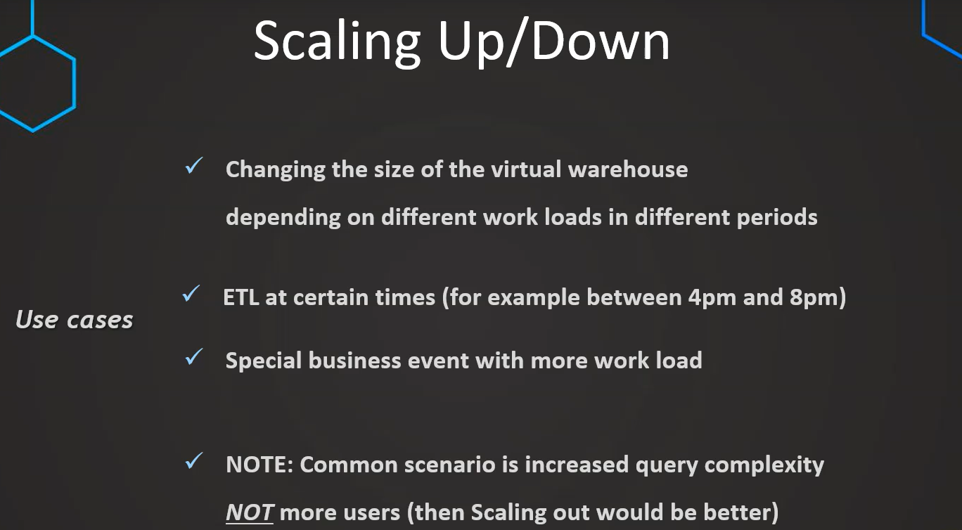
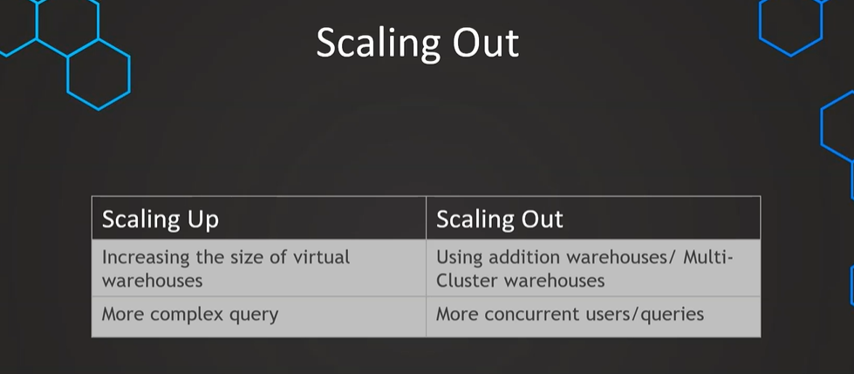
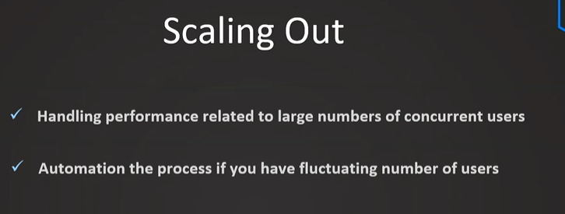
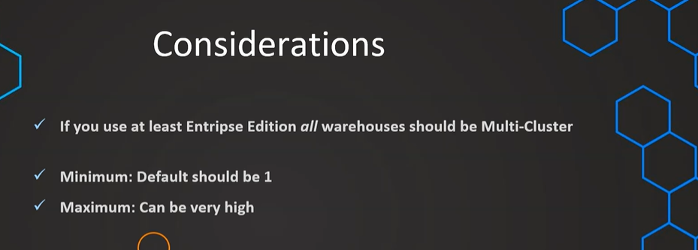
SELECT * FROM SNOWFLAKE_SAMPLE_DATA.TPCDS_SF100TCL.WEB_SITE T1
CROSS JOIN SNOWFLAKE_SAMPLE_DATA.TPCDS_SF100TCL.WEB_SITE T2
CROSS JOIN SNOWFLAKE_SAMPLE_DATA.TPCDS_SF100TCL.WEB_SITE T3
CROSS JOIN (SELECT TOP 57 * FROM SNOWFLAKE_SAMPLE_DATA.TPCDS_SF100TCL.WEB_SITE) T4
We can run this query from multiple sheets and see how the clusters are being assigned and hoe many will be in active status based on number of queries and their complexity
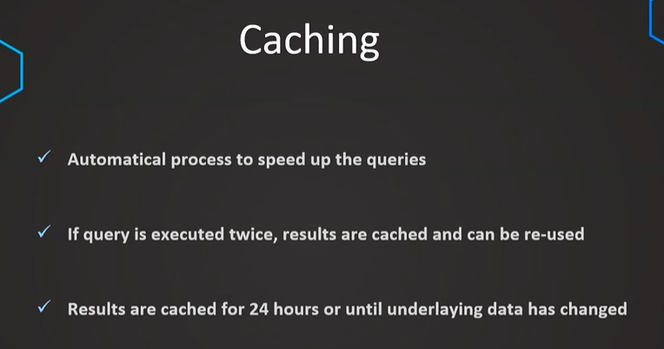
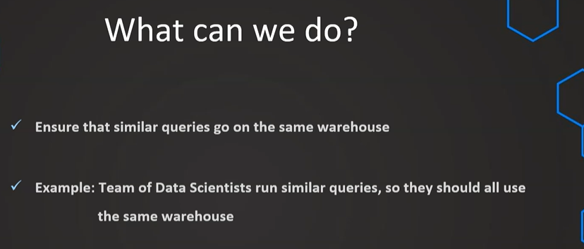
SELECT AVG(C_BIRTH_YEAR) FROM SNOWFLAKE_SAMPLE_DATA.TPCDS_SF100TCL.CUSTOMER

// Setting up an additional user
CREATE ROLE DATA_SCIENTIST;
GRANT USAGE ON WAREHOUSE COMPUTE_WH TO ROLE DATA_SCIENTIST;

CREATE USER DS1 PASSWORD = 'DS1' LOGIN_NAME = 'DS1' DEFAULT_ROLE='DATA_SCIENTIST' DEFAULT_WAREHOUSE = 'DS_WH' MUST_CHANGE_PASSWORD = FALSE;
GRANT ROLE DATA_SCIENTIST TO USER DS1;

CLUSTERING:
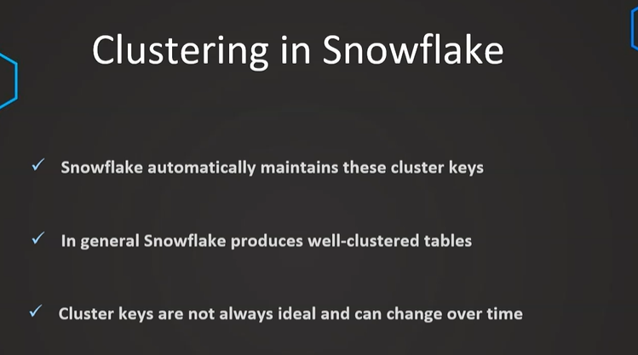
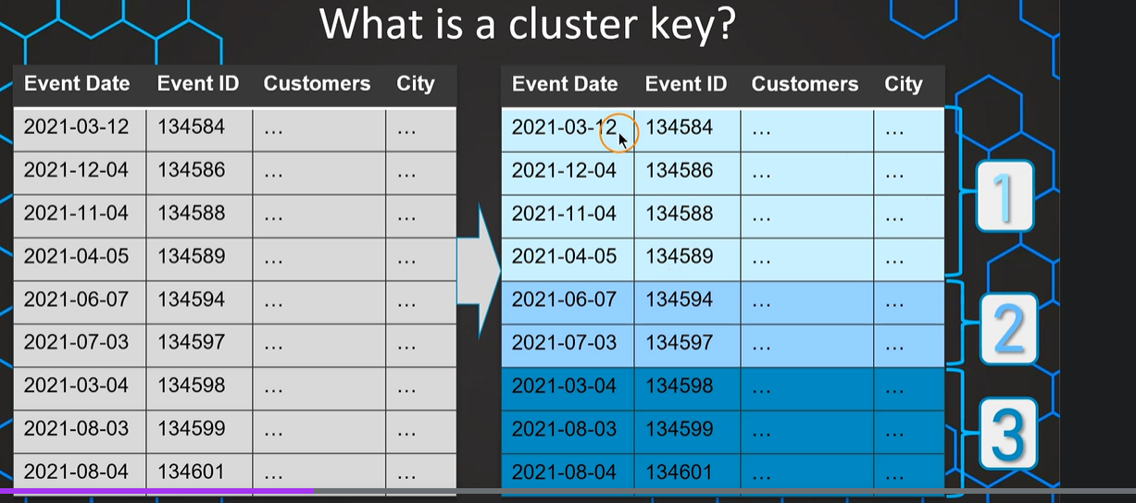
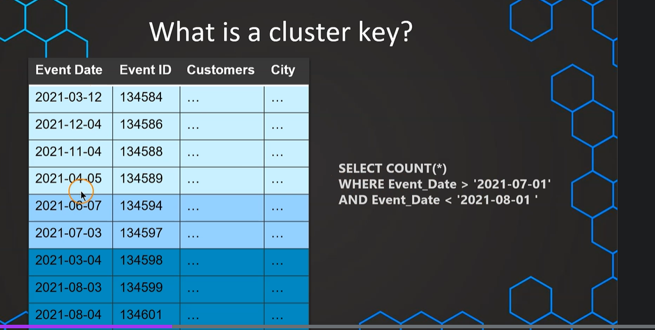
UNFORTUNATELY, Full table scan is happening here because clustering is on event id (based on range) but users may query on event date (full scan)
So that’s why we change it to event date by having custom clustering keys
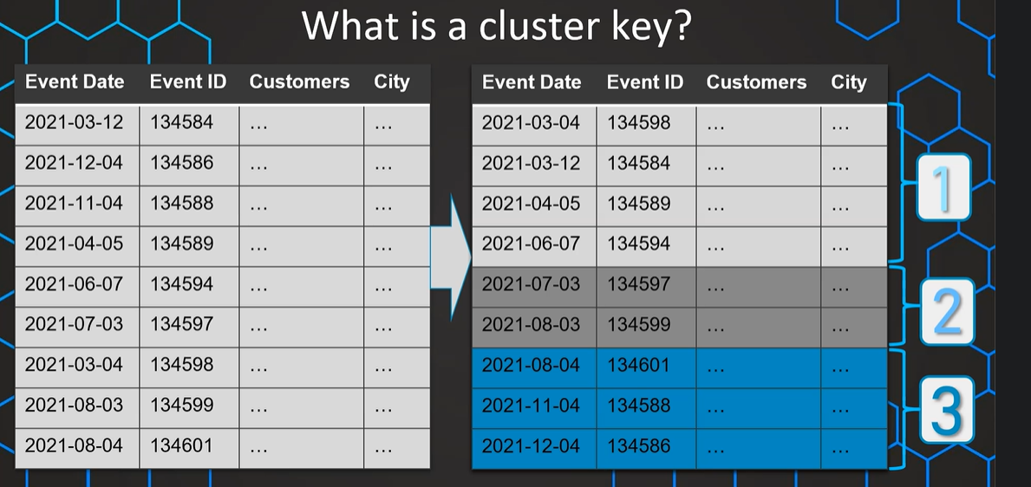
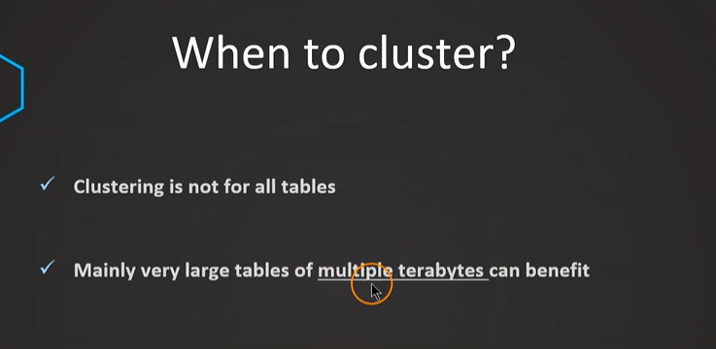
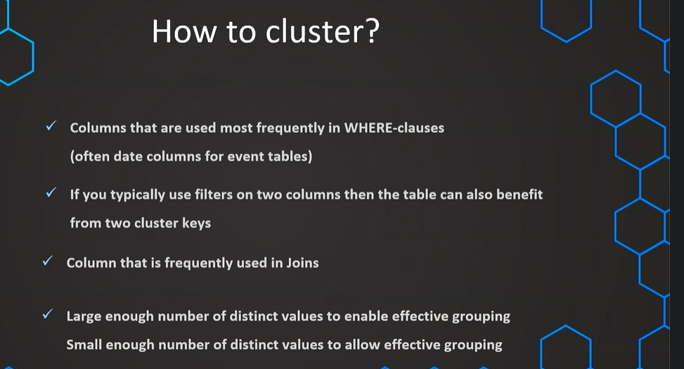
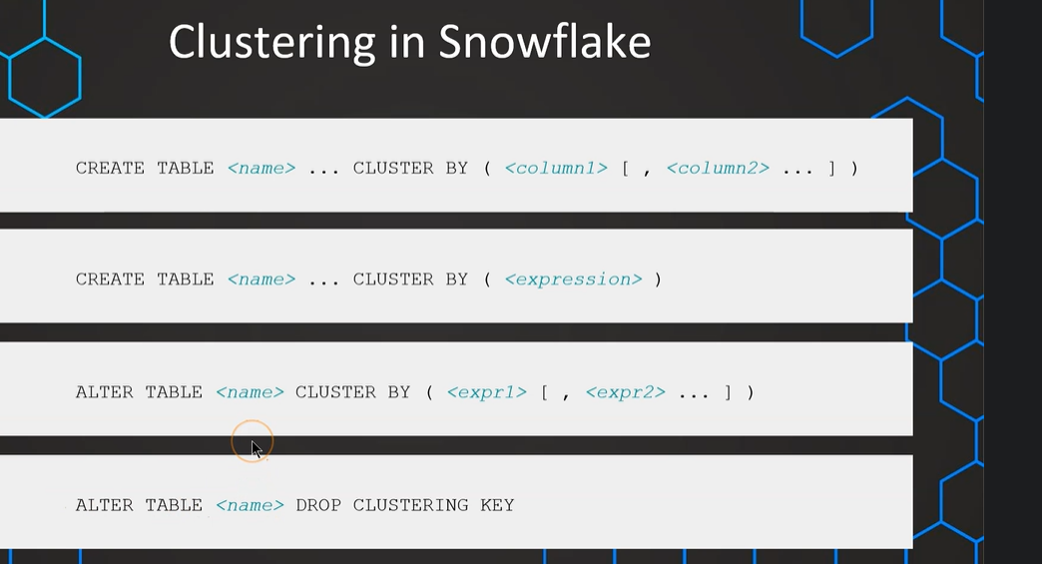

// Publicly accessible staging area

CREATE OR REPLACE STAGE MANAGE_DB.external_stages.aws_stage
url='s3://bucketsnowflakes3';

// List files in stage

LIST @MANAGE_DB.external_stages.aws_stage;

//Load data using copy command

COPY INTO OUR_FIRST_DB.PUBLIC.ORDERS
FROM @MANAGE_DB.external_stages.aws_stage
file_format= (type = csv field_delimiter=',' skip_header=1)
pattern='.*OrderDetails.*';

// Create table

CREATE OR REPLACE TABLE ORDERS_CACHING (
ORDER_ID VARCHAR(30)
,AMOUNT NUMBER(38,0)
,PROFIT NUMBER(38,0)
,QUANTITY NUMBER(38,0)
,CATEGORY VARCHAR(30)
,SUBCATEGORY VARCHAR(30)
,DATE DATE)

INSERT INTO ORDERS_CACHING
SELECT
t1.ORDER_ID
,t1.AMOUNT
,t1.PROFIT
,t1.QUANTITY
,t1.CATEGORY
,t1.SUBCATEGORY
,DATE(UNIFORM(1500000000,1700000000,(RANDOM())))
FROM ORDERS t1
CROSS JOIN (SELECT * FROM ORDERS) t2
CROSS JOIN (SELECT TOP 100 * FROM ORDERS) t3

// Query Performance before Cluster Key

SELECT * FROM ORDERS_CACHING WHERE DATE = '2020-06-09'

// Adding Cluster Key & Compare the result

ALTER TABLE ORDERS_CACHING CLUSTER BY ( DATE )

SELECT * FROM ORDERS_CACHING WHERE DATE = '2020-01-05'

// Not ideal clustering & adding a different Cluster Key using function

SELECT * FROM ORDERS_CACHING WHERE MONTH(DATE)=11

ALTER TABLE ORDERS_CACHING CLUSTER BY ( MONTH(DATE) )

LOADING FROM S3:
- CREATE S3 bucket and folders in the same aws region where snowflake hosted
- Create IAM roles (s3fullaccess) by giving account id and give 00000 for external ID as we can update this later by getting the same from snowflake
- Create s3 integration object in snowflake like below
create or replace storage integration s3_int
TYPE = EXTERNAL_STAGE
STORAGE_PROVIDER = S3
ENABLED = TRUE
STORAGE_AWS_ROLE_ARN = 'arn:aws:iam::045119972392:role/snowflake-access-role'
STORAGE_ALLOWED_LOCATIONS = ('s3://learnsnowflake05/csv/', 's3://learnsnowflake05/json/')
COMMENT = 'This an optional comment'

// See storage integration properties to fetch external_id so we can update it in S3
DESC integration s3_int;
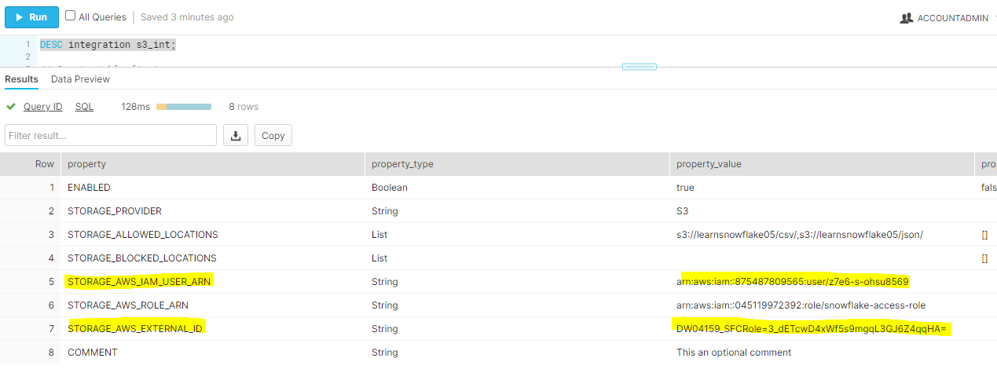
Update the above two highlighted values in AWS role like below
- Goto the IAM role we created earlier
- Click on the role created and goto trust relationships edit relationships
- Update the two highlited values in json like below
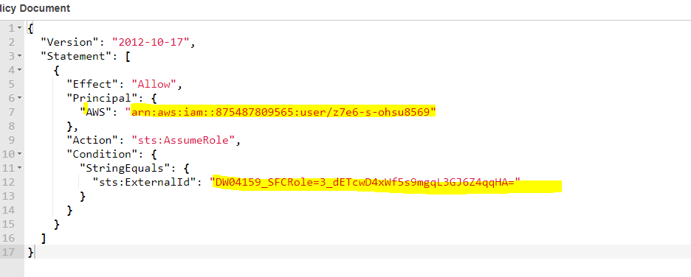

Now load from S3 :

// Create table first
CREATE OR REPLACE TABLE OUR_FIRST_DB.PUBLIC.movie_titles (
show_id STRING,
type STRING,
title STRING,
director STRING,
cast STRING,
country STRING,
date_added STRING,
release_year STRING,
rating STRING,
duration STRING,
listed_in STRING,
description STRING )

// Create file format object
CREATE OR REPLACE file format MANAGE_DB.file_formats.csv_fileformat
type = csv
field_delimiter = ','
skip_header = 1
null_if = ('NULL','null')
empty_field_as_null = TRUE;

// Create stage object with integration object & file format object
CREATE OR REPLACE stage MANAGE_DB.external_stages.csv_folder
URL = 's3://learnsnowflake05/csv/'
STORAGE_INTEGRATION = s3_int
FILE_FORMAT = MANAGE_DB.file_formats.csv_fileformat

// Use Copy command
COPY INTO OUR_FIRST_DB.PUBLIC.movie_titles
FROM @MANAGE_DB.external_stages.csv_folder

// Create file format object
CREATE OR REPLACE file format MANAGE_DB.file_formats.csv_fileformat
type = csv
field_delimiter = ','
skip_header = 1
null_if = ('NULL','null')
empty_field_as_null = TRUE
FIELD_OPTIONALLY_ENCLOSED_BY = '"'

SELECT * FROM OUR_FIRST_DB.PUBLIC.movie_titles
-------------------------------------------------------------------------------------------------
Load JSON:
// Taming the JSON file

// First query from S3 Bucket

SELECT * FROM @MANAGE_DB.external_stages.json_folder

// Introduce columns
SELECT
$1:asin,
$1:helpful,
$1:overall,
$1:reviewText,
$1:reviewTime,
$1:reviewerID,
$1:reviewTime,
$1:reviewerName,
$1:summary,
$1:unixReviewTime
FROM @MANAGE_DB.external_stages.json_folder

// Format columns & use DATE function
SELECT
$1:asin::STRING as ASIN,
$1:helpful as helpful,
$1:overall as overall,
$1:reviewText::STRING as reviewtext,
$1:reviewTime::STRING,
$1:reviewerID::STRING,
$1:reviewTime::STRING,
$1:reviewerName::STRING,
$1:summary::STRING,
DATE($1:unixReviewTime::int) as Revewtime
FROM @MANAGE_DB.external_stages.json_folder

// Format columns & handle custom date
SELECT
$1:asin::STRING as ASIN,
$1:helpful as helpful,
$1:overall as overall,
$1:reviewText::STRING as reviewtext,
DATE_FROM_PARTS( <year>, <month>, <day> )
$1:reviewTime::STRING,
$1:reviewerID::STRING,
$1:reviewTime::STRING,
$1:reviewerName::STRING,
$1:summary::STRING,
DATE($1:unixReviewTime::int) as Revewtime
FROM @MANAGE_DB.external_stages.json_folder

// Use DATE_FROM_PARTS and see another difficulty
SELECT
$1:asin::STRING as ASIN,
$1:helpful as helpful,
$1:overall as overall,
$1:reviewText::STRING as reviewtext,
DATE_FROM_PARTS( RIGHT($1:reviewTime::STRING,4), LEFT($1:reviewTime::STRING,2), SUBSTRING($1:reviewTime::STRING,4,2) ),
$1:reviewerID::STRING,
$1:reviewTime::STRING,
$1:reviewerName::STRING,
$1:summary::STRING,
DATE($1:unixReviewTime::int) as unixRevewtime
FROM @MANAGE_DB.external_stages.json_folder

// Use DATE_FROM_PARTS and handle the case difficulty
SELECT
$1:asin::STRING as ASIN,
$1:helpful as helpful,
$1:overall as overall,
$1:reviewText::STRING as reviewtext,
DATE_FROM_PARTS(
RIGHT($1:reviewTime::STRING,4),
LEFT($1:reviewTime::STRING,2),
CASE WHEN SUBSTRING($1:reviewTime::STRING,5,1)=','
THEN SUBSTRING($1:reviewTime::STRING,4,1) ELSE SUBSTRING($1:reviewTime::STRING,4,2) END),
$1:reviewerID::STRING,
$1:reviewTime::STRING,
$1:reviewerName::STRING,
$1:summary::STRING,
DATE($1:unixReviewTime::int) as UnixRevewtime
FROM @MANAGE_DB.external_stages.json_folder

// Create destination table
CREATE OR REPLACE TABLE OUR_FIRST_DB.PUBLIC.reviews (
asin STRING,
helpful STRING,
overall STRING,
reviewtext STRING,
reviewtime DATE,
reviewerid STRING,
reviewername STRING,
summary STRING,
unixreviewtime DATE
)

// Copy transformed data into destination table
COPY INTO OUR_FIRST_DB.PUBLIC.reviews
FROM (SELECT
$1:asin::STRING as ASIN,
$1:helpful as helpful,
$1:overall as overall,
$1:reviewText::STRING as reviewtext,
DATE_FROM_PARTS(
RIGHT($1:reviewTime::STRING,4),
LEFT($1:reviewTime::STRING,2),
CASE WHEN SUBSTRING($1:reviewTime::STRING,5,1)=','
THEN SUBSTRING($1:reviewTime::STRING,4,1) ELSE SUBSTRING($1:reviewTime::STRING,4,2) END),
$1:reviewerID::STRING,
$1:reviewerName::STRING,
$1:summary::STRING,
DATE($1:unixReviewTime::int) Revewtime
FROM @MANAGE_DB.external_stages.json_folder)

// Validate results
SELECT * FROM OUR_FIRST_DB.PUBLIC.reviews

Load from Azure:
- Create free tier account in azure
- Goto create storage accounts
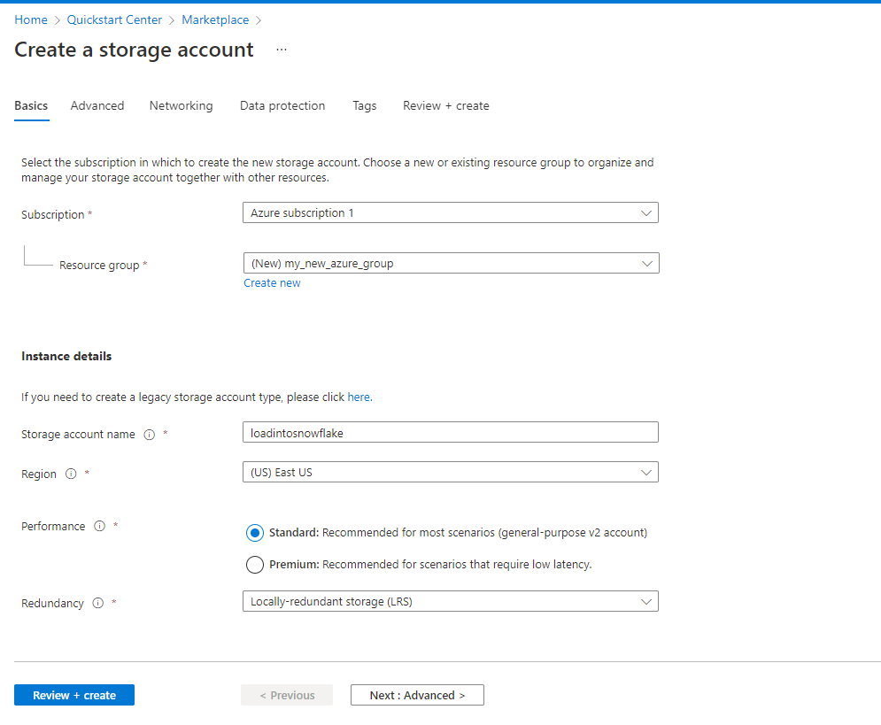
- Create container under storage account created
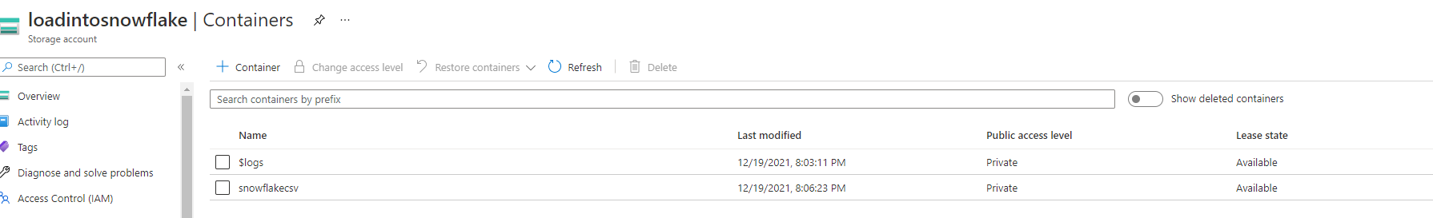

- Create integration object in snowflake which will have access to azure like below
USE DATABASE MANAGE_DB;
-- create integration object that contains the access information
CREATE STORAGE INTEGRATION azure_integration
TYPE = EXTERNAL_STAGE
STORAGE_PROVIDER = AZURE
ENABLED = TRUE
AZURE_TENANT_ID = 'a359f806-bb7e-47e2-b23e-aaf514a66359'
STORAGE_ALLOWED_LOCATIONS = ('azure://loadintosnowflake.blob.core.windows.net/snowflakecsv', 'azure://loadintosnowflake.blob.core.windows.net/snowflakejson');

To get AZURE_TENANT_ID, in azure account , search for azure active directory then will get tenant id like below.
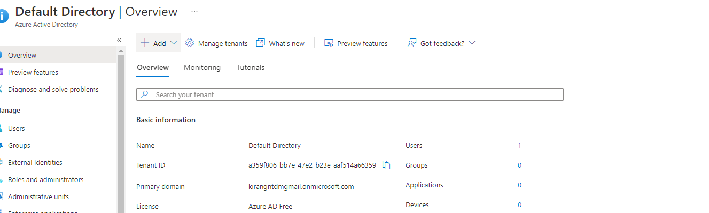

And in the allowed location are where our files exists so loadintosnowflake is our storage account created and snowflakecsv is the container name we created under storage object to store source files.

- Set up permissions
- To set up permissions do the following :
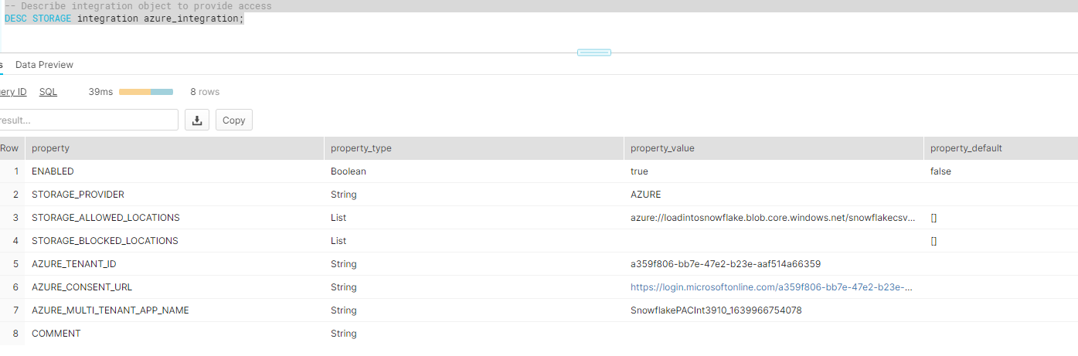
Copy the URL from azure_consent_URL above and paste in the browser
Click on consent on behalf of organization then accept
Now goto the storage object Access control select role as storage blob data contributor and then in the members select snowflake like below
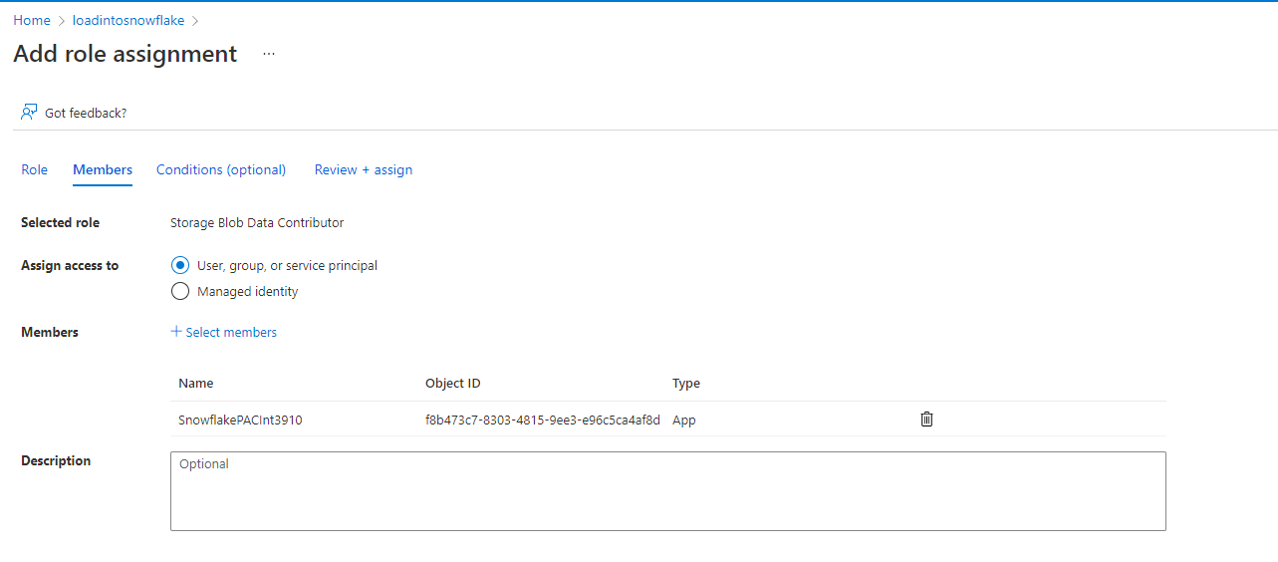
- Now lets see the files from azure by doing the following

---- Create file format & stage objects ----

-- create file format
create or replace file format manage_db.public.fileformat_azure
TYPE = CSV
FIELD_DELIMITER = ','
SKIP_HEADER = 0;

-- create stage object
create or replace stage manage_db.public.stage_azure
STORAGE_INTEGRATION = azure_integration
URL = 'azure://loadintosnowflake.blob.core.windows.net/snowflakecsv'
FILE_FORMAT = fileformat_azure;

-- list files
LIST @manage_db.public.stage_azure;

- Now load the data from azure to snowflake

---- Query files & Load data ----

--query files
SELECT
$1,
$2,
$3,
$4,
$5,
$6,
$7,
$8,
$9,
$10,
$11,
$12,
$13,
$14,
$15,
$16,
$17,
$18,
$19,
$20
FROM @manage_db.public.stage_azure;

create or replace table happiness (
country_name varchar,
regional_indicator varchar,
ladder_score number(4,3),
standard_error number(4,3),
upperwhisker number(4,3),
lowerwhisker number(4,3),
logged_gdp number(5,3),
social_support number(4,3),
healthy_life_expectancy number(5,3),
freedom_to_make_life_choices number(4,3),
generosity number(4,3),
perceptions_of_corruption number(4,3),
ladder_score_in_dystopia number(4,3),
explained_by_log_gpd_per_capita number(4,3),
explained_by_social_support number(4,3),
explained_by_healthy_life_expectancy number(4,3),
explained_by_freedom_to_make_life_choices number(4,3),
explained_by_generosity number(4,3),
explained_by_perceptions_of_corruption number(4,3),
dystopia_residual number (4,3));

create or replace file format manage_db.public.fileformat_azure
TYPE = CSV
FIELD_DELIMITER = ','
SKIP_HEADER = 1;

COPY INTO HAPPINESS
FROM @manage_db.public.stage_azure;

SELECT * FROM HAPPINESS;

SNOWPIPE:
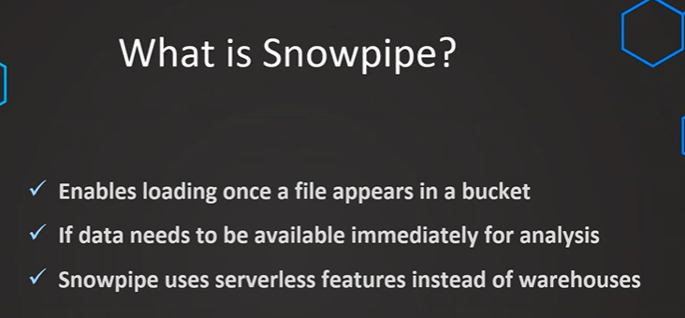

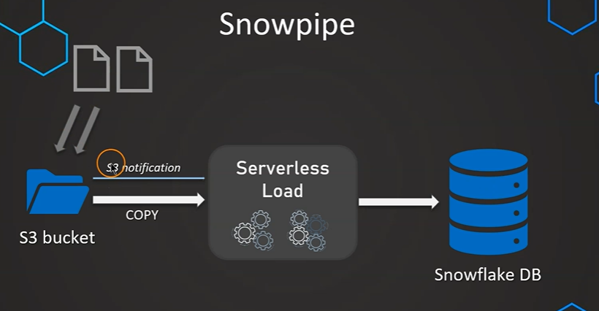
Hive Level steps:
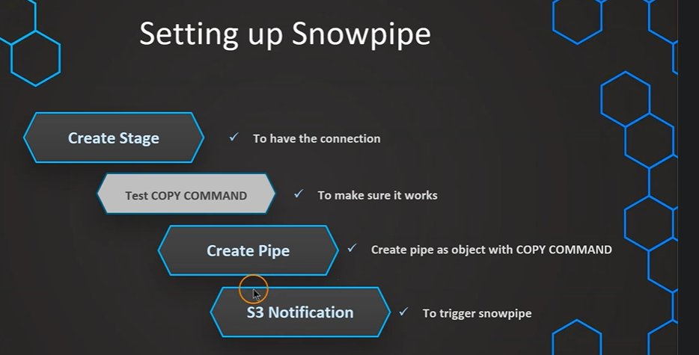

// Create table first
CREATE OR REPLACE TABLE MANAGE_DB.PUBLIC.employees (
id INT,
first_name STRING,
last_name STRING,
email STRING,
location STRING,
department STRING
)

// Create file format object
CREATE OR REPLACE file format MANAGE_DB.file_formats.csv_fileformat
type = csv
field_delimiter = ','
skip_header = 1
null_if = ('NULL','null')
empty_field_as_null = TRUE;

// Create stage object with integration object & file format object
CREATE OR REPLACE stage MANAGE_DB.external_stages.csv_folder
URL = 's3://learnsnowflake05/csv/snowpipe'
STORAGE_INTEGRATION = s3_int
FILE_FORMAT = MANAGE_DB.file_formats.csv_fileformat

// Create stage object with integration object & file format object
LIST @MANAGE_DB.external_stages.csv_folder

// Create schema to keep things organized
CREATE OR REPLACE SCHEMA MANAGE_DB.pipes

// Define pipe
CREATE OR REPLACE pipe MANAGE_DB.pipes.employee_pipe
auto_ingest = TRUE
AS
COPY INTO MANAGE_DB.PUBLIC.employees
FROM @MANAGE_DB.external_stages.csv_folder

// Describe pipe
DESC pipe employee_pipe
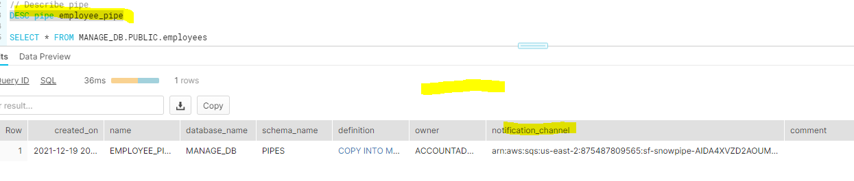
Copy the value from notification channel and enter into the SQS ARN field when creating the s3 notification object.
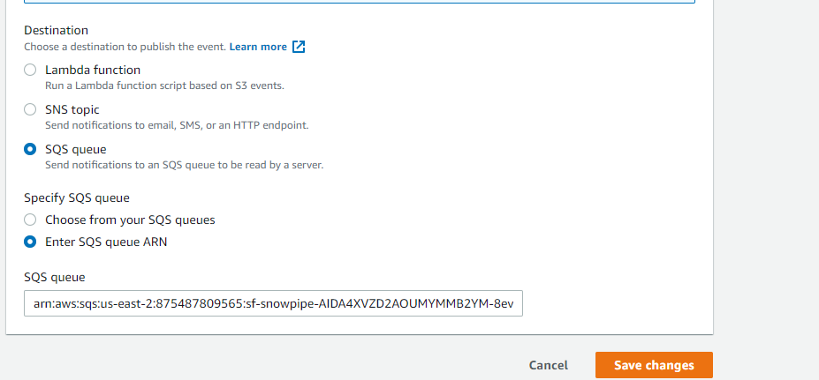
Once above is done , then upload a any new file to s3 folder then the new file will be loaded to Snowflake table in about 30 to 60 seconds.

SELECT * FROM MANAGE_DB.PUBLIC.employees

// Handling errors

// Create file format object
CREATE OR REPLACE file format MANAGE_DB.file_formats.csv_fileformat
type = csv
field_delimiter = ','
skip_header = 1
null_if = ('NULL','null')
empty_field_as_null = TRUE;

SELECT * FROM OUR_FIRST_DB.PUBLIC.employees

ALTER PIPE employee_pipe refresh

// Validate pipe is actually working
SELECT SYSTEM$PIPE_STATUS('employee_pipe')

// Snowpipe error message
SELECT * FROM TABLE(VALIDATE_PIPE_LOAD(
PIPE_NAME => 'MANAGE_DB.pipes.employee_pipe',
START_TIME => DATEADD(HOUR,-2,CURRENT_TIMESTAMP())))

// COPY command history from table to see error massage

SELECT * FROM TABLE (INFORMATION_SCHEMA.COPY_HISTORY(
table_name => 'OUR_FIRST_DB.PUBLIC.EMPLOYEES',
START_TIME =>DATEADD(HOUR,-2,CURRENT_TIMESTAMP())))

Manage Pipes:
-- Manage pipes --

DESC pipe MANAGE_DB.pipes.employee_pipe;

SHOW PIPES;

SHOW PIPES like '%employee%'

SHOW PIPES in database MANAGE_DB

SHOW PIPES in schema MANAGE_DB.pipes

SHOW PIPES like '%employee%' in Database MANAGE_DB

-- Changing pipe (alter stage or file format) --

// Preparation table first
CREATE OR REPLACE TABLE MANAGE_DB.PUBLIC.employees2 (
id INT,
first_name STRING,
last_name STRING,
email STRING,
location STRING,
department STRING
)

// Pause pipe
ALTER PIPE MANAGE_DB.pipes.employee_pipe SET PIPE_EXECUTION_PAUSED = true

// Verify pipe is paused and has pendingFileCount 0
SELECT SYSTEM$PIPE_STATUS('MANAGE_DB.pipes.employee_pipe')

// Recreate the pipe to change the COPY statement in the definition
CREATE OR REPLACE pipe MANAGE_DB.pipes.employee_pipe
auto_ingest = TRUE
AS
COPY INTO OUR_FIRST_DB.PUBLIC.employees2
FROM @MANAGE_DB.external_stages.csv_folder

ALTER PIPE MANAGE_DB.pipes.employee_pipe refresh

// List files in stage
LIST @MANAGE_DB.external_stages.csv_folder

SELECT * FROM OUR_FIRST_DB.PUBLIC.employees2

// Reload files manually that where aleady in the bucket
COPY INTO OUR_FIRST_DB.PUBLIC.employees2
FROM @MANAGE_DB.external_stages.csv_folder

// Resume pipe
ALTER PIPE MANAGE_DB.pipes.employee_pipe SET PIPE_EXECUTION_PAUSED = false

// Verify pipe is running again
SELECT SYSTEM$PIPE_STATUS('MANAGE_DB.pipes.employee_pipe')

Time Travel : in enterprise edition , we can travel back upto 90 days and in standard, we can travel back upto 1 day
There are three diff way we can query: using OFFSET , Before and query ID syntax
// Setting up table

CREATE OR REPLACE TABLE MANAGE_DB.public.test (
id int,
first_name string,
last_name string,
email string,
gender string,
Job string,
Phone string)

CREATE OR REPLACE FILE FORMAT MANAGE_DB.file_formats.csv_file
type = csv
field_delimiter = ','
skip_header = 1

CREATE OR REPLACE STAGE MANAGE_DB.external_stages.time_travel_stage
URL = 's3://data-snowflake-fundamentals/time-travel/'
file_format = MANAGE_DB.file_formats.csv_file;

LIST @MANAGE_DB.external_stages.time_travel_stage

COPY INTO MANAGE_DB.public.test
from @MANAGE_DB.external_stages.time_travel_stage
files = ('customers.csv')

SELECT * FROM MANAGE_DB.public.test

// Use-case: Update data (by mistake)

UPDATE OUR_FIRST_DB.public.test
SET FIRST_NAME = 'Joyen'

// // // Using time travel: Method 1 - 2 minutes back
SELECT * FROM MANAGE_DB.public.test at (OFFSET => -60*1.5)

// // // Using time travel: Method 2 - before timestamp
SELECT * FROM MANAGE_DB.public.test before (timestamp => '2021-04-15 17:47:50.581'::timestamp)

-- Setting up table
CREATE OR REPLACE TABLE MANAGE_DB.public.test (
id int,
first_name string,
last_name string,
email string,
gender string,
Job string,
Phone string);

COPY INTO OUR_FIRST_DB.public.test
from @MANAGE_DB.external_stages.time_travel_stage
files = ('customers.csv');

SELECT * FROM OUR_FIRST_DB.public.test;

2021-04-17 08:16:24.259

-- Setting up UTC time for convenience

ALTER SESSION SET TIMEZONE ='UTC'
SELECT DATEADD(DAY, 1, CURRENT_TIMESTAMP)

UPDATE OUR_FIRST_DB.public.test
SET Job = 'Data Scientist'

SELECT * FROM OUR_FIRST_DB.public.test;

SELECT * FROM OUR_FIRST_DB.public.test before (timestamp => '2021-04-16 07:30:47.145'::timestamp)

// // // Using time travel: Method 3 - before Query ID

// Preparing table
CREATE OR REPLACE TABLE OUR_FIRST_DB.public.test (
id int,
first_name string,
last_name string,
email string,
gender string,
Phone string,
Job string)

COPY INTO OUR_FIRST_DB.public.test
from @MANAGE_DB.external_stages.time_travel_stage
files = ('customers.csv')

SELECT * FROM OUR_FIRST_DB.public.test

// Altering table (by mistake)
UPDATE OUR_FIRST_DB.public.test
SET EMAIL = null

SELECT * FROM OUR_FIRST_DB.public.test

SELECT * FROM OUR_FIRST_DB.public.test before (statement => '019b9ee5-0500-8473-0043-4d8300073062')

RESTORING THE DATA :

// Setting up table

CREATE OR REPLACE TABLE MANAGE_DB.public.test (
id int,
first_name string,
last_name string,
email string,
gender string,
Job string,
Phone string);

COPY INTO MANAGE_DB.public.test
from @MANAGE_DB.external_stages.time_travel_stage
files = ('customers.csv');

SELECT * FROM MANAGE_DB.public.test;

// Use-case: Update data (by mistake)

UPDATE MANAGE_DB.public.test
SET LAST_NAME = 'Tyson';

UPDATE MANAGE_DB.public.test
SET JOB = 'Data Analyst';

SELECT * FROM MANAGE_DB.public.test before (statement => '01a11624-0000-62cb-0000-00014bc6754d')

// // // Bad method

CREATE OR REPLACE TABLE OUR_FIRST_DB.public.test as
SELECT * FROM OUR_FIRST_DB.public.test before (statement => '019b9eea-0500-845a-0043-4d830007402a')

SELECT * FROM OUR_FIRST_DB.public.test

CREATE OR REPLACE TABLE OUR_FIRST_DB.public.test as
SELECT * FROM OUR_FIRST_DB.public.test before (statement => '019b9eea-0500-8473-0043-4d830007307a')

This is a bad method because we are recreating the table so we are losing the table metadata so time travel cannot be achieved.

// // // Good method

CREATE OR REPLACE TABLE OUR_FIRST_DB.public.test_backup as
SELECT * FROM OUR_FIRST_DB.public.test before (statement => '019b9ef0-0500-8473-0043-4d830007309a')

TRUNCATE OUR_FIRST_DB.public.test

INSERT INTO OUR_FIRST_DB.public.test
SELECT * FROM OUR_FIRST_DB.public.test_backup

SELECT * FROM OUR_FIRST_DB.public.test

UNDROP TABLES:

// Setting up table

CREATE OR REPLACE STAGE MANAGE_DB.external_stages.time_travel_stage
URL = 's3://data-snowflake-fundamentals/time-travel/'
file_format = MANAGE_DB.file_formats.csv_file;

CREATE OR REPLACE TABLE OUR_FIRST_DB.public.customers (
id int,
first_name string,
last_name string,
email string,
gender string,
Job string,
Phone string);

COPY INTO OUR_FIRST_DB.public.customers
from @MANAGE_DB.external_stages.time_travel_stage
files = ('customers.csv');

SELECT * FROM OUR_FIRST_DB.public.customers;

// UNDROP command - Tables

DROP TABLE OUR_FIRST_DB.public.customers;

SELECT * FROM OUR_FIRST_DB.public.customers;

UNDROP TABLE OUR_FIRST_DB.public.customers;

// UNDROP command - Schemas

DROP SCHEMA OUR_FIRST_DB.public;

SELECT * FROM OUR_FIRST_DB.public.customers;

UNDROP SCHEMA OUR_FIRST_DB.public;

// UNDROP command - Database

DROP DATABASE OUR_FIRST_DB;

SELECT * FROM OUR_FIRST_DB.public.customers;

UNDROP DATABASE OUR_FIRST_DB;

// Restore replaced table

UPDATE OUR_FIRST_DB.public.customers
SET LAST_NAME = 'Tyson';

UPDATE OUR_FIRST_DB.public.customers
SET JOB = 'Data Analyst';

// // // Undroping a with a name that already exists

CREATE OR REPLACE TABLE OUR_FIRST_DB.public.customers as
SELECT * FROM OUR_FIRST_DB.public.customers before (statement => '019b9f7c-0500-851b-0043-4d83000762be')

SELECT * FROM OUR_FIRST_DB.public.customers

UNDROP table OUR_FIRST_DB.public.customers;

ALTER TABLE OUR_FIRST_DB.public.customers
RENAME TO OUR_FIRST_DB.public.customers_wrong;

DESC table OUR_FIRST_DB.public.customers

RETENTION TIME:
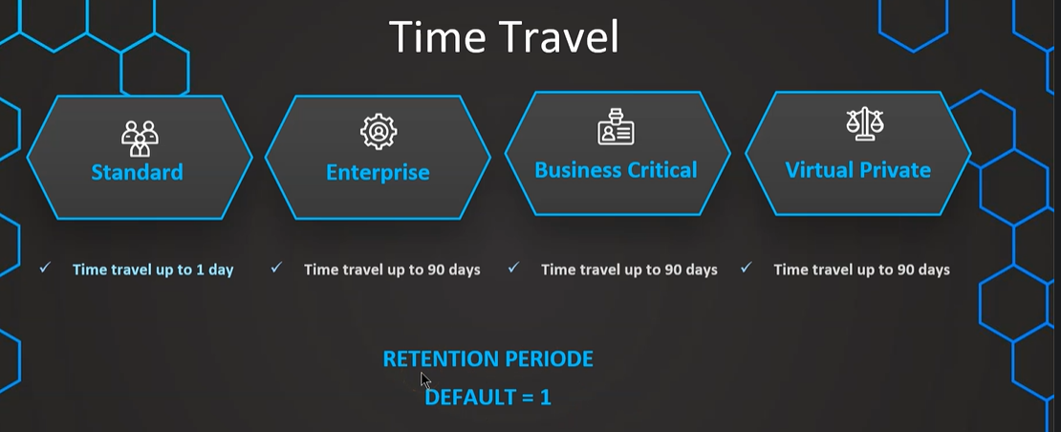
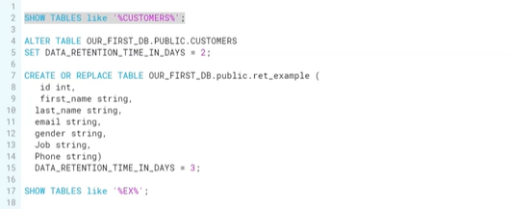
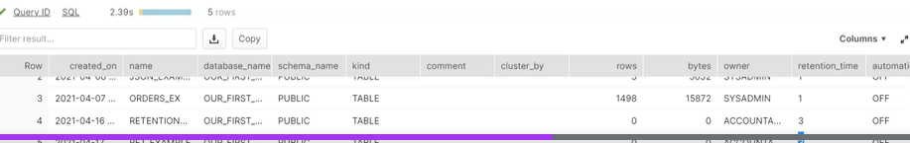
Undrop table will not work if table retention period is set 0 as there wont be any time travel.
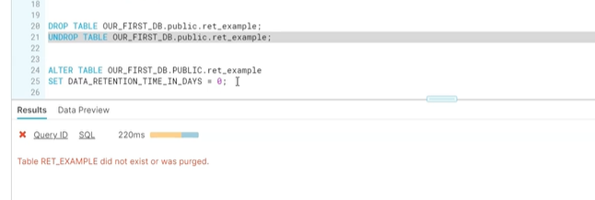
Time travel cost:

SELECT * FROM SNOWFLAKE.ACCOUNT_USAGE.STORAGE_USAGE ORDER BY USAGE_DATE DESC;

SELECT * FROM SNOWFLAKE.ACCOUNT_USAGE.TABLE_STORAGE_METRICS;

// Query time travel storage
SELECT ID,
TABLE_NAME,
TABLE_SCHEMA,
TABLE_CATALOG,
ACTIVE_BYTES / (1024*1024*1024) AS STORAGE_USED_GB,
TIME_TRAVEL_BYTES / (1024*1024*1024) AS TIME_TRAVEL_STORAGE_USED_GB
FROM SNOWFLAKE.ACCOUNT_USAGE.TABLE_STORAGE_METRICS
ORDER BY STORAGE_USED_GB DESC, TIME_TRAVEL_STORAGE_USED_GB DESC;

Fail Safe:
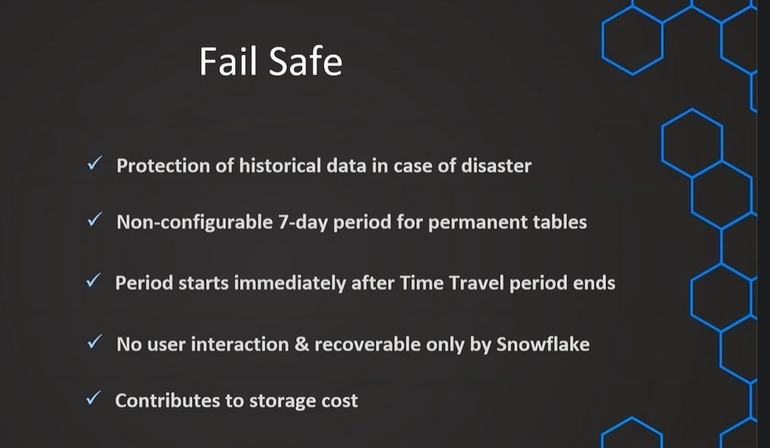
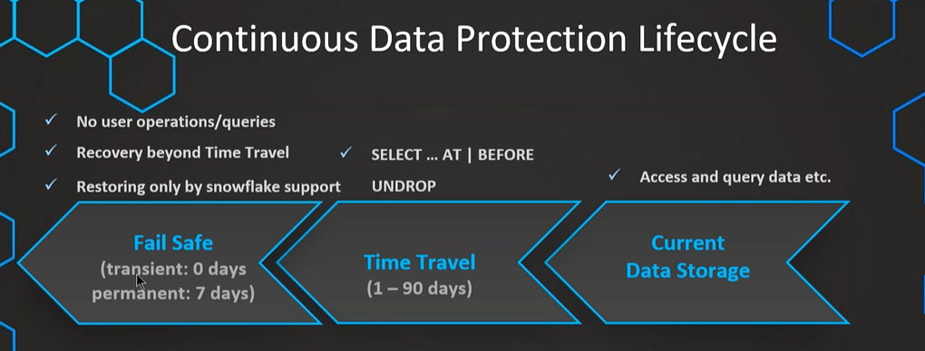
// Storage usage on account level

SELECT * FROM SNOWFLAKE.ACCOUNT_USAGE.STORAGE_USAGE ORDER BY USAGE_DATE DESC;

// Storage usage on account level formatted

SELECT USAGE_DATE,
STORAGE_BYTES / (1024*1024*1024) AS STORAGE_GB,
STAGE_BYTES / (1024*1024*1024) AS STAGE_GB,
FAILSAFE_BYTES / (1024*1024*1024) AS FAILSAFE_GB
FROM SNOWFLAKE.ACCOUNT_USAGE.STORAGE_USAGE ORDER BY USAGE_DATE DESC;

// Storage usage on table level

SELECT * FROM SNOWFLAKE.ACCOUNT_USAGE.TABLE_STORAGE_METRICS;

// Storage usage on table level formatted

SELECT ID,
TABLE_NAME,
TABLE_SCHEMA,
ACTIVE_BYTES / (1024*1024*1024) AS STORAGE_USED_GB,
TIME_TRAVEL_BYTES / (1024*1024*1024) AS TIME_TRAVEL_STORAGE_USED_GB,
FAILSAFE_BYTES / (1024*1024*1024) AS FAILSAFE_STORAGE_USED_GB
FROM SNOWFLAKE.ACCOUNT_USAGE.TABLE_STORAGE_METRICS
ORDER BY FAILSAFE_STORAGE_USED_GB DESC;

Table Types:
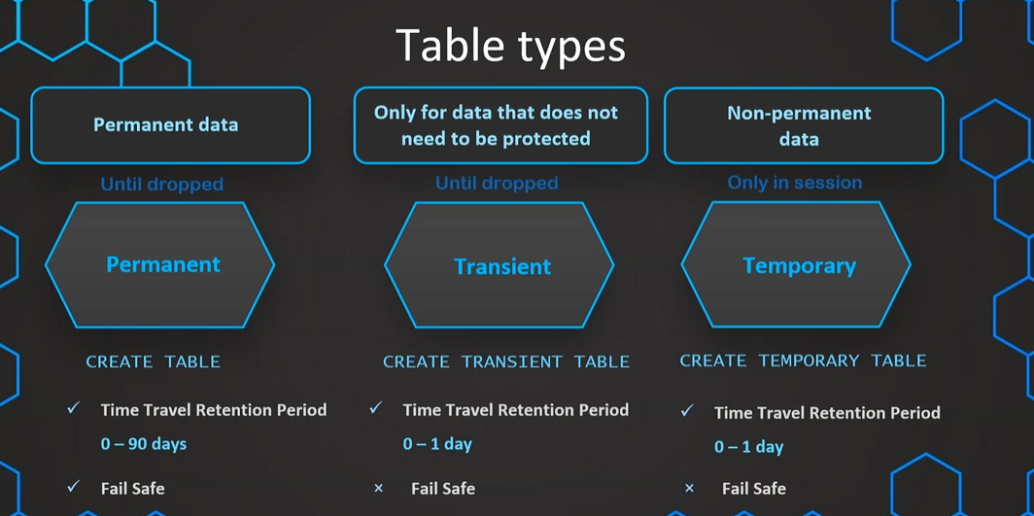
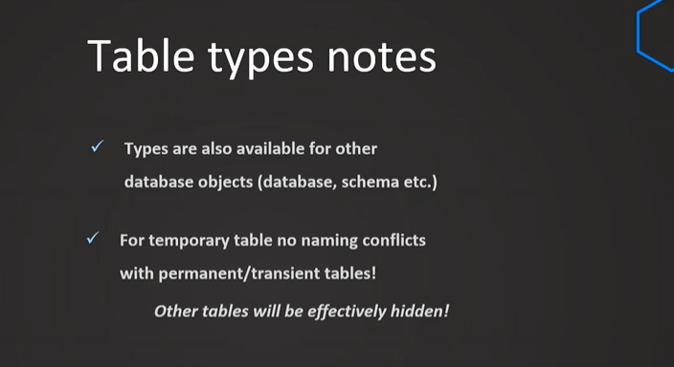
// Permanent tables

USE OUR_FIRST_DB

CREATE OR REPLACE TABLE customers (
id int,
first_name string,
last_name string,
email string,
gender string,
Job string,
Phone string);

CREATE OR REPLACE DATABASE PDB;

SHOW DATABASES;

SHOW TABLES;

// View table metrics (takes a bit to appear)
SELECT * FROM SNOWFLAKE.ACCOUNT_USAGE.TABLE_STORAGE_METRICS

SELECT ID,
TABLE_NAME,
TABLE_SCHEMA,
TABLE_CATALOG,
ACTIVE_BYTES / (1024*1024*1024) AS ACTIVE_STORAGE_USED_GB,
TIME_TRAVEL_BYTES / (1024*1024*1024) AS TIME_TRAVEL_STORAGE_USED_GB,
FAILSAFE_BYTES / (1024*1024*1024) AS FAILSAFE_STORAGE_USED_GB,
IS_TRANSIENT,
DELETED,
TABLE_CREATED,
TABLE_DROPPED,
TABLE_ENTERED_FAILSAFE
FROM SNOWFLAKE.ACCOUNT_USAGE.TABLE_STORAGE_METRICS
--WHERE TABLE_CATALOG ='PDB'
WHERE TABLE_DROPPED is not null
ORDER BY FAILSAFE_BYTES DESC;

// Creating transient schema and then table

CREATE OR REPLACE TRANSIENT SCHEMA TRANSIENT_SCHEMA;

SHOW SCHEMAS;

CREATE OR REPLACE TABLE TDB.TRANSIENT_SCHEMA.new_table (
id int,
first_name string,
last_name string,
email string,
gender string,
Job string,
Phone string);

ALTER TABLE TDB.TRANSIENT_SCHEMA.new_table
SET DATA_RETENTION_TIME_IN_DAYS = 2
For the transient tables , retention period is only either 0 or 1 day.
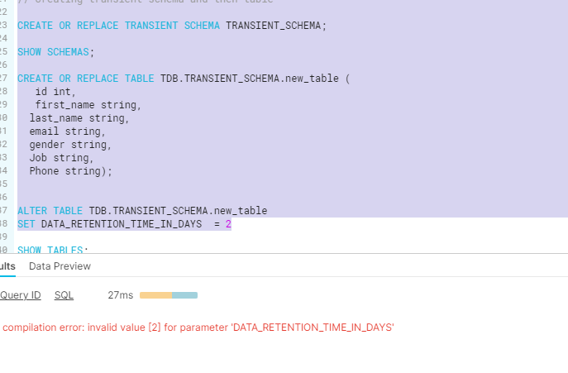
And tables those are created in transient schema , will be created as transient tables and follows the same retention period which is 0 or 1

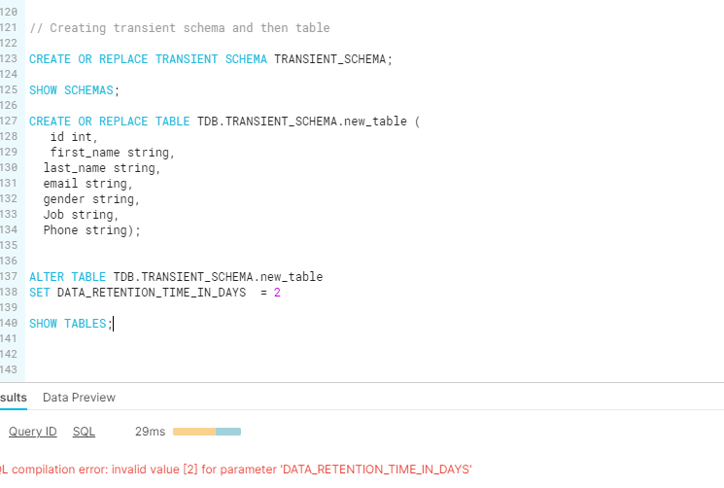
USE DATABASE PDB;

// Create permanent table

CREATE OR REPLACE TABLE PDB.public.customers (
id int,
first_name string,
last_name string,
email string,
gender string,
Job string,
Phone string);

INSERT INTO PDB.public.customers
SELECT t1.* FROM OUR_FIRST_DB.public.customers t1

SELECT * FROM PDB.public.customers

// Create temporary table (with the same name)
CREATE OR REPLACE TEMPORARY TABLE PDB.public.customers (
id int,
first_name string,
last_name string,
email string,
gender string,
Job string,
Phone string);

// Validate temporary table is the active table
SELECT * FROM PDB.public.customers;

// Create second temporary table (with a new name)
CREATE OR REPLACE TEMPORARY TABLE PDB.public.temp_table (
id int,
first_name string,
last_name string,
email string,
gender string,
Job string,
Phone string);

// Insert data in the new table
INSERT INTO PDB.public.temp_table
SELECT * FROM PDB.public.customers

SELECT * FROM PDB.public.temp_table

SHOW TABLES;
If we create the temp table with the table name that already exists then to that particular session permanent table will get hidden and temp table will get higher control
ZERO COPY CLONING:
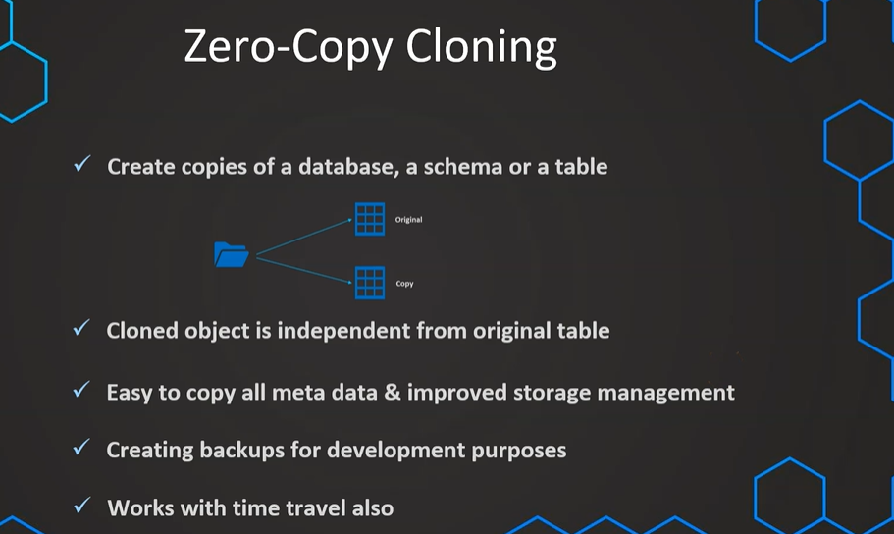
There won’t be any additional storage cost for cloned copy but if we make any changes to metadata / data then there will be storage cost.

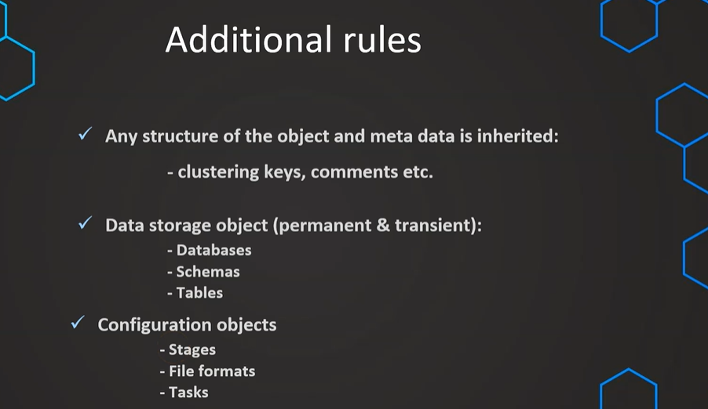

// Cloning Schema
CREATE TRANSIENT SCHEMA OUR_FIRST_DB.COPIED_SCHEMA
CLONE OUR_FIRST_DB.PUBLIC;

SELECT * FROM COPIED_SCHEMA.CUSTOMERS

CREATE TRANSIENT SCHEMA OUR_FIRST_DB.EXTERNAL_STAGES_COPIED
CLONE MANAGE_DB.EXTERNAL_STAGES;

// Cloning Database
CREATE TRANSIENT DATABASE OUR_FIRST_DB_COPY
CLONE OUR_FIRST_DB;

DROP DATABASE OUR_FIRST_DB_COPY
DROP SCHEMA OUR_FIRST_DB.EXTERNAL_STAGES_COPIED
DROP SCHEMA OUR_FIRST_DB.COPIED_SCHEMA

SHOW TABLES;

// Cloning Schema
CREATE TRANSIENT SCHEMA OUR_FIRST_DB.COPIED_SCHEMA
CLONE OUR_FIRST_DB.PUBLIC;

SELECT * FROM COPIED_SCHEMA.CUSTOMERS

CREATE TRANSIENT SCHEMA OUR_FIRST_DB.EXTERNAL_STAGES_COPIED
CLONE MANAGE_DB.EXTERNAL_STAGES;

// Cloning Tables
SELECT *FROM OUR_FIRST_DB.COPIED_SCHEMA.MOVIE_TITLES

CREATE TABLE OUR_FIRST_DB.COPIED_SCHEMA.MOVIE_TITLES_CLONE
CLONE OUR_FIRST_DB.COPIED_SCHEMA.MOVIE_TITLES

// Validate cloned table

SELECT *FROM OUR_FIRST_DB.COPIED_SCHEMA.MOVIE_TITLES_CLONE

// update cloned tables

UPDATE OUR_FIRST_DB.COPIED_SCHEMA.MOVIE_TITLES_CLONE
SET TYPE = NULL

SELECT *FROM OUR_FIRST_DB.COPIED_SCHEMA.MOVIE_TITLES_CLONE // ONLY THE UPDATE HAPPENED ON THE CLONED TABLE , BUT NOT ON THE REGULAR TABLE

SELECT *FROM OUR_FIRST_DB.COPIED_SCHEMA.MOVIE_TITLES

SHOW TABLES IN OUR_FIRST_DB;

SHOW TABLES;

CLONE WITH TIME TRAVEL :

// Cloning using time travel

// Setting up table

CREATE OR REPLACE TABLE OUR_FIRST_DB.public.time_travel (
id int,
first_name string,
last_name string,
email string,
gender string,
Job string,
Phone string);

CREATE OR REPLACE FILE FORMAT MANAGE_DB.file_formats.csv_file
type = csv
field_delimiter = ','
skip_header = 1;

CREATE OR REPLACE STAGE MANAGE_DB.external_stages.time_travel_stage
URL = 's3://data-snowflake-fundamentals/time-travel/'
file_format = MANAGE_DB.file_formats.csv_file;

LIST @MANAGE_DB.external_stages.time_travel_stage;

COPY INTO OUR_FIRST_DB.public.time_travel
from @MANAGE_DB.external_stages.time_travel_stage
files = ('customers.csv');

SELECT * FROM OUR_FIRST_DB.public.time_travel

// Update data

UPDATE OUR_FIRST_DB.public.time_travel
SET FIRST_NAME = 'Frank'

// Using time travel
SELECT * FROM OUR_FIRST_DB.public.time_travel at (OFFSET => -60*1)

// Using time travel
CREATE OR REPLACE TABLE OUR_FIRST_DB.PUBLIC.time_travel_clone
CLONE OUR_FIRST_DB.public.time_travel at (OFFSET => -60*2)

SELECT * FROM OUR_FIRST_DB.PUBLIC.time_travel_clone

// Update data again

UPDATE OUR_FIRST_DB.public.time_travel_clone
SET JOB = 'Snowflake Analyst'

// Using time travel: Method 2 - before Query
SELECT * FROM OUR_FIRST_DB.public.time_travel_clone before (statement => '<your-query-id>)

CREATE OR REPLACE TABLE OUR_FIRST_DB.PUBLIC.time_travel_clone_of_clone
CLONE OUR_FIRST_DB.public.time_travel_clone before (statement => '<your-query-id>')

SELECT * FROM OUR_FIRST_DB.public.time_travel_clone_of_clone

SWAPPING TABLE:
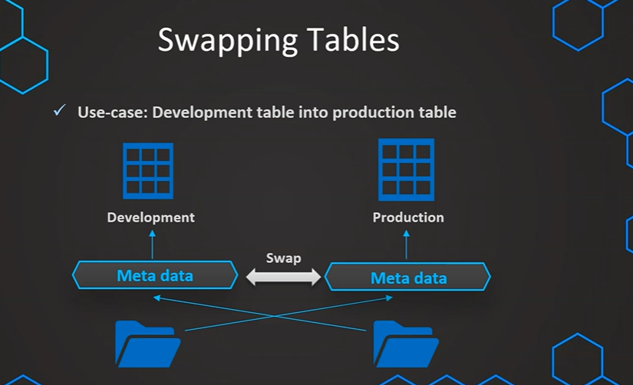
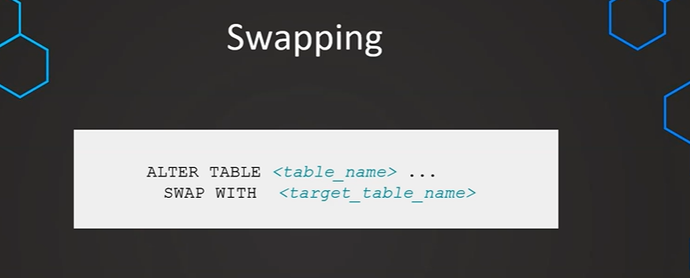
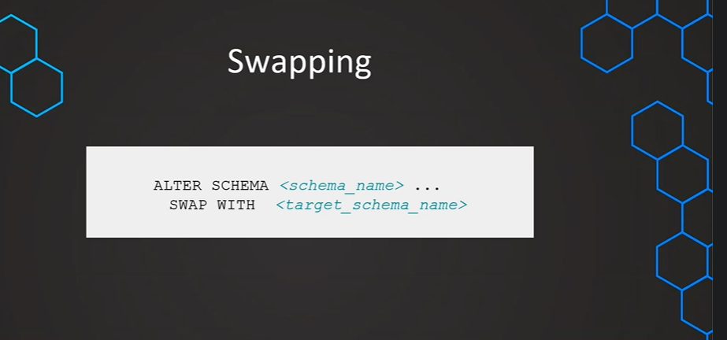
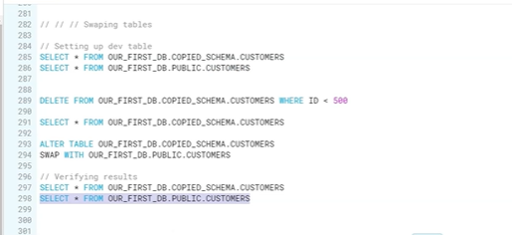

Data Sharing:
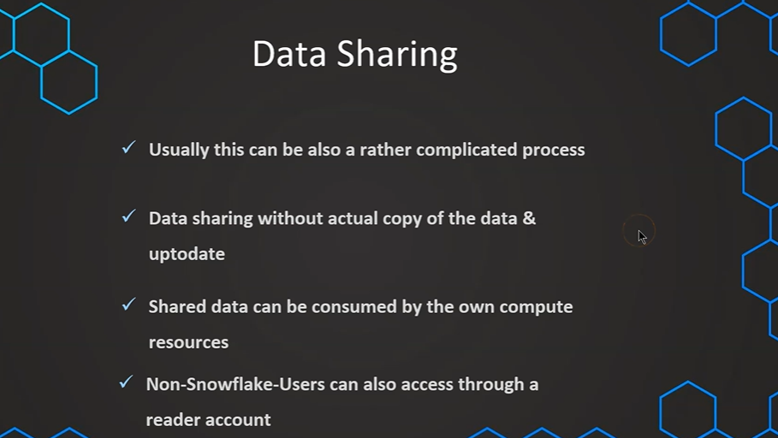
CREATE OR REPLACE DATABASE DATA_S;

CREATE OR REPLACE STAGE aws_stage
url='s3://bucketsnowflakes3';

// List files in stage
LIST @aws_stage;

// Create table
CREATE OR REPLACE TABLE ORDERS (
ORDER_ID VARCHAR(30)
,AMOUNT NUMBER(38,0)
,PROFIT NUMBER(38,0)
,QUANTITY NUMBER(38,0)
,CATEGORY VARCHAR(30)
,SUBCATEGORY VARCHAR(30))

// Load data using copy command
COPY INTO ORDERS
FROM @MANAGE_DB.external_stages.aws_stage
file_format= (type = csv field_delimiter=',' skip_header=1)
pattern='.*OrderDetails.*';

SELECT * FROM ORDERS;

// Create a share object
CREATE OR REPLACE SHARE ORDERS_SHARE;

---- Setup Grants ----

// Grant usage on database
GRANT USAGE ON DATABASE DATA_S TO SHARE ORDERS_SHARE;

// Grant usage on schema
GRANT USAGE ON SCHEMA DATA_S.PUBLIC TO SHARE ORDERS_SHARE;

// Grant SELECT on table

GRANT SELECT ON TABLE DATA_S.PUBLIC.ORDERS TO SHARE ORDERS_SHARE;

// Validate Grants
SHOW GRANTS TO SHARE ORDERS_SHARE;

---- Add Consumer Account ----
ALTER SHARE ORDERS_SHARE ADD ACCOUNT=kaa74702;

Above is the place where we see our account id and if we want to establish the data share to other org / consumer we should give their account id like below.
---- Add Consumer Account ----
ALTER SHARE ORDERS_SHARE ADD ACCOUNT=kaa74702;
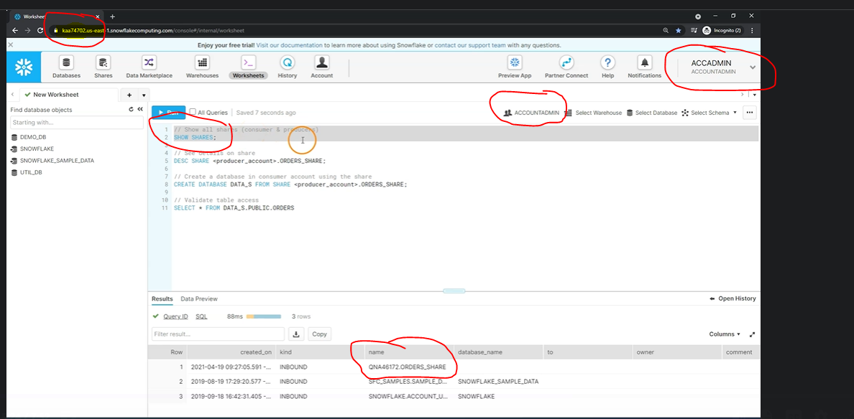

Reading from share
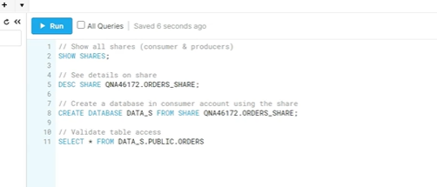
Data share with Non-snowflake user:
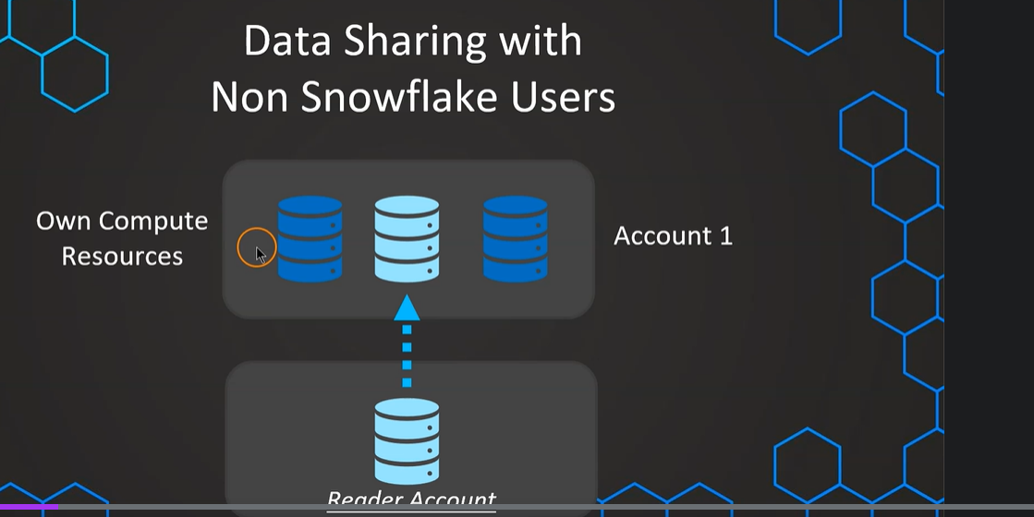
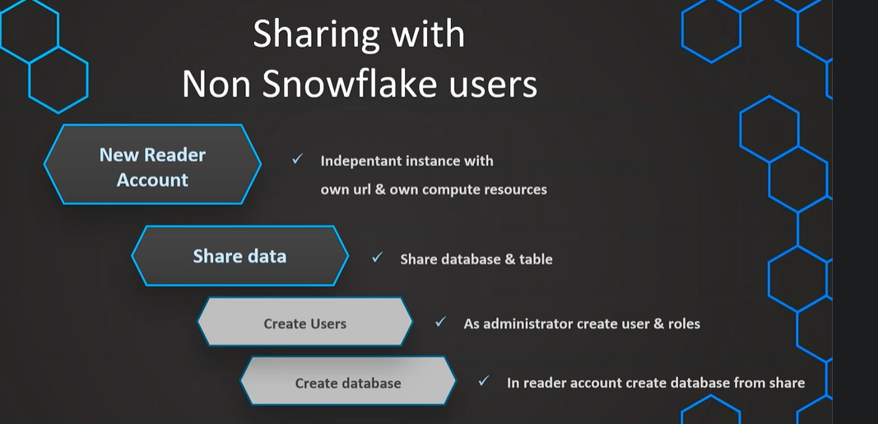

-- Create Reader Account --

CREATE MANAGED ACCOUNT tech_joy_account
ADMIN_NAME = tech_joy_admin,
ADMIN_PASSWORD = 'tech_joy_Account@465',
TYPE = READER;

// Make sure to have selected the role of accountadmin

// Show accounts
SHOW MANAGED ACCOUNTS; //to get the account id

-- Share the data --

ALTER SHARE ORDERS_SHARE
ADD ACCOUNT = OR07112;

ALTER SHARE ORDERS_SHARE
ADD ACCOUNT = OR07112
SHARE_RESTRICTIONS=false;

-- Create database from share --

// Show all shares (consumer & producers)
SHOW SHARES;

// See details on share
DESC SHARE QNA46172.ORDERS_SHARE;

// Create a database in consumer account using the share
CREATE DATABASE DATA_SHARE_DB FROM SHARE <account_name_producer>.ORDERS_SHARE;

// Validate table access
SELECT * FROM DATA_SHARE_DB.PUBLIC.ORDERS

// Setup virtual warehouse
CREATE WAREHOUSE READ_WH WITH
WAREHOUSE_SIZE='X-SMALL'
AUTO_SUSPEND = 180
AUTO_RESUME = TRUE
INITIALLY_SUSPENDED = TRUE;

-- Create and set up users --

// Create user
CREATE USER MYRIAM PASSWORD = 'difficult_passw@ord=123'

// Grant usage on warehouse
GRANT USAGE ON WAREHOUSE READ_WH TO ROLE PUBLIC;

// Grating privileges on a Shared Database for other users
GRANT IMPORTED PRIVILEGES ON DATABASE DATA_SHARE_DB TO REOLE PUBLIC;

Sharing database and schema:
SHOW SHARES;

// Create share object
CREATE OR REPLACE SHARE COMEPLETE_SCHEMA_SHARE;

// Grant usage on dabase & schema
GRANT USAGE ON DATABASE OUR_FIRST_DB TO SHARE COMEPLETE_SCHEMA_SHARE;
GRANT USAGE ON SCHEMA OUR_FIRST_DB.PUBLIC TO SHARE COMEPLETE_SCHEMA_SHARE;

// Grant select on all tables
GRANT SELECT ON ALL TABLES IN SCHEMA OUR_FIRST_DB.PUBLIC TO SHARE COMEPLETE_SCHEMA_SHARE;
GRANT SELECT ON ALL TABLES IN DATABASE OUR_FIRST_DB TO SHARE COMEPLETE_SCHEMA_SHARE;

// Add account to share
ALTER SHARE COMEPLETE_SCHEMA_SHARE
ADD ACCOUNT=KAA74702
// Updating data
UPDATE OUR_FIRST_DB.PUBLIC.ORDERS
SET PROFIT=0 WHERE PROFIT < 0

// Add new table
CREATE TABLE OUR_FIRST_DB.PUBLIC.NEW_TABLE (ID int)
Sharing view:

-- Create database & table --
CREATE OR REPLACE DATABASE CUSTOMER_DB;

CREATE OR REPLACE TABLE CUSTOMER_DB.public.customers (
id int,
first_name string,
last_name string,
email string,
gender string,
Job string,
Phone string);

// Stage and file format
CREATE OR REPLACE FILE FORMAT MANAGE_DB.file_formats.csv_file
type = csv
field_delimiter = ','
skip_header = 1;

CREATE OR REPLACE STAGE MANAGE_DB.external_stages.time_travel_stage
URL = 's3://data-snowflake-fundamentals/time-travel/'
file_format = MANAGE_DB.file_formats.csv_file;

LIST @MANAGE_DB.external_stages.time_travel_stage;

// Copy data and insert in table
COPY INTO CUSTOMER_DB.public.customers
FROM @MANAGE_DB.external_stages.time_travel_stage
files = ('customers.csv');

SELECT * FROM CUSTOMER_DB.PUBLIC.CUSTOMERS;

-- Create VIEW --
CREATE OR REPLACE VIEW CUSTOMER_DB.PUBLIC.CUSTOMER_VIEW AS
SELECT
FIRST_NAME,
LAST_NAME,
EMAIL
FROM CUSTOMER_DB.PUBLIC.CUSTOMERS
WHERE JOB != 'DATA SCIENTIST';
-- Grant usage & SELECT --
GRANT USAGE ON DATABASE CUSTOMER_DB TO ROLE PUBLIC;
GRANT USAGE ON SCHEMA CUSTOMER_DB.PUBLIC TO ROLE PUBLIC;
GRANT SELECT ON TABLE CUSTOMER_DB.PUBLIC.CUSTOMERS TO ROLE PUBLIC;
GRANT SELECT ON VIEW CUSTOMER_DB.PUBLIC.CUSTOMER_VIEW TO ROLE PUBLIC;
SHOW VIEWS LIKE '%CUSTOMER%';

-- Create SECURE VIEW --
CREATE OR REPLACE SECURE VIEW CUSTOMER_DB.PUBLIC.CUSTOMER_VIEW_SECURE AS
SELECT
FIRST_NAME,
LAST_NAME,
EMAIL
FROM CUSTOMER_DB.PUBLIC.CUSTOMERS
WHERE JOB != 'DATA SCIENTIST'

GRANT SELECT ON VIEW CUSTOMER_DB.PUBLIC.CUSTOMER_VIEW_SECURE TO ROLE PUBLIC;

SHOW VIEWS LIKE '%CUSTOMER%';
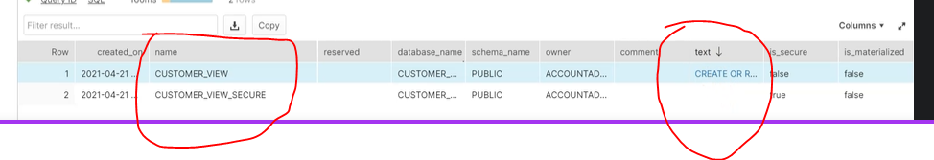
Metadata will not be visible to the consumer if we create the secure view to limit what consumer can see as part of data protection.

Data Sampling:
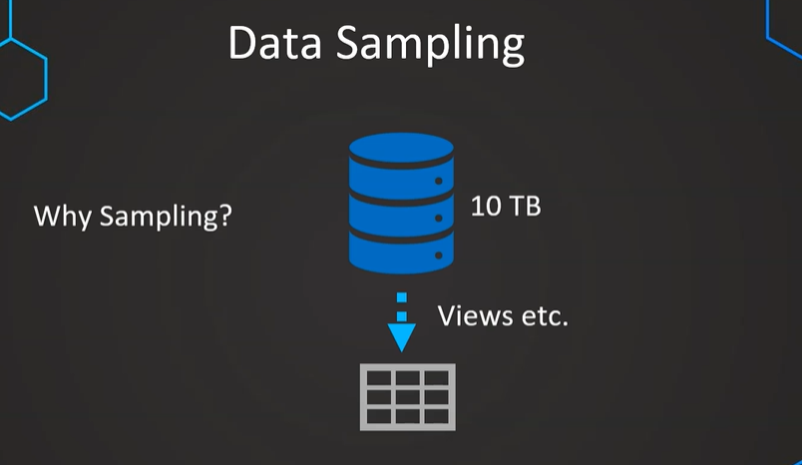
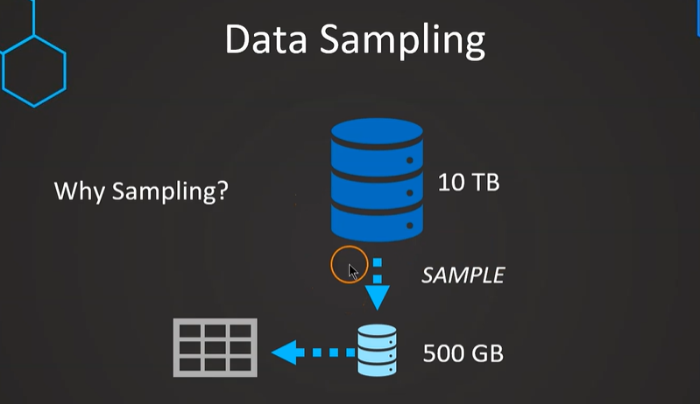
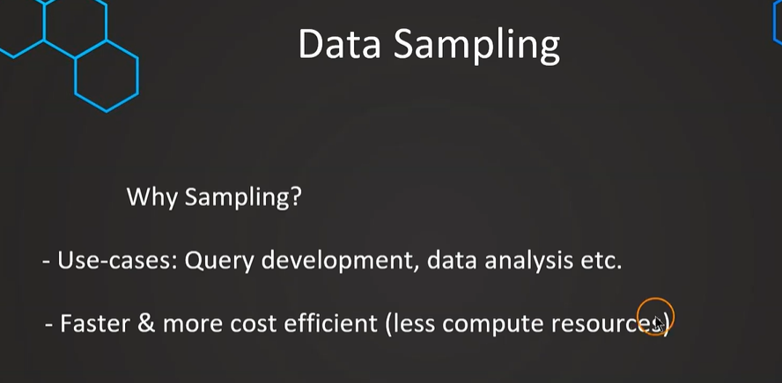

Data sampling methods:
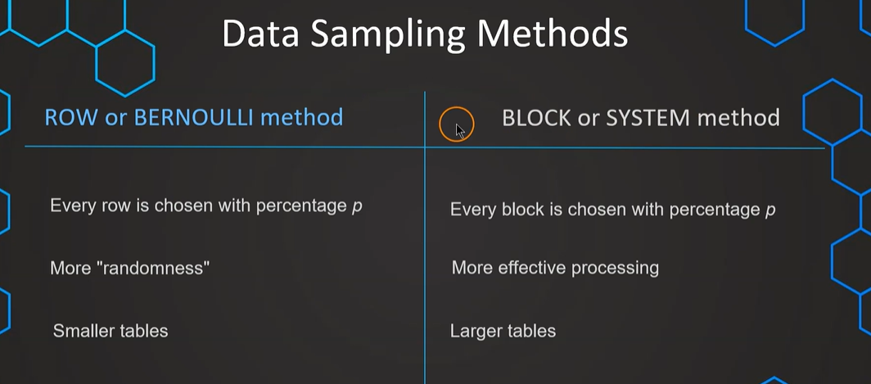

CREATE OR REPLACE TRANSIENT DATABASE SAMPLING_DB;

CREATE OR REPLACE VIEW ADDRESS_SAMPLE
AS
SELECT * FROM SNOWFLAKE_SAMPLE_DATA.TPCDS_SF10TCL.CUSTOMER_ADDRESS
SAMPLE ROW (1) SEED(27); // 1 means one percent

SELECT * FROM ADDRESS_SAMPLE // 325448 rows

SELECT CA_LOCATION_TYPE, COUNT(*)/325448*100
FROM ADDRESS_SAMPLE
GROUP BY CA_LOCATION_TYPE

SELECT * FROM SNOWFLAKE_SAMPLE_DATA.TPCDS_SF10TCL.CUSTOMER_ADDRESS
SAMPLE SYSTEM (1) SEED(23);

SELECT * FROM SNOWFLAKE_SAMPLE_DATA.TPCDS_SF10TCL.CUSTOMER_ADDRESS
SAMPLE SYSTEM (10) SEED(23); // 10 means 10 percent

Scheduling tasks:
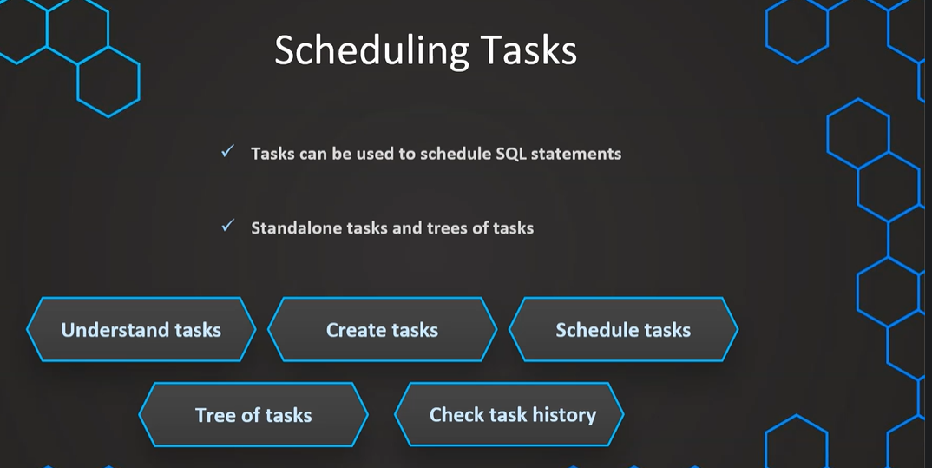

CREATE OR REPLACE TRANSIENT DATABASE TASK_DB;

// Prepare table
CREATE OR REPLACE TABLE CUSTOMERS (
CUSTOMER_ID INT AUTOINCREMENT START = 1 INCREMENT =1,
FIRST_NAME VARCHAR(40) DEFAULT 'JENNIFER' ,
CREATE_DATE DATE)

// Create task
CREATE OR REPLACE TASK CUSTOMER_INSERT
WAREHOUSE = COMPUTE_WH
SCHEDULE = '1 MINUTE'
AS
INSERT INTO CUSTOMERS(CREATE_DATE) VALUES(CURRENT_TIMESTAMP);

SHOW TASKS;

// Task starting and suspending
ALTER TASK CUSTOMER_INSERT RESUME;
ALTER TASK CUSTOMER_INSERT SUSPEND;

SELECT * FROM CUSTOMERS
---------------

CREATE OR REPLACE TASK CUSTOMER_INSERT
WAREHOUSE = COMPUTE_WH
SCHEDULE = '60 MINUTE'
AS
INSERT INTO CUSTOMERS(CREATE_DATE) VALUES(CURRENT_TIMESTAMP);

CREATE OR REPLACE TASK CUSTOMER_INSERT
WAREHOUSE = COMPUTE_WH
SCHEDULE = 'USING CRON 0 7,10 * * 5L UTC'
AS
INSERT INTO CUSTOMERS(CREATE_DATE) VALUES(CURRENT_TIMESTAMP);

# __________ minute (0-59)
# | ________ hour (0-23)
# | | ______ day of month (1-31, or L)
# | | | ____ month (1-12, JAN-DEC)
# | | | | __ day of week (0-6, SUN-SAT, or L)
# | | | | |
# | | | | |
# * * * * *

// Every minute
SCHEDULE = 'USING CRON * * * * * UTC'

// Every day at 6am UTC timezone
SCHEDULE = 'USING CRON 0 6 * * * UTC'

// Every hour starting at 9 AM and ending at 5 PM on Sundays
SCHEDULE = 'USING CRON 0 9-17 * * SUN America/Los_Angeles'

CREATE OR REPLACE TASK CUSTOMER_INSERT
WAREHOUSE = COMPUTE_WH
SCHEDULE = 'USING CRON 0 9,17 * * * UTC'
AS
INSERT INTO CUSTOMERS(CREATE_DATE) VALUES(CURRENT_TIMESTAMP);

Tree of Tasks:
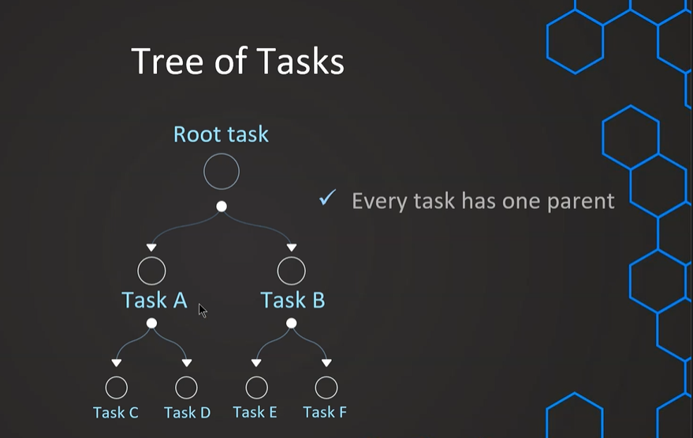
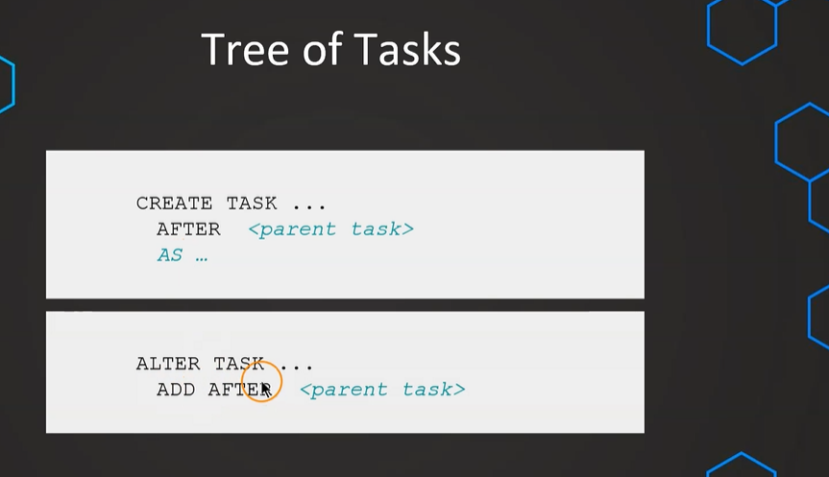

USE TASK_DB;

SHOW TASKS;

SELECT * FROM CUSTOMERS;

// Prepare a second table
CREATE OR REPLACE TABLE CUSTOMERS2 (
CUSTOMER_ID INT,
FIRST_NAME VARCHAR(40),
CREATE_DATE DATE)

// Suspend parent task
ALTER TASK CUSTOMER_INSERT SUSPEND;

// Create a child task
CREATE OR REPLACE TASK CUSTOMER_INSERT2
WAREHOUSE = COMPUTE_WH
AFTER CUSTOMER_INSERT
AS
INSERT INTO CUSTOMERS2 SELECT * FROM CUSTOMERS;

// Prepare a third table
CREATE OR REPLACE TABLE CUSTOMERS3 (
CUSTOMER_ID INT,
FIRST_NAME VARCHAR(40),
CREATE_DATE DATE,
INSERT_DATE DATE DEFAULT DATE(CURRENT_TIMESTAMP))

// Create a child task
CREATE OR REPLACE TASK CUSTOMER_INSERT3
WAREHOUSE = COMPUTE_WH
AFTER CUSTOMER_INSERT2
AS
INSERT INTO CUSTOMERS3 (CUSTOMER_ID,FIRST_NAME,CREATE_DATE) SELECT * FROM CUSTOMERS2;

SHOW TASKS;

ALTER TASK CUSTOMER_INSERT
SET SCHEDULE = '1 MINUTE'

// Resume tasks (first root task)
ALTER TASK CUSTOMER_INSERT RESUME;
ALTER TASK CUSTOMER_INSERT2 RESUME;
ALTER TASK CUSTOMER_INSERT3 RESUME;

SELECT * FROM CUSTOMERS2

SELECT * FROM CUSTOMERS3

// Suspend tasks again
ALTER TASK CUSTOMER_INSERT SUSPEND;
ALTER TASK CUSTOMER_INSERT2 SUSPEND;
ALTER TASK CUSTOMER_INSERT3 SUSPEND;

CALLING A STOTED PROCEDURE:

// Create a stored procedure
USE TASK_DB;

SELECT * FROM CUSTOMERS

CREATE OR REPLACE PROCEDURE CUSTOMERS_INSERT_PROCEDURE (CREATE_DATE varchar)
RETURNS STRING NOT NULL
LANGUAGE JAVASCRIPT
AS
$$
var sql_command = 'INSERT INTO CUSTOMERS(CREATE_DATE) VALUES(:1);'
snowflake.execute(
{
sqlText: sql_command,
binds: [CREATE_DATE]
});
return "Successfully executed.";
$$;

CREATE OR REPLACE TASK CUSTOMER_TAKS_PROCEDURE
WAREHOUSE = COMPUTE_WH
SCHEDULE = '1 MINUTE'
AS CALL CUSTOMERS_INSERT_PROCEDURE (CURRENT_TIMESTAMP);

SHOW TASKS;

ALTER TASK CUSTOMER_TAKS_PROCEDURE RESUME;

SELECT * FROM CUSTOMERS;

TASK HISTORY:
SHOW TASKS;
USE DEMO_DB;
// Use the table function "TASK_HISTORY()"
select *
from table(information_schema.task_history())
order by scheduled_time desc;
// See results for a specific Task in a given time
select *
from table(information_schema.task_history(
scheduled_time_range_start=>dateadd('hour',-4,current_timestamp()),
result_limit => 5,
task_name=>'CUSTOMER_INSERT2'));

// See results for a given time period
select *
from table(information_schema.task_history(
scheduled_time_range_start=>to_timestamp_ltz('2021-04-22 11:28:32.776 -0700'),
scheduled_time_range_end=>to_timestamp_ltz('2021-04-22 11:35:32.776 -0700')));

SELECT TO_TIMESTAMP_LTZ(CURRENT_TIMESTAMP)

STREAMS:
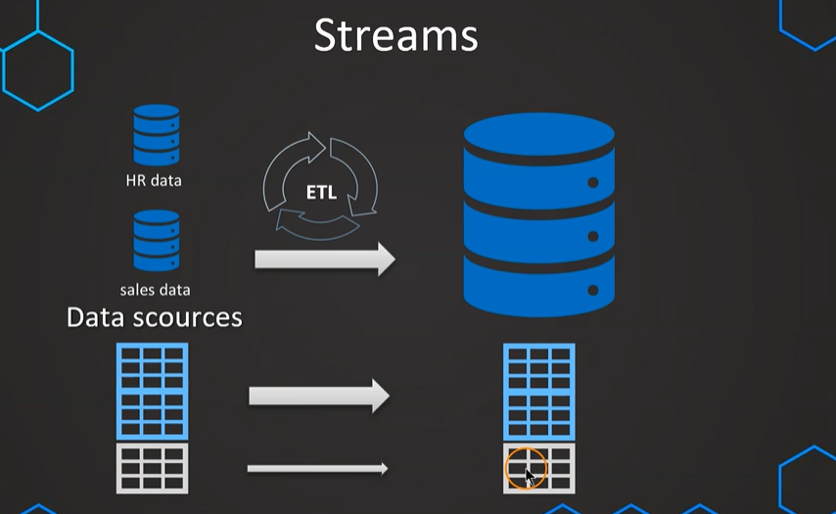
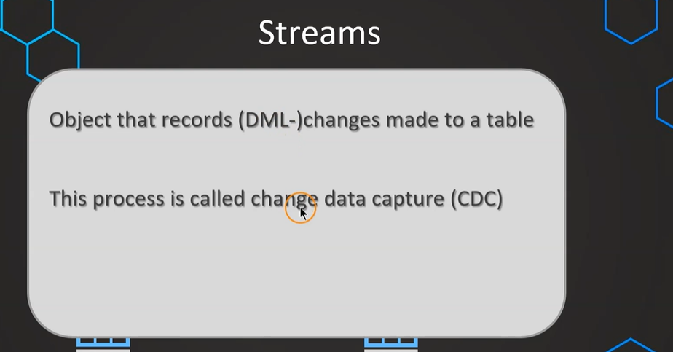
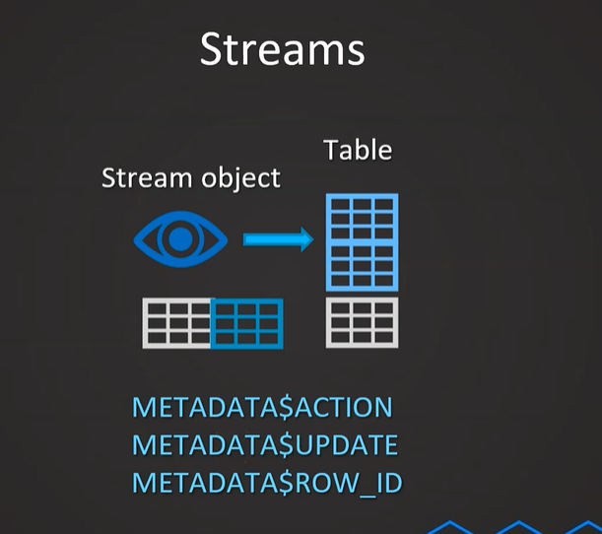
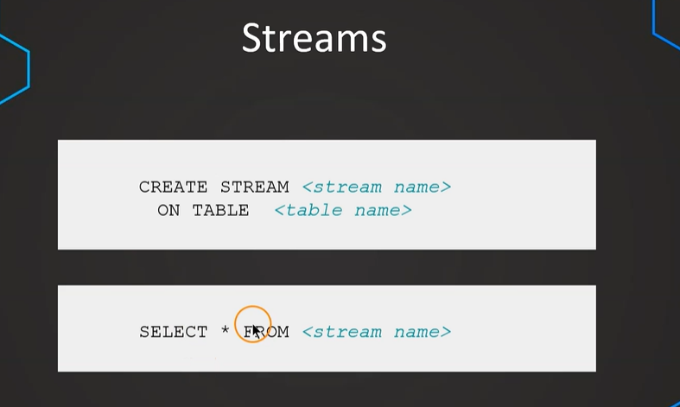
INSERT OPEARTION:

-------------------- Stream example: INSERT ------------------------
CREATE OR REPLACE TRANSIENT DATABASE STREAMS_DB;

-- Create example table
create or replace table sales_raw_staging(
id varchar,
product varchar,
price varchar,
amount varchar,
store_id varchar);

-- insert values
insert into sales_raw_staging
values
(1,'Banana',1.99,1,1),
(2,'Lemon',0.99,1,1),
(3,'Apple',1.79,1,2),
(4,'Orange Juice',1.89,1,2),
(5,'Cereals',5.98,2,1);

create or replace table store_table(
store_id number,
location varchar,
employees number);

INSERT INTO STORE_TABLE VALUES(1,'Chicago',33);
INSERT INTO STORE_TABLE VALUES(2,'London',12);

create or replace table sales_final_table(
id int,
product varchar,
price number,
amount int,
store_id int,
location varchar,
employees int);

-- Insert into final table
INSERT INTO sales_final_table
SELECT
SA.id,
SA.product,
SA.price,
SA.amount,
ST.STORE_ID,
ST.LOCATION,
ST.EMPLOYEES
FROM SALES_RAW_STAGING SA
JOIN STORE_TABLE ST ON ST.STORE_ID=SA.STORE_ID ;

-- Create a stream object
create or replace stream sales_stream on table sales_raw_staging;

SHOW STREAMS;

DESC STREAM sales_stream;

-- Get changes on data using stream (INSERTS)
select * from sales_stream;

select * from sales_raw_staging;

-- insert values
insert into sales_raw_staging
values
(6,'Mango',1.99,1,2),
(7,'Garlic',0.99,1,1);

-- Get changes on data using stream (INSERTS)
select * from sales_stream;

select * from sales_raw_staging;

select * from sales_final_table;

-- Consume stream object
INSERT INTO sales_final_table
SELECT
SA.id,
SA.product,
SA.price,
SA.amount,
ST.STORE_ID,
ST.LOCATION,
ST.EMPLOYEES
FROM SALES_STREAM SA
JOIN STORE_TABLE ST ON ST.STORE_ID=SA.STORE_ID ;

-- Get changes on data using stream (INSERTS)
select * from sales_stream;

-- insert values
insert into sales_raw_staging
values
(8,'Paprika',4.99,1,2),
(9,'Tomato',3.99,1,2);

-- Consume stream object
INSERT INTO sales_final_table
SELECT
SA.id,
SA.product,
SA.price,
SA.amount,
ST.STORE_ID,
ST.LOCATION,
ST.EMPLOYEES
FROM SALES_STREAM SA
JOIN STORE_TABLE ST ON ST.STORE_ID=SA.STORE_ID ;

SELECT * FROM SALES_FINAL_TABLE;

SELECT * FROM SALES_RAW_STAGING;

SELECT * FROM SALES_STREAM;

UPDATE OPERATION :

-- ******* UPDATE 1 ********

SELECT * FROM SALES_RAW_STAGING;

SELECT * FROM SALES_STREAM;

UPDATE SALES_RAW_STAGING
SET PRODUCT ='Potato' WHERE PRODUCT = 'Banana'

merge into SALES_FINAL_TABLE F -- Target table to merge changes from source table
using SALES_STREAM S -- Stream that has captured the changes
on f.id = s.id
when matched
and S.METADATA$ACTION ='INSERT'
and S.METADATA$ISUPDATE ='TRUE' -- Indicates the record has been updated
then update
set f.product = s.product,
f.price = s.price,
f.amount= s.amount,
f.store_id=s.store_id;

SELECT * FROM SALES_FINAL_TABLE

SELECT * FROM SALES_RAW_STAGING;

SELECT * FROM SALES_STREAM;

-- ******* UPDATE 2 ********

UPDATE SALES_RAW_STAGING
SET PRODUCT ='Green apple' WHERE PRODUCT = 'Apple';

merge into SALES_FINAL_TABLE F -- Target table to merge changes from source table
using SALES_STREAM S -- Stream that has captured the changes
on f.id = s.id
when matched
and S.METADATA$ACTION ='INSERT'
and S.METADATA$ISUPDATE ='TRUE' -- Indicates the record has been updated
then update
set f.product = s.product,
f.price = s.price,
f.amount= s.amount,
f.store_id=s.store_id;

SELECT * FROM SALES_FINAL_TABLE;

SELECT * FROM SALES_RAW_STAGING;

SELECT * FROM SALES_STREAM;
Delete Operation:

-- ******* DELETE ********

SELECT * FROM SALES_FINAL_TABLE

SELECT * FROM SALES_RAW_STAGING;

SELECT * FROM SALES_STREAM;

DELETE FROM SALES_RAW_STAGING
WHERE PRODUCT = 'Lemon';

-- ******* Process stream ********

merge into SALES_FINAL_TABLE F -- Target table to merge changes from source table
using SALES_STREAM S -- Stream that has captured the changes
on f.id = s.id
when matched
and S.METADATA$ACTION ='DELETE'
and S.METADATA$ISUPDATE = 'FALSE'
then delete
PROCESS ALL STREAMS “
-- ******* Process UPDATE,INSERT & DELETE simultaneously ********
merge into SALES_FINAL_TABLE F -- Target table to merge changes from source table
USING ( SELECT STRE.*,ST.location,ST.employees
FROM SALES_STREAM STRE
JOIN STORE_TABLE ST
ON STRE.store_id = ST.store_id
) S
ON F.id=S.id
when matched -- DELETE condition
and S.METADATA$ACTION ='DELETE'
and S.METADATA$ISUPDATE = 'FALSE'
then delete
when matched -- UPDATE condition
and S.METADATA$ACTION ='INSERT'
and S.METADATA$ISUPDATE = 'TRUE'
then update
set f.product = s.product,
f.price = s.price,
f.amount= s.amount,
f.store_id=s.store_id
when not matched
and S.METADATA$ACTION ='INSERT'
then insert
(id,product,price,store_id,amount,employees,location)
values
(s.id, s.product,s.price,s.store_id,s.amount,s.employees,s.location)

SELECT * FROM SALES_RAW_STAGING;

SELECT * FROM SALES_STREAM;

SELECT * FROM SALES_FINAL_TABLE;

INSERT INTO SALES_RAW_STAGING VALUES (2,'Lemon',0.99,1,1);

UPDATE SALES_RAW_STAGING
SET PRODUCT = 'Lemonade'
WHERE PRODUCT ='Lemon'

DELETE FROM SALES_RAW_STAGING
WHERE PRODUCT = 'Lemonade';

--- Example 2 ---

INSERT INTO SALES_RAW_STAGING VALUES (10,'Lemon Juice',2.99,1,1);

UPDATE SALES_RAW_STAGING
SET PRICE = 3
WHERE PRODUCT ='Mango';

DELETE FROM SALES_RAW_STAGING
WHERE PRODUCT = 'Potato';
COMBINE STREAMS AND TASKS :

------- Automatate the updates using tasks --

CREATE OR REPLACE TASK all_data_changes
WAREHOUSE = COMPUTE_WH
SCHEDULE = '1 MINUTE'
WHEN SYSTEM$STREAM_HAS_DATA('SALES_STREAM')
AS
merge into SALES_FINAL_TABLE F -- Target table to merge changes from source table
USING ( SELECT STRE.*,ST.location,ST.employees
FROM SALES_STREAM STRE
JOIN STORE_TABLE ST
ON STRE.store_id = ST.store_id
) S
ON F.id=S.id
when matched -- DELETE condition
and S.METADATA$ACTION ='DELETE'
and S.METADATA$ISUPDATE = 'FALSE'
then delete
when matched -- UPDATE condition
and S.METADATA$ACTION ='INSERT'
and S.METADATA$ISUPDATE = 'TRUE'
then update
set f.product = s.product,
f.price = s.price,
f.amount= s.amount,
f.store_id=s.store_id
when not matched
and S.METADATA$ACTION ='INSERT'
then insert
(id,product,price,store_id,amount,employees,location)
values
(s.id, s.product,s.price,s.store_id,s.amount,s.employees,s.location)

ALTER TASK all_data_changes RESUME;
SHOW TASKS;

// Change data

INSERT INTO SALES_RAW_STAGING VALUES (11,'Milk',1.99,1,2);
INSERT INTO SALES_RAW_STAGING VALUES (12,'Chocolate',4.49,1,2);
INSERT INTO SALES_RAW_STAGING VALUES (13,'Cheese',3.89,1,1);

UPDATE SALES_RAW_STAGING
SET PRODUCT = 'Chocolate bar'
WHERE PRODUCT ='Chocolate';

DELETE FROM SALES_RAW_STAGING
WHERE PRODUCT = 'Mango';

// Verify results
SELECT * FROM SALES_RAW_STAGING;

SELECT * FROM SALES_STREAM;

SELECT * FROM SALES_FINAL_TABLE;

// Verify the history
select *
from table(information_schema.task_history())
order by name asc,scheduled_time desc;

STREAM TYPES:
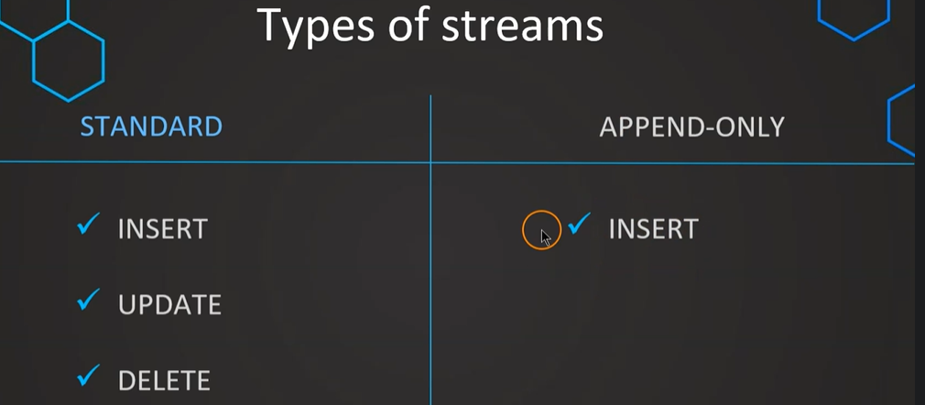

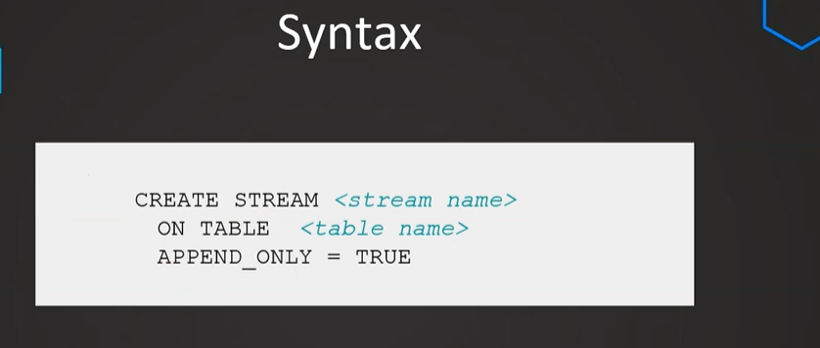
------- Append-only type ------
USE STREAMS_DB;
SHOW STREAMS;

SELECT * FROM SALES_RAW_STAGING;

-- Create stream with default
CREATE OR REPLACE STREAM SALES_STREAM_DEFAULT
ON TABLE SALES_RAW_STAGING;

-- Create stream with append-only
CREATE OR REPLACE STREAM SALES_STREAM_APPEND
ON TABLE SALES_RAW_STAGING
APPEND_ONLY = TRUE;

-- View streams
SHOW STREAMS;

-- Insert values
INSERT INTO SALES_RAW_STAGING VALUES (14,'Honey',4.99,1,1);
INSERT INTO SALES_RAW_STAGING VALUES (15,'Coffee',4.89,1,2);
INSERT INTO SALES_RAW_STAGING VALUES (15,'Coffee',4.89,1,2);

SELECT * FROM SALES_STREAM_APPEND;
SELECT * FROM SALES_STREAM_DEFAULT;

-- Delete values
SELECT * FROM SALES_RAW_STAGING

DELETE FROM SALES_RAW_STAGING WHERE ID=7;

SELECT * FROM SALES_STREAM_APPEND;
SELECT * FROM SALES_STREAM_DEFAULT;

-- Consume stream via "CREATE TABLE ... AS"
CREATE OR REPLACE TEMPORARY TABLE PRODUCT_TABLE
AS SELECT * FROM SALES_STREAM_DEFAULT;
CREATE OR REPLACE TEMPORARY TABLE PRODUCT_TABLE
AS SELECT * FROM SALES_STREAM_APPEND;

-- Update
UPDATE SALES_RAW_STAGING
SET PRODUCT = 'Coffee 200g'
WHERE PRODUCT ='Coffee';

SELECT * FROM SALES_STREAM_APPEND;
SELECT * FROM SALES_STREAM;

Chnages clause :
----- Change clause ------

--- Create example db & table ---

CREATE OR REPLACE DATABASE SALES_DB;

create or replace table sales_raw(
id varchar,
product varchar,
price varchar,
amount varchar,
store_id varchar);

-- insert values
insert into sales_raw
values
(1, 'Eggs', 1.39, 1, 1),
(2, 'Baking powder', 0.99, 1, 1),
(3, 'Eggplants', 1.79, 1, 2),
(4, 'Ice cream', 1.89, 1, 2),
(5, 'Oats', 1.98, 2, 1);

ALTER TABLE sales_raw
SET CHANGE_TRACKING = TRUE;

SELECT * FROM SALES_RAW
CHANGES(information => default)
AT (offset => -0.5*60)

SELECT CURRENT_TIMESTAMP;

-- Insert values
INSERT INTO SALES_RAW VALUES (6, 'Bread', 2.99, 1, 2);
INSERT INTO SALES_RAW VALUES (7, 'Onions', 2.89, 1, 2);

SELECT * FROM SALES_RAW
CHANGES(information => default)
AT (timestamp => 'your-timestamp'::timestamp_tz)

UPDATE SALES_RAW
SET PRODUCT = 'Toast2' WHERE ID=6;

// information value

SELECT * FROM SALES_RAW
CHANGES(information => default)
AT (timestamp => 'your-timestamp'::timestamp_tz)
SELECT * FROM SALES_RAW
CHANGES(information => append_only)
AT (timestamp => 'your-timestamp'::timestamp_tz)

CREATE OR REPLACE TABLE PRODUCTS
AS
SELECT * FROM SALES_RAW
CHANGES(information => append_only)
AT (timestamp => 'your-timestamp'::timestamp_tz)
SELECT * FROM PRODUCTS;

Materialized Views:
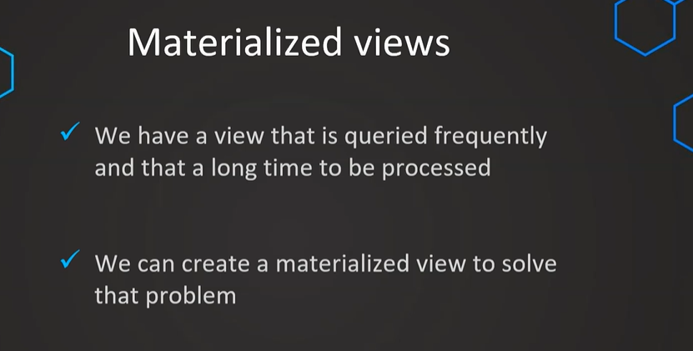
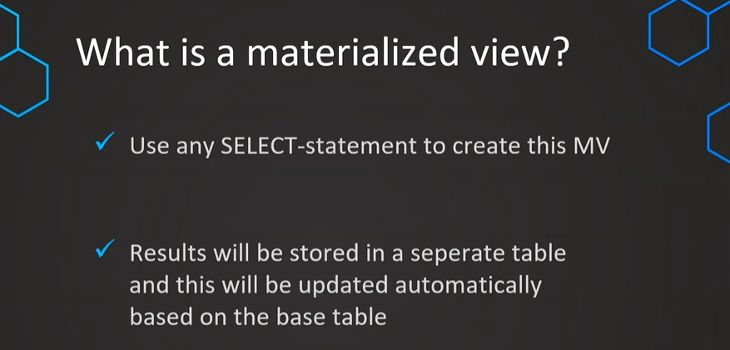
-- Remove caching just to have a fair test -- Part 1

ALTER SESSION SET USE_CACHED_RESULT=FALSE; -- disable global caching
ALTER warehouse compute_wh suspend;
ALTER warehouse compute_wh resume;

-- Prepare table
CREATE OR REPLACE TRANSIENT DATABASE ORDERS;

CREATE OR REPLACE SCHEMA TPCH_SF100;

CREATE OR REPLACE TABLE TPCH_SF100.ORDERS AS
SELECT * FROM SNOWFLAKE_SAMPLE_DATA.TPCH_SF100.ORDERS;

SELECT * FROM ORDERS LIMIT 100

-- Example statement view --
SELECT
YEAR(O_ORDERDATE) AS YEAR,
MAX(O_COMMENT) AS MAX_COMMENT,
MIN(O_COMMENT) AS MIN_COMMENT,
MAX(O_CLERK) AS MAX_CLERK,
MIN(O_CLERK) AS MIN_CLERK
FROM ORDERS.TPCH_SF100.ORDERS
GROUP BY YEAR(O_ORDERDATE)
ORDER BY YEAR(O_ORDERDATE);

-- Create materialized view
CREATE OR REPLACE MATERIALIZED VIEW ORDERS_MV
AS
SELECT
YEAR(O_ORDERDATE) AS YEAR,
MAX(O_COMMENT) AS MAX_COMMENT,
MIN(O_COMMENT) AS MIN_COMMENT,
MAX(O_CLERK) AS MAX_CLERK,
MIN(O_CLERK) AS MIN_CLERK
FROM ORDERS.TPCH_SF100.ORDERS
GROUP BY YEAR(O_ORDERDATE);

SHOW MATERIALIZED VIEWS;

-- Query view
SELECT * FROM ORDERS_MV
ORDER BY YEAR;

-- UPDATE or DELETE values
UPDATE ORDERS
SET O_CLERK='Clerk#99900000'
WHERE O_ORDERDATE='1992-01-01'

-- Test updated data --
-- Example statement view --
SELECT
YEAR(O_ORDERDATE) AS YEAR,
MAX(O_COMMENT) AS MAX_COMMENT,
MIN(O_COMMENT) AS MIN_COMMENT,
MAX(O_CLERK) AS MAX_CLERK,
MIN(O_CLERK) AS MIN_CLERK
FROM ORDERS.TPCH_SF100.ORDERS
GROUP BY YEAR(O_ORDERDATE)
ORDER BY YEAR(O_ORDERDATE);

-- Query view
SELECT * FROM ORDERS_MV
ORDER BY YEAR;

SHOW MATERIALIZED VIEWS;
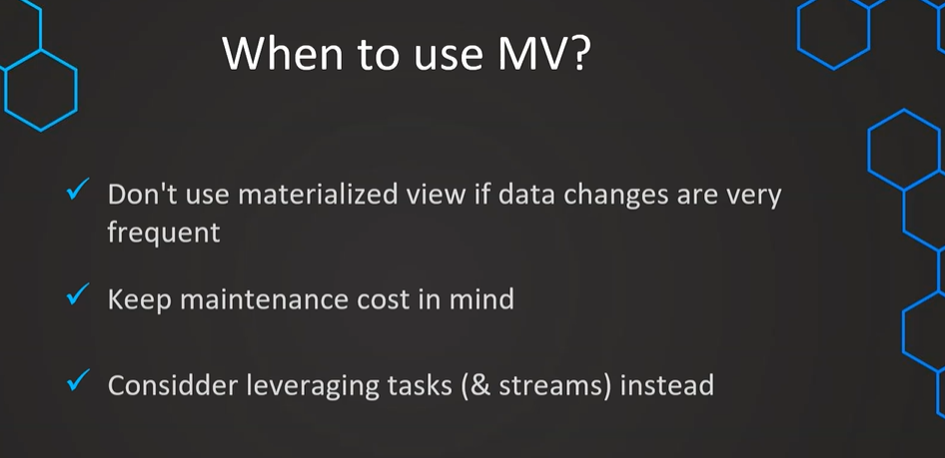

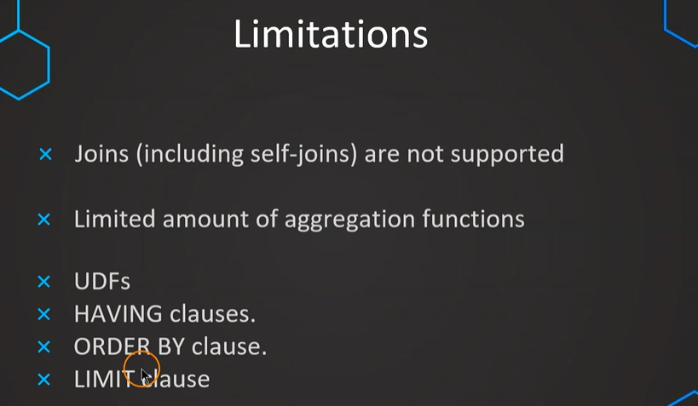

Dynamic Data Masking: Column Level Security
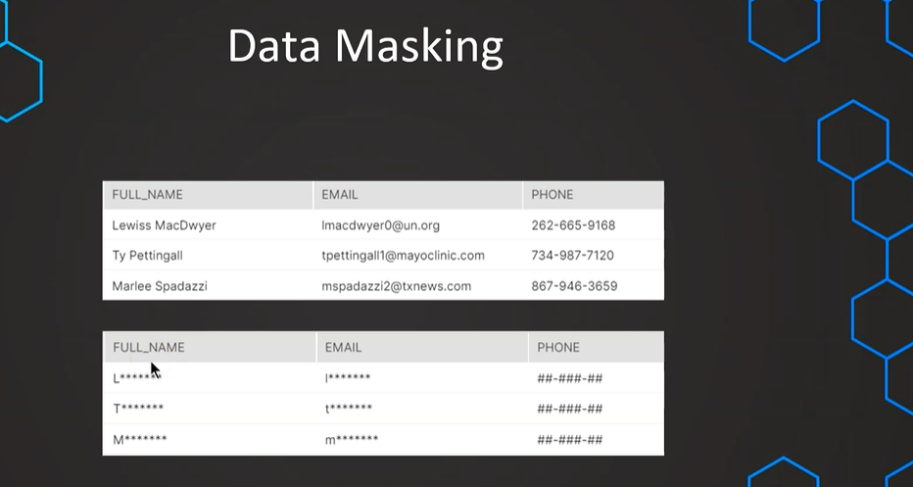

USE DEMO_DB;
USE ROLE ACCOUNTADMIN;

-- Prepare table --
create or replace table customers(
id number,
full_name varchar,
email varchar,
phone varchar,
spent number,
create_date DATE DEFAULT CURRENT_DATE);

-- insert values in table --
insert into customers (id, full_name, email,phone,spent)
values
(1,'Lewiss MacDwyer','lmacdwyer0@un.org','262-665-9168',140),
(2,'Ty Pettingall','tpettingall1@mayoclinic.com','734-987-7120',254),
(3,'Marlee Spadazzi','mspadazzi2@txnews.com','867-946-3659',120),
(4,'Heywood Tearney','htearney3@patch.com','563-853-8192',1230),
(5,'Odilia Seti','oseti4@globo.com','730-451-8637',143),
(6,'Meggie Washtell','mwashtell5@rediff.com','568-896-6138',600);

-- set up roles
CREATE OR REPLACE ROLE ANALYST_MASKED;
CREATE OR REPLACE ROLE ANALYST_FULL;

-- grant select on table to roles
GRANT SELECT ON TABLE ORDERS.PUBLIC.CUSTOMERS TO ROLE ANALYST_MASKED;
GRANT SELECT ON TABLE ORDERS.PUBLIC.CUSTOMERS TO ROLE ANALYST_FULL;

GRANT USAGE ON SCHEMA ORDERS.PUBLIC TO ROLE ANALYST_MASKED;
GRANT USAGE ON SCHEMA ORDERS.PUBLIC TO ROLE ANALYST_FULL;

-- grant warehouse access to roles
GRANT USAGE ON WAREHOUSE COMPUTE_WH TO ROLE ANALYST_MASKED;
GRANT USAGE ON WAREHOUSE COMPUTE_WH TO ROLE ANALYST_FULL;

-- assign roles to a user
GRANT ROLE ANALYST_MASKED TO USER KIRAN419PAV;
GRANT ROLE ANALYST_FULL TO USER KIRAN419PAV;

-- Set up masking policy

create or replace masking policy phone
as (val varchar) returns varchar ->
case
when current_role() in ('ANALYST_FULL', 'ACCOUNTADMIN') then val
else '##-###-##'
end;

-- Apply policy on a specific column
ALTER TABLE IF EXISTS CUSTOMERS MODIFY COLUMN phone
SET MASKING POLICY PHONE;

-- Validating policies

USE ROLE ANALYST_FULL;
SELECT * FROM CUSTOMERS;

USE ROLE ANALYST_MASKED;
SELECT * FROM CUSTOMERS;

